

**Safeguarding And Child Protection Policy**

**Whole school including EYFS**

**V4.2**

|  |  |
| --- | --- |
| Approved (Date): | 19 September 2024 |
| Next review (Date): | September 2025 |
| Owner (Name, Title): | Deputy Head Safeguarding (DSL) |
| Classification: | Statutory |
| Comment: | KCSIE 2024 amendments |

1 INTRODUCTION 3

2 REFERENCES 3

3 KEY PERSONNEL AND EXTERNAL AGENCIES 4

4 STATEMENT OF INTENT 7

5 OBJECTIVES 8

6 DEFINITIONS OF SAFEGUARDING AND TYPES AND SIGNS OF ABUSE 8

7 PUPIL EDUCATION AND CHILD ON CHILD ABUSE 10

8 SEXUAL VIOLENCE AND SEXUAL HARASSMENT BETWEEN CHILDREN 10

9 EARLY HELP 16

10 PROCEDURES FOR DEALING WITH CONCERNS OR SUSPICIONS OF ABUSE OR NEGLECT 17

11 REFERRALS 19

12 SECTION ONE: PROCEDURES FOR MANAGING ALLEGATIONS OF ABUSE AGAINST STAFF, SUPPLY STAFF, VOLUNTEERS, CONTRACTORS OR THE WARDEN 20

13 DBS – TRA REFERRALS 23

14 SECTION TWO: CONCERNS THAT DO NOT MEET THE HARM THRESHOLD 24

15 WHISTLEBLOWING 25

16 CHILD'S WISHES 26

17 TRANSPARENCY 26

18 LOOKED AFTER CHILDREN 26

19 GOVERNING BODY 26

20 ROLE OF THE DESIGNATED SAFEGUARDING LEAD 27

21 RECRUITMENT, SAFER EMPLOYMENT PRACTICES 28

22 VOLUNTEERS 30

23 INDUCTION AND TRAINING 31

24 STAFF/PUPIL RELATIONS 32

25 DISQUALIFICATION UNDER THE CHILDCARE ACT 2006 (JULY 2018) 33

26 PREVENTING RADICALISATION 35

27 OUTSIDE VISITORS, CONTRACTORS 36

28 ADMISSION, ATTENDANCE AND SCHOOL ROLL 37

29 HOMELESSNESS 38

30 CHILDREN MISSING FROM EDUCATION 38

31 SO-CALLED 'HONOUR BASED' ABUSE 40

32 FEMALE GENITAL MUTILATION (FGM) 41

33 DOMESTIC VIOLENCE 41

34 SPECIAL EDUCATIONAL NEEDS AND DISABILITY 42

35 PHOTOGRAPHY AND PRIVACY, INCLUDING MOBILE PHONES 42

36 ONLINE SAFETY 43

37 PUPILS MENTAL HEALTH 44

38 PROMOTING AWARENESS 44

39 POSITION OF TRUST 45

40 ORGANISATIONS AND INDIVIDUALS USING SCHOOL PREMISES 46

41 RECORDS 46

42 MONITORING AND EVALUATION OF THIS POLICY 46

43 Appendix A - Signs and Definitions of Child Abuse 47

44 Appendix C - ‘Prevent’ Anti-Radicalisation 56

45 Appendix D – Forced Marriage 63

46 Appendix E – Actions where there are concerns about a child 64

47 Appendix F Safeguarding Team Poster 66

48 Appendix G Child-on-Child Abuse Toolkit 67

# INTRODUCTION

## This policy is applicable to the whole school community, including those pupils in the Early Years Foundation Stage (EYFS). The policy is applicable to all on and off-site activities undertaken by pupils whilst they are the responsibility of the School.

## This Safeguarding and Child Protection Policy is available to all parents and pupils via the School Website and printed copies are available upon request. An e-mail with a link to this Safeguarding and Child Protection Policy is sent at the start of the academic year to all parents and explains where to find the policy.

# REFERENCES

## Forest School recognises its duty is to safeguard and promote the welfare of all its pupils. This includes children who are in need (Section 17, Children Act [1989]) and children who are at risk of harm (Section 47, Children Act [1989]).

## Forest School’s Safeguarding and Child Protection Policy has regard to:

* [*Keeping Children Safe in Education*](https://www.google.com/url?sa=t&rct=j&q=&esrc=s&source=web&cd=5&cad=rja&uact=8&ved=2ahUKEwi28I3b16jmAhWkRxUIHWqyDhcQFjAEegQIAxAB&url=https%3A%2F%2Fwww.gov.uk%2Fgovernment%2Fpublications%2Fkeeping-children-safe-in-education--2&usg=AOvVaw0xyQc-oYGH8hkSZOOsmJmX) *(September 2024) (KCSIE)*

* This incorporates the additional statutory guidance, Disqualification under the Childcare Act 2006

* KCSIE also refers to the non-statutory advice for practitioners: What to do if you’re worried a child is being abused (March 2015)

* [*Working Together to Safeguard Children*](https://assets.publishing.service.gov.uk/government/uploads/system/uploads/attachment_data/file/779401/Working_Together_to_Safeguard-Children.pdf) *(December 2023) (WT)*

* WT refers to the non-statutory advice: [Information sharing](https://assets.publishing.service.gov.uk/government/uploads/system/uploads/attachment_data/file/721581/Information_sharing_advice_practitioners_safeguarding_services.pdf) (May 2024)

* [*Prevent Duty Guidance: For England and Wales*](https://www.google.com/url?sa=t&rct=j&q=&esrc=s&source=web&cd=1&cad=rja&uact=8&ved=2ahUKEwjc063816jmAhWZURUIHZWPBYsQFjAAegQIARAB&url=https%3A%2F%2Fwww.gov.uk%2Fgovernment%2Fpublications%2Fprevent-duty-guidance&usg=AOvVaw0x2RTWb50mJYivprtmyCAj) *(July 2015) (Updated December 2023)*

* The Prevent Duty: safeguarding learners vulnerable to radicalisation Oct 2022 (updated Sept 2023

* The use of social media for on-line radicalisation (July 2015)

* *Relationships education, relationships, and sex education (RSE) and health education* (September 2021).
* *Children Missing Education (August 2024)*
* *Multi Agency Guidance on FGM (July 2020)*
* *Behaviour in schools (February 2024)*
* *Working together to improve school attendance (May 2022)*
* *Digital and technology standards in schools and colleges (March 2023)*
* *After school clubs, community activities, and tuition (safeguarding guidance for providers) (September 2023)*
* *The Charity Commission guidance Safeguarding and protecting people for charities and trustees (June 2022)*

This policy also takes into account the procedures and practice of Waltham Forest as part of the inter-agency safeguarding procedures set up by the Waltham Forest Safeguarding Children Board (WFSCB).

# KEY PERSONNEL AND EXTERNAL AGENCIES

## The Designated Safeguarding Lead (DSL) and Deputies for Forest School including Forest Preparatory School, including EYFS are:

|  |  |  |
| --- | --- | --- |
| **Designated Safeguarding Lead** | **Email** | **Phone number** |
| Jeff Kayne, Deputy Head Safeguarding, Member of Leadership Team Designated Teacher of Looked After Children | [jhk@forest.org.uk](mailto:jhk@forest.org.uk) | 020 8509 6528 mobile number issued to staff for out of hours |
| **Deputy DSLs** |  |  |
| Jon Sloan, Head of Lower School  Member of Leadership Team | jts@forest.org.uk | 020 8509 4681 |
| Louise Lechmere-Smith, Head of Middle School  Member of Leadership Team | [lel@forest.org.uk](mailto:lel@forest.org.uk) | 020 8509 6552 |
| Kate Spencer Ellis, Head of Sixth Form  Member of Leadership Team | [kse@forest.org.uk](mailto:kse@forest.org.uk) | 020 8509 4666 |
| Natassja Milton, Deputy Head Pastoral  Member of Leadership Team | [nsm@forest.org.uk](mailto:nsm@forest.org.uk) | 020 8509 6529 |
| Kate Clark, Deputy Head of Pupil Development and Wellbeing, Prep School | klc@forest.org.uk | 020 8509 6516 |
| Emily Arthur, Deputy Head of Middle School | [ela@forest.org.uk](mailto:ela@forest.org.uk) | 020 8509 6570 |
| Mel Wright, Senior school SEND | [mw@forest.org.uk](mailto:mw@forest.org.uk) | 020 8509 4664 |
| Maggie Pickwick, Prep School SEND | [mp@forest.org.uk](mailto:mp@forest.org.uk) | 020 8509 6637 |
| Amanda Gale, Place2Be School Project Manager | [agale@forest.org.uk](mailto:agale@forest.org.uk) | 020 8509 4960 |
| Kim Wolstenholme, School Office Manager | [kwolstenholme@forest.org.uk](mailto:kwolstenholme@forest.org.uk) | 020 8509 4696 |
| Hattie Birkett, Lead Nurse and Medical Operations Manager | [hbirkett@forest.org.uk](mailto:hbirkett@forest.org.uk) | 020 8509 6515 |
| **For concerns or allegation against a member of staff or volunteer** |  |  |
| Marcus Cliff Hodges, Warden  Member of Leadership Team | [mch@forest.org.uk](mailto:mch@forest.org.uk) | 020 8509 6525 |
| **Forest Preparatory School** |  |  |
| Anna Manlangit Deputy Head of Pupil Welfare and Engagement – EYFS, DDSL  Member of PS Leadership Team | [aam@forest.org.uk](mailto:aam@forest.org.uk) | 020 8352 6636 |
| James Sanderson, Head of the Preparatory School  Member of Leadership Team | [jers@forest.org.uk](mailto:jers@forest.org.uk) | 020 8509 6630 |
| **Safeguarding Team** |  |  |
| Wayne Bishop, Health & Safety and Compliance Director, DDSL | [wbishop@forest.org.uk](mailto:wbishop@forest.org.uk) | 07818543695 020 8509 6545 |
| Jordan Wilson, Leisure Facilities Manager | [jwilson@forest.org.uk](mailto:jwilson@forest.org.uk) | 020 8509 6614/  020 8509 6526 |
| **Nominated Governor responsible for Safeguarding** |  |  |
| Steven Berryman Whole School Incl. EYFS | [sberryman@forest.org.uk](mailto:sberryman@forest.org.uk) | 020 8509 6504 (clerk to the Governors) |
| **Chair of Governors** |  |  |
| David TM Wilson | [dwilson@forest.org.uk](mailto:dwilson@forest.org.uk) | 020 8509 6504 (clerk to the Governors) |
| **External Agencies** |  |  |
| Waltham Forest Safeguarding Children Board (WFSCB) | MASHrequests@walthamforest.gov.uk Juniper House, 221 Hoe Street, London E17 9PH | 020 8496 6310 out of hours 020 8496 3000 |
| Waltham Forest Designated Officer (LADO) – Caroline Aitkin | LADO@walthamforest.gov.uk Juniper House, 221 Hoe Street, London E17 9PH | 020 8496 3646/8279 |
| Waltham Forest BACME (Behaviour, Attendance and Children Missing Education) Lead  Lisa Smith | BACME Service, Early Help Division  Waltham Forest Council   Magistrates Building  Forest Road  Walthamstow  E17 4NX | Tel: 020 8496 1753  Mobile: 07536039213 |
| Emergency Police number |  | 999 |
| Non-emergency Police number |  | 101 |
| Anti-Terrorist Hotline |  | 0800 789 321 (emergency) |
| DfE dedicated telephone helpline for non-emergency advice for staff and Governors (Risk of Terrorism) | [counter-extremism@education.gsi.gov.uk](mailto:counter-extremism@education.gsi.gov.uk) | 020 7340 7264 or |
| Waltham Forest Prevent Officer– Amy Strode | [amy.strode@walthamforest.gov.uk](mailto:amy.strode@walthamforest.gov.uk) | 020 8496 4990 Out of Hours Emergency Duty Team - 020 8496 3000 07970 769 073 |
| Waltham Forest Prevent Education Officer - Amy Strode | [Amy.Strode@walthamforest.gov.uk](mailto:Amy.Strode@walthamforest.gov.uk) | 07816 150 037 |
| OFSTED Safeguarding Children | [whistleblowing@ofsted.gov.uk](mailto:whistleblowing@ofsted.gov.uk) | 0300 123 4666 |
| Independent Schools Inspectorate | [concerns@isi.net](mailto:concerns@isi.net) | 0207 6000100 |
| Disclosure and Barring Service Address: DBS customer services  PO Box 3961  Royal Wootton Bassett   SN4 4HF | [customerservices@dbs.gov.uk](mailto:customerservices@dbs.gov.uk) | 01325 953795 |
| Teaching Regulation Agency (TRA)  Address: Teacher Misconduct  Ground Floor South  Cheylesmore House  5 Quinton Road  Coventry CV1 2WT | [misconduct.teacher@education.gov.u](mailto:misconduct.teacher@education.gov.u)k | 0207 593 5393 |
| NSPCC Whistleblowing hotline Address: Weston House  42 Curtain Road   London  EC2A 3NH | [help@nspcc.org.uk](mailto:help@nspcc.org.uk) | 0800 028 0285 |

## **Protecting pupils from the risk of extremism:**

* Unlike other Child Protection referrals, all Prevent referrals must be made to LB Waltham Forest (numbers above) regardless of the Borough a child lives in.

# STATEMENT OF INTENT

## The safety and welfare of all our pupils at Forest School is our highest priority. Our business is to know everyone as an individual and to provide a secure and caring environment so that every pupil can learn in safety. In all matters relating to Child Protection the School will follow the procedures laid down by our own (or where appropriate the relevant child's) Local authorities which is Waltham Forest Safeguarding Children Board (WFSCB) together with DfE guidance contained in Working Together to Safeguard Children (December 2023) and Keeping Children Safe in Education (September 2024):

<https://www.gov.uk/government/publications/keeping-children-safe-in-education--2>

## This policy is applicable to the whole School community, including those pupils in the Early Years Foundation Stage (EYFS). ('The School')

## All members of staff have a duty to safeguard our pupils' welfare and must therefore familiarise themselves and comply at all times with this policy; safeguarding and promoting the welfare of children is everyone's responsibility. This includes a duty both to children in need and to children at risk of harm. All staff should read at least Part 1 of KCSIE. Those involved directly with children should also read Annex A. All School staff should be aware that Child Protection incidents can happen at any time and anywhere and are required to be alert to any possible concerns. The Governors, Warden and Designated Safeguarding Lead and Deputies ensure that the following mechanisms are in place to assist staff to understand and discharge their role and responsibilities as set out in Part 1 of KCSIE:

## Forest School makes a commitment to always act in the best interests of the child and to take action to enable all children to have the best outcomes.

## The Safeguarding Committee will meet every week to discuss new and ongoing child protection cases. Minutes are recorded and uploaded to the Safeguarding folder.

## Where possible, content from other Forest School Policies has not been duplicated in this document. The following Policies, therefore, may be regarded as linked to this document and may be understood in conjunction with it:

-Health & Safety Policy

-Staff Code of Conduct

-Whistleblowing Policy

-Recruitment Policy

-Online Safety Policy

-Anti-Bullying, Including Cyber-Bullying

-First Aid Policy

-Searches, Contact and Reasonable Force Policy

-Behaviour Policy

-School Rules

### -Data Protection Policy

-Visitors and Site Security Policy.  
-Mental Health Policy (senior school)  
- School Attendance and Punctuality Policy

# OBJECTIVES

## There are three main elements to our safeguarding culture to ensure it is fully and effectively implemented:

### **Prevention:** (e.g. following safer recruitment practices; supportive school atmosphere; teaching and pastoral support available to pupils, including PSHE curriculum teaching children to keep themselves safe)

### **Protection:** (e.g. by following agreed procedures and monitoring their implementation; by ensuring staff are trained and supported appropriately and sensitively in safeguarding matters; by encouraging open communication)

### **Support:** Appropriate support will be offered to pupils and staff who make disclosures or voice concerns. The School will outline carefully the process that will follow for handling a complaint and will offer counselling or other pastoral support as necessary.

# DEFINITIONS OF SAFEGUARDING AND TYPES AND SIGNS OF ABUSE

## Safeguarding and promoting the welfare of children is defined for the purposes of this guidance as:

• providing help and support to meet the needs of children as soon as problems emerge

• protecting children from maltreatment, whether that is within or outside the home, including online

• preventing impairment of children’s mental and physical health or development

• ensuring that children grow up in circumstances consistent with the provision of safe and effective care

• promoting the upbringing of children with their birth parents, or otherwise their family network4 through a kinship care arrangement, whenever possible and where this is in the best interests of the children

• taking action to enable all children to have the best outcomes in line with the outcomes set out in the Children’s Social Care National Framework5.

Child protection is part of safeguarding and promoting the welfare of children and is defined for the purpose of this guidance as activity that is undertaken to protect specific children who are suspected to be suffering, or likely to suffer, significant harm. This includes harm that occurs inside or outside the home, including online.

Effective safeguarding means practitioners should understand and be sensitive to factors, including economic and social circumstances and ethnicity, which can impact children and families’ lives.

## Abuse is a form of maltreatment of a child. Somebody may abuse or neglect a child by inflicting harm or by failing to act to prevent harm. Harm can include ill treatment that is not physical as well as the impact of witnessing ill treatment of others. This can be particularly relevant, for example, in relation to the impact on children of all forms of domestic abuse. Children may be abused in a family or in an institutional or community setting by those known to them or, more rarely, by others (e.g. via the internet). Abuse can take place wholly online, or technology may be used to facilitate offline abuse. They may be abused by an adult or adults or by another child or children. Abuse can be:

## • physical abuse; • emotional abuse; • sexual abuse; and/or • neglect.

## Staff are referred to Appendix A of this policy for further detail of the types of abuse and possible signs of abuse.

## **The Departmental advice:**

* What to do if you are worried a child is being abused - Advice for Practitioners <https://www.gov.uk/government/publications/what-to-do-if-youre-worried-a-child-is-being-abused--2>

Should be referred to by all staff in raising their awareness of and helping them to identify the signs of child abuse.

* Staff are encouraged to refer to the NSPCC Website <https://www.nspcc.org.uk/preventing-abuse/> which also provides helpful information on types of abuse and what to look out for. This is also found in Appendix A at the end of this document.
* Annex A of KCSIE should also be referred to by all members of staff and those staff working directly with children. Such staff include Leadership team, teachers, coaches, volunteers, nurses and certain support staff (who work directly with children on a regular basis).

# PUPIL EDUCATION AND CHILD ON CHILD ABUSE

## All staff will be made aware that children can abuse other children (often referred to as child on child abuse). And that it can happen both inside and outside of school and online. It is important that all staff recognise the indicators and signs of child on child abuse and know how to identify it and respond to reports.

## All staff should understand, that even if there are no reports in this school it does not mean it is not happening, it may be the case that it is just not being reported. As such it is important if staff have any concerns regarding child on child abuse, they should speak to their designated safeguarding lead (or deputy).

## It is essential that all staff understand the importance of challenging inappropriate behaviours between peers, many of which are listed below, that are actually abusive in nature. Downplaying certain behaviours, for example dismissing sexual harassment as “just banter”, “just having a laugh”, “part of growing up” or “boys being boys” can lead to a culture of unacceptable behaviours, an unsafe environment for children and in worst case scenarios a culture that normalises abuse leading to children accepting it as normal and not coming forward to report it.

## Child on child abuse is most likely to include, but may not be limited to:

• bullying (including cyberbullying, prejudice-based and discriminatory bullying);

• abuse in intimate personal relationships between peers;

• physical abuse such as hitting, kicking, shaking, biting, hair pulling, or otherwise causing physical harm (this may include an online element which facilitates, threatens and/or encourages physical abuse);

• sexual violence,11 such as rape, assault by penetration and sexual assault; (this may include an online element which facilitates, threatens and/or encourages sexual violence);

• sexual harassment,12 such as sexual comments, remarks, jokes and online sexual harassment, which may be standalone or part of a broader pattern of abuse;

• causing someone to engage in sexual activity without consent, such as forcing someone to strip, touch themselves sexually, or to engage in sexual activity with a third party;

• consensual and non-consensual sharing of nudes and semi nudes images and or videos (also known as Youth Produced Sexual Imagery or youth produced sexual imagery);

• upskirting, which typically involves taking a picture under a person’s clothing without their permission, with the intention of viewing their genitals or buttocks to obtain sexual gratification, or cause the victim humiliation, distress or alarm; and

• initiation/hazing type violence and rituals (this could include activities involving harassment, abuse or humiliation used as a way of initiating a person into a group and may also include an online element).

## All teaching staff will be required to read and understand the Schools separate Child on child Abuse Policy, located within the Compliance Centre for policies.

# SEXUAL VIOLENCE AND SEXUAL HARASSMENT BETWEEN CHILDREN

Sexual violence and sexual harassment can occur between two children of any sex. They can also occur through a group of children sexually assaulting or sexually harassing a single child or group of children. Children who are the victims of sexual violence and sexual harassment will likely find the experience stressful and distressing. Sexual violence and sexual harassment exist on a continuum and may overlap, they can occur online and offline.

## **Sexual violence**

It is important that staff are aware of sexual violence and the fact children can, and sometimes do, abuse their peers in this way. When referring to sexual violence in this advice, we do so in the context of child on child sexual violence.

For the purpose of this advice, when referring to sexual violence we are referring to sexual offences under the Sexual Offences Act 2003 as described below:

**Rape:** A person (A) commits an offence of rape if: he intentionally penetrates the vagina, anus or mouth of another person (B) with his penis, B does not consent to the penetration and A does not reasonably believe that B consents.

**Assault by Penetration:** A person (A) commits an offence if: s/he intentionally penetrates the vagina or anus of another person (B) with a part of her/his body or anything else, the penetration is sexual, B does not consent to the penetration and A does not reasonably believe that B consents.

**Sexual Assault:** A person (A) commits an offence of sexual assault if: s/he intentionally touches another person (B), the touching is sexual, B does not consent to the touching and A does not reasonably believe that B consents.

**What is consent?** Someone consents to vaginal, anal or oral penetration only if s/he agrees by choice to that penetration and has the freedom and capacity to make that choice. Consent to sexual activity may be given to one sort of sexual activity but not another, e.g.to vaginal but not anal sex or penetration with conditions, such as wearing a condom. Consent can be withdrawn at any time during sexual activity and each time activity occurs.

## **Sexual harassment**

For the purpose of this advice, when referring to sexual harassment we mean ‘unwanted conduct of a sexual nature’ that can occur online and offline. When we reference sexual harassment, we do so in the context of child on child sexual harassment. Sexual harassment is likely to: violate a child’s dignity, and/or make them feel intimidated, degraded or humiliated and/or create a hostile, offensive or sexualised environment.

Whilst not intended to be an exhaustive list, sexual harassment can include:

* sexual comments, such as: telling sexual stories, making lewd comments, making sexual remarks about clothes and appearance and calling someone sexualised names;
* sexual “jokes” or taunting;
* physical behaviour, such as: deliberating brushing against someone, interfering with someone’s clothes (schools and colleges should be considering when any of this crosses a line into sexual violence - it is important to talk to and consider the experience of the victim) and displaying pictures, photos or drawings of a sexual nature; and
* online sexual harassment, which might include: sharing nudes and semi-nudes images and/or videos (both often referred to as Youth Produced Sexual Imagery); inappropriate sexual comments on social media; exploitation; coercion and threats. Online sexual harassment may be standalone, or part of a wider pattern of sexual harassment and/or sexual violence.

It is important that staff consider sexual harassment in broad terms. Sexual harassment (as set out above) creates an atmosphere that, if not challenged, can normalise inappropriate behaviours and provide an environment that may lead to sexual violence.

## **Harmful sexual behaviours**

Children’s sexual behaviours exist on a wide continuum, from normal and developmentally expected to inappropriate, problematic, abusive and violent.

Problematic, abusive and violent sexual behaviours are developmentally inappropriate and may cause developmental damage. A useful umbrella term is “harmful sexual behaviours”. Advice on signs, indicators and effects of harmful sexual behaviours is available here: [NSPCC: Harmful sexual behaviour: signs-indicators-effects.](https://www.nspcc.org.uk/preventing-abuse/child-abuse-and-neglect/harmful-sexual-behaviour/signs-symptoms-effects/) The term has been widely adopted in child protection and is used in this advice. **Harmful sexual behaviours can occur online and offline and can occur simultaneously between the two.** Harmful sexual behaviours should be considered in a child protection context.

When considering harmful sexual behaviours, ages and the stages of development of the children are critical factors to consider. Sexual behaviour between children can be considered harmful if one of the children is much older, particularly if there is more than two years’ difference in age or if one of the children is pre-pubescent and the other is not. However, a younger child can abuse an older child, particularly if they have power over them, for example, if the older child is disabled or smaller in stature. The [Brook sexual behaviours traffic light tool](https://www.brook.org.uk/our-work/the-sexual-behaviours-traffic-light-tool) can help when considering harmful sexual behaviours.

Detailed advice on harmful sexual behaviours is available from the specialist sexual violence sector: contact [Rape Crisis](https://rapecrisis.org.uk/) or [the Survivors Trust](https://www.thesurvivorstrust.org/)for details of the nearest centre. Also, see [NSPCC: Harmful sexual behaviour,](https://www.nspcc.org.uk/preventing-abuse/child-abuse-and-neglect/harmful-sexual-behaviour/) and [NICE guidance](https://www.nice.org.uk/guidance/ng55) for advice on, amongst other things: developing interventions; working with families and carers; and multi-agency working. It is effective safeguarding practice for the designated safeguarding lead (and their deputies) to have a good understanding of harmful sexual behaviour. This could form part of their safeguarding training. This will aid in planning preventative education, implementing preventative measures, drafting and implementing an effective child protection policy and incorporating the approach to sexual violence and sexual harassment into the whole school or college approach to safeguarding.

Harmful sexual behaviours **can,** in some cases, progress on a continuum. Addressing inappropriate behaviour **can** be an important intervention that helps prevent problematic, abusive and/or violent behaviour in the future. Children displaying harmful sexual behaviours have often experienced their own abuse and trauma. It is important that they are offered appropriate support.

## **‘Upskirting’**

The Voyeurism (Offences) Act 2020 creates two new offences criminalising certain acts of voyeurism. The new offences criminalise the operation of equipment or recording of an image under another person's clothing (without that person's consent or a reasonable belief in their consent) with the intention of viewing, or enabling another person to view, their genitals or buttocks (whether exposed or covered with underwear) in circumstances where the genitals, buttocks or underwear would not otherwise be visible, where the purpose is to obtain sexual gratification or to cause humiliation, distress or harm. The victim may be male or female.

Offences carry a two-year maximum prison sentence and may result in the convicted offender being made the subject of police notification requirements (commonly referred to as being placed on the sex offenders register).

Where a person **intends** to carry out an upskirting offence and does an act which is more than merely preparatory to committing the offence e.g. by attempting to take a photograph on a telephone or camera but failing to do so because of lack of storage space or battery, they can still be charged with attempt to commit the offence under the Criminal Attempts Act 1981.

## **Responding to reports of sexual violence and sexual harassment**

Reports of sexual violence and sexual harassment are likely to be complex and require difficult professional decisions to be made, often quickly and under pressure. Where the allegation relates to harmful sexual behaviours, if possible the disclosure should be managed with two members of staff present (preferably one of them being the Designated Safeguarding Lead (‘DSL’) or their deputy).

Any decisions are for the school to make on a case-by-case basis, with the designated safeguarding lead (or a deputy) taking a leading role and using their professional judgment, supported by other agencies, such as children’s social care and the police as required.

All staff must therefore liaise with the DSL or Deputy at the earliest opportunity to ensure decision can be made and early intervention initiated.

Some situations are statutorily clear:

* a child under the age of 13 can never consent to any sexual activity;
* the age of consent is 16;
* sexual intercourse without consent is rape;
* rape, assault by penetration and sexual assault are defined in law (as set out at section 8.1); and
* creating and sharing sexual photos and videos of under-18s is illegal (often referred to as Youth Produced Sexual Imagery, see section 8.5). This includes children making and sharing sexual images and videos of themselves.

## **Immediate Response to a disclosure report**

The initial response to a disclosure is important and staff should ensure the victim is taken seriously and supported.

• Staff should not assume that someone else is dealing with the incident, and should discuss concerns with the DSL.

• Where an incident between two pupils takes place away from the school, the school’s duties remain the same.

• Staff should be trained as per Part One of KCSIE on how to manage a disclosure.

• Staff should never promise confidentiality.

• The DSL and deputies should be aware of anonymity in cases where an allegation is progressing through the criminal justice system.

• Forest School will do all that it reasonably can to protect the anonymity of any children involved in any report of sexual violence or sexual harassment, including considering the impact of social media.

• The DSL and/or deputies should make a risk assessment in cases of a report of sexual violence, considering the victim, alleged perpetrator and other children at the school.

• Risk assessments should be kept under review. In cases of sexual violence a professional risk assessment by external specialists may be required, and should be used to inform the school’s own risk assessment.

Forest School will consider carefully any report of sexual violence or harassment and act in the best interests of the child.

It is important that sexual violence and sexual harassment are shown to be unacceptable, and not passed off as ‘banter’ or ‘part of growing up’.

The DSL or DDSL will consider the following during the initial response to an allegation: (List not exhaustive)

1. the wishes of the victim in terms of how they want to proceed. This is especially important in the context of sexual violence and sexual harassment. Victims should be given as much control as is reasonably possible over decisions regarding how any investigation will be progressed and any support that they will be offered. This will however need to be balanced with the school’s or college’s duty and responsibilities to protect other children
2. the nature of the alleged incident(s), including whether a crime may have been committed and/or whether HSB has been displayed
3. the ages of the children involved
4. the developmental stages of the children involved
5. any power imbalance between the children. For example, is/are the alleged perpetrator(s) significantly older, more mature, confident and well-known social standing? Does the victim have a disability or learning difficulty?
6. if the alleged incident is a one-off or a sustained pattern of abuse (sexual abuse can be accompanied by other forms of abuse and a sustained pattern may not just be of a sexual nature)
7. that sexual violence and sexual harassment can take place within intimate personal relationships between children
8. importance of understanding intra familial harms and any necessary support for siblings following incidents
9. are there ongoing risks to the victim, other children, adult students or school or college staff, and
10. other related issues and wider context, including any links to child sexual exploitation and child criminal exploitation.

While the facts are being established, the DSL and/or deputies should remove the alleged perpetrator from any classes shared with the victim, and consider how best to keep them a reasonable distance apart, in the best interests of both children.

The DSL and/or Deputies should also consider carefully when to inform the alleged perpetrator, and this may be discussed with relevant agencies.

In relation to a report of sexual violence or sexual harassment, the DSL (and indeed all staff) will reassure any victim that they are being taken seriously and that they will be supported and kept safe. The victim will never be made to feel ashamed for making a report nor will they be given the impression that they are creating a problem by reporting sexual violence or sexual harassment; nor would a victim ever be made to feel ashamed for making a report or have their experience minimised.

The DSL or DDSL will explain to the child in a way that avoids alarming or distressing them that the law is in place to protect children rather than to criminalise them. The School will consider the age and the developmental stage of the victim, the nature of the allegations and the potential risk of further abuse.

## **YOUTH PRODUCED SEXUAL IMAGERY**:

Definition (NSPCC) “Youth Produced Sexual Imagery is when someone shares nudes and semi-nudes images or videos of themselves or others, or sends sexually explicit messages. They can be sent using any device that allows you to share media and messages such as mobiles, tablets, smartphones and laptops”.

### All incidents involving youth produced sexual imagery and/or sexually explicit messages should be responded to in line with the school’s safeguarding and child protection policy.

### When an incident involving youth produced sexual imagery and/or sexually explicit messages comes to a member of staff’s attention:

* The incident should be referred to the DSL as soon as possible
* The DSL should hold an initial review meeting with appropriate school staff
* There should be subsequent interviews with the young people involved (if appropriate)
* Parents should be informed at an early stage and involved in the process unless there is good reason to believe that involving parents would put the young person at risk of harm.
* At any point in the process if there is a concern a young person has been harmed or is at risk of harm a referral should be made to children’s social care and/or the police immediately.

## **Initial review meeting**

The initial review meeting should consider the initial evidence and aim to establish:

* Whether there is an immediate risk to a young person or young people
* If a referral should be made to the police and/or children’s social care
* If it is necessary to view the imagery in order to safeguard the young person – in most cases, imagery should not be viewed
* What further information is required to decide on the best response
* Whether the imagery has been shared widely and via what services and/or platforms. This may be unknown.
* Whether immediate action should be taken to delete or remove images from devices or online services
* Any relevant facts about the young people involved which would influence risk assessment
* If there is a need to contact another school, college, setting or individual
* Whether to contact parents or carers of the pupils involved - in most cases parents should be involved

## An immediate referral to police and/or children’s social care should be made if at this initial stage:

* The incident involves an adult
* There is reason to believe that a young person has been coerced, blackmailed or groomed, or if there are concerns about their capacity to consent (for example owing to special educational needs)
* What you know about the imagery or messages suggests the content depicts sexual acts which are unusual for the young person’s developmental stage, or are violent
* The imagery involves sexual acts and any pupil in the imagery is under 13
* You have reason to believe a pupil or pupil is at immediate risk of harm owing to the sharing of the imagery or messages, for example, the young person is presenting as suicidal or self-harming

## If none of the above apply, then the school may decide to respond to the incident without involving the police or children’s social care (the school can choose to escalate the incident at any time if further information/concerns come to light).

## The decision to respond to the incident without involving the police or children’s social care would be made in cases when the DSL is confident that they have enough information to assess the risks to pupils involved and the risks can be managed within the school’s pastoral support and disciplinary framework and if appropriate local network of support

## Further guidance is available from [UK Council for Child Internet Safety (UKCIS) – Youth Produced Sexual Imagery in Schools and Colleges](https://assets.publishing.service.gov.uk/government/uploads/system/uploads/attachment_data/file/759007/6_2939_SP_NCA_Sexting_In_Schools_FINAL_Update_Jan17.pdf) and [College of Policing, Briefing note – Police Action in response to youth produced sexual imagery (Youth Produced Sexual Imagery) – November 2016.](https://www.college.police.uk/News/College-news/Pages/Sexting-briefing-note.aspx)

# EARLY HELP

## Early help is support for children of all ages that improves a family’s resilience and outcomes or reduces the chance of a problem getting worse.

## Staff at the School are aware of the importance of being alert to the potential need for early help for a child who:

* is disabled and has specific additional needs;
* has special educational needs (whether or not they have a statutory education, health and care plan);
* is a young carer;
* is showing signs of being drawn into anti-social or criminal behaviour, including gang involvement and association with organised crime groups;
* is frequently missing/goes missing from education, home or care
* Has experienced multiple suspensions, is at risk of being permanently excluded from school
* is misusing drugs or alcohol themselves;
* Is at risk of modern slavery, trafficking, and/or criminal exploitation
* is in a family circumstance presenting challenges for the child, such as substance abuse, adult mental health problems or domestic abuse;
* has returned home to their family from care;
* is showing early signs of abuse and/or neglect;
* is at risk of being radicalised or exploited;
* is a privately fostered child.
* With certain health conditions (in addition to those who are disabled or have specific additional needs
* With mental health needs
* Showing signs of sexual or criminal exploitation
* With a family member in custody or is affected by parental offending
* At risk of honour-based abuse (e.g. FGM or forced marriage)
* Those who are persistently absent from education, including for part of the school day

If early help is appropriate, the designated safeguarding lead (or deputy) will generally lead on liaising with other agencies and setting up an inter-agency assessment as appropriate. Staff may be required to support other agencies and professionals in an early help assessment, in some cases acting as the lead practitioner. Any such cases should be kept under constant review and consideration given to a referral to children’s social care for assessment for statutory services, if the child’s situation does not appear to be improving or is getting worse.

## Staff are aware of the benefits of early help to a pupil who may be experiencing difficulty, and understand their role in identifying emerging problems, liaising with members of the pastoral team and sharing concerns with the Designated Safeguarding Lead as soon as possible and certainly within 24 hours.

## Statutory assessments

Where a child is suffering, or is likely to suffer from harm, it is important that a referral to children’s social care (and if appropriate the police) is made immediately. Referrals should follow the local authority’s referral process.

## Children in need

A child in need is defined under the Children Act 1989 as a child who is unlikely to achieve or maintain a reasonable level of health or development, or whose health and development is likely to be significantly or further impaired, without the provision of services; or a child who is disabled. Local authorities are required to provide services for children in need for the purposes of safeguarding and promoting their welfare. Children in need may be assessed under section 17 of the Children Act 1989.

## Children suffering or likely to suffer significant harm

Local authorities, with the help of other organisations as appropriate, have a duty to make enquires under section 47 of the Children Act 1989 if they have reasonable cause to suspect that a child is suffering, or is likely to suffer, significant harm. Such enquiries enable them to decide whether they should take any action to safeguard and promote the child’s welfare and must be initiated where there are concerns about maltreatment, including all forms of abuse and neglect, female genital mutilation or other so-called honour based abuse, and extra-familial threats like radicalisation and sexual exploitation.

The online tool [Report child abuse to local council](https://www.gov.uk/report-child-abuse-to-local-council) directs to the relevant local children’s social care contact number.

**Contextual Safeguarding**

Safeguarding incidents and/or behaviours can be associated with factors outside the school or college and/or can occur between children outside the school or college. All staff, but especially the designated safeguarding lead (or deputy) should be considering the context within which such incidents and/or behaviours occur. This is known as contextual safeguarding, which simply means assessments of children should consider whether wider environmental factors are present in a child’s life that are a threat to their safety and/or welfare. Children’s social care assessments should consider such factors so it is important that schools and colleges provide as much information as possible as part of the referral process. This will allow any assessment to consider all the available evidence and the full context of any abuse. Additional information regarding contextual safeguarding is available here: [Contextual Safeguarding.](https://contextualsafeguarding.org.uk/about/what-is-contextual-safeguarding)

# PROCEDURES FOR DEALING WITH CONCERNS OR SUSPICIONS OF ABUSE, NEGLECT AND EXPLOITATION

## The School treats the safeguarding of the pupils in its care as the highest priority and recognises the important role it has to play in the recognition and referral of children who may be at risk. All our school staff are made aware of their duty to safeguard and promote the welfare of children in the School's care. Staff members are alerted to the particular potential vulnerabilities of looked after children.

## The School recognises that there may also be children who, whilst not suffering harm or at immediate risk, require additional support from external agencies. Where appropriate, the School may consult with the child concerned and their parents regarding a referral to external agencies (such as Children's Social Care). This may lead to a written plan to support a child in need being drawn up or an early help assessment, such as the Common Assessment Framework, being carried out. In either case, the School will liaise and take advice from external agencies as appropriate.

## If a member of staff is made aware of any allegation of abuse, or if knowledge of possible abuse comes to his/her attention it is his/her duty to:

## listen to the child

## to provide re-assurance and to record the child's statements, but not to probe or put words into the child's mouth

## On hearing an allegation of abuse or complaint about abuse directly from a child, a member of staff should limit questioning to the minimum necessary for clarification

## Leading questions should be avoided

## No inappropriate guarantees of confidentiality should be given; rather the child should be told that the matter will be referred in confidence to the appropriate people in positions of responsibility

## Every member of staff, including part-timers, temporary, visiting, contract and volunteer staff working in School should report any concerns (including those where a pupil may benefit from early help or where it includes alleged abuse by one or more pupils against another pupil) to the DSL or deputy and submit an accurate written record of the disclosure or concerns. However, any staff member can make a direct referral to Children's Social Care or other external services such as early help services in accordance with the referral threshold set out by WFSCB.

## The DSL and deputies should liaise with WFLSB and work with other agencies in lines with *Working Together to Safeguard Children* and [NPCC – When to call the police](https://www.npcc.police.uk/documents/Children%20and%20Young%20people/When%20to%20call%20the%20police%20guidance%20for%20schools%20and%20colleges.pdf) to help understand when they should consider calling the police and what to expect when they do.

## As set out above, staff should not assume that somebody else will take action and share information that might be critical in keeping children safe. All concerns, discussions and decisions made and the reasons for those decisions should be recorded in writing.

## **What staff should do if they have concerns that children are at risk from or involved with serious violent crime**

## All staff should be aware of the indicators of abuse, neglect and exploitation which may signal children are at risk from, or are involved with serious violent crime. These may include increased absence from school, a change in friendships or relationships with older individuals or groups, a significant decline in performance, signs of self-harm or a significant change in wellbeing, or signs of assault or unexplained injuries. Unexplained gifts or new possessions could also indicate that children have been approached by, or are involved with, individuals associated with criminal networks or gangs and may be at risk of criminal exploitation.

## All staff should be aware of the range of risk factors which increase the likelihood of involvement in serious violence, such as being male, having been frequently absent or permanently excluded from school, having experienced child maltreatment and having been involved in offending, such as theft or robbery. Advice for schools and colleges is provided in the Home Office’s Preventing youth violence and gang involvement and its Criminal exploitation of children and vulnerable adults: county lines guidance.

## If staff have any concerns about a child (as opposed to a child being in immediate danger), they should, where possible, speak with the DSL or deputies to agree a course of action, although staff can make a direct referral to children’s social care.

## The guidance, Information Sharing: Advice for Practitioners Providing Safeguarding Services to Children, Young People, Parents and Carers supports staff who have to make decisions about sharing information. Fears regarding sharing information under the Data Protection Act 2018 and the UK GDPR should not be allowed to stand in the way of the need to promote the welfare, and protect the safety of children. If in doubt about what information can and should be shared, staff should speak to the Designated Safeguarding Lead ("DSL").

## PARENTS

In general, we believe that parents should be informed about any safeguarding concerns regarding their children. It is important that we are honest and open in our dealings with parents. However, concerns of this nature must be referred to the DSL, deputy or the Warden who will decide on the appropriate response. In a very few cases, it may not be right to inform them of our concerns immediately as that action could prejudice any investigation, or place the child at further risk. In such cases, advice will be sought from the Childs social care.

# REFERRALS

## Safeguarding referrals should be made to the Waltham Forest Safeguarding Children Board (WFSCB) in the Local Authority where the child lives (see Appendix A) via a Common Assessment Framework (CAF) form and copied to the LA’s Schools Safeguarding Co-ordinator. Prior to any written CAF being sent as a referral to Social Care, there should be a verbal consultation with the WFSCB Social Worker or Manager, to ensure that making a referral is an appropriate action. It is important to ensure the child receives the right help at the right time to address risks and prevent issues escalating.

## In circumstances where a child has an unexplained or suspicious injury that requires urgent medical attention, the CP referral process should not delay the administration of first aid or emergency medical assistance. If a pupil is thought to be at immediate risk because of parental violence, intoxication, substance abuse, mental illness or threats to remove the child during the school day, for example, urgent Police intervention will be requested.

## In line with KCSIE (2024)

## ), the School will report historical abuse allegations to the Police.

## All Prevent referrals should be made to the Waltham Forest Prevent Team regardless of the Local Authority in which a child lives.

## reference to parental consent must not apply when a child is or may be at risk of harm; and schools do not require the consent of parents to refer allegations to Children’s Social Care.

## Where staff have concerns that a child is in immediate danger or is at risk of harm a referral should be made to Children's Social Care and/or the Police immediately. Anyone can make a referral. If anyone other than the DSL makes a referral, they should inform the DSL that a referral has been made as soon as possible. Staff must share information with Children's Social Care and/or the Police where there are any concerns that a child may be at risk of harm or neglect.

## Where the outcome of a referral is not reported to the referring member of staff or DSL and/or where a child's situation does not appear to be improving, the DSL or member of staff must follow this up with the Children's Social Care, push for reconsideration where appropriate. Any member of staff who has concerns that a child's situation does not appear to be improving should press for re-consideration.

## Please refer to flow chart for actions where there are concerns about a child, Appendix E.

## **if a child needs a social worker (Children in Need and Child Protection Plans)**

## Children may need a social worker due to safeguarding or welfare needs. Children may need this help due to abuse, neglect, exploitation and complex family circumstances. A child’s experiences of adversity and trauma can leave them vulnerable to further harm, as well as educationally disadvantaged in facing barriers to attendance, learning, behaviour and mental health.

## Local authorities should share the fact a child has a social worker, and the DSL should hold and use this information so that decisions can be made in the best interests of the child’s safety, welfare and educational outcomes. This should be considered as a matter of routine.

## Where children need a social worker, this should inform decisions about safeguarding (for example, responding to unauthorised absence or missing education where there are known safeguarding risks) and about promoting welfare (for example, considering the provision of pastoral and/or academic support, alongside action by statutory services).

# SECTION ONE: PROCEDURES FOR MANAGING ALLEGATIONS OF ABUSE AGAINST STAFF, SUPPLY STAFF, VOLUNTEERS, CONTRACTORS OR THE WARDEN

## The School's procedures for dealing with allegations against any staff member (including supply staff, volunteers and contractors) aim to strike a balance between the need to protect children from abuse and the need to protect staff, volunteers and contractors from vexatious allegations. The School will make every reasonable effort to maintain confidentiality and guard against unwanted publicity whilst an allegation is being investigated or considered.

## The School will not undertake its own investigation without prior consultation with the LADO, or in the most serious cases, the police, so as not to jeopardise statutory investigations. Only basic enquiries in lines with local guidance will be made by The School prior to informing the LADO to establish the facts to help determine whether there is ant foundation to the allegation. The School will immediately (or, at the latest, within 24 hours of the allegation being made) liaise with the LADO, Police and Social Services as to managing confidentiality as appropriate. The School’s procedures for managing allegations against staff (including the Warden and DSL) and volunteers follows Departmental guidance and Waltham Forest Safeguarding Children Board (WFSCB) arrangements and apply when staff, including volunteers and contractors, have (or are alleged to have):

## Behaved in a way that has harmed a pupil, or may have harmed a pupil

## Possibly committed a criminal offence against or related to a pupil

## Behaved towards a pupil in a way that indicated that they may pose a risk of harm if they were to work regularly or closely with children or

## Behaved or may have behaved in a way that indicates they may not be suitable to work with children. This may have happened outside of School, that might make an individual unsuitable to work with children. This is known as a transferable risk.

## Any allegation about any member of staff, volunteer or contractor should be referred direct to the Warden or the DSL, Jeff Kayne only

## In the Warden’s absence from School, you should discuss your allegation with Jeff Kayne.

## Should the allegation be about Jeff Kayne, the member of staff should immediately inform the Warden.

## Should the allegation be against the Warden or School Governor the member of staff should immediately inform the Chairman of Governors without the Warden or School Governor being informed first. It will be the Chair's responsibility to contact the LADO.

## If the allegation concerns a member of staff, supply staff, contractor, the Warden or a volunteer, he/she would normally be informed as soon as possible after the result of any initial investigation authorised or conducted by the LADO is known. Advice will always be sought from the LADO first, however. The School will normally appoint a member of staff to keep the person informed of the likely course of action and the progress of the case.

## The outcome of investigation of an allegation will record whether it is substantiated (sufficient evidence either to prove or disprove it), unsubstantiated (insufficient evidence either to prove or disprove it), false (sufficient evidence to disprove it) or malicious (sufficient evidence to disprove it and that there has been a deliberate act to deceive). If it is established that the allegation is malicious, no details of the allegation will be retained on the individual's personnel records. In all other circumstances a written record will be made of the decision and retained on the individual's personnel file in accordance with DfE advice. A copy will only be provided to the individual concerned following consultation with appropriate agencies and agreement has been reached as to what information can be disclosed. Allegations proven to be false, low-level concern, unsubstantiated or malicious will not be included in employer references.

## Were an inquiry can be resolved quickly and without the need for suspension, the school will decide whether the individual should continue to work at the school, based on consultation with the LADO who will provide relevant information they have received from the police or children’s social care on whether they have any objections to the member of staff continuing to work during the investigation of the case. The schools should be as inventive as possible to avoid suspension.

## based on the advice for the Schools HR dept and risk analysis drawn up with the LADO, the following alternatives should be considered before suspending the member of staff:

* redeployment within the school or college so that the individual does not have
* direct contact with the child or children concerned;
* providing an assistant to be present when the individual has contact with children;
* redeploying to alternative work in the school or college so the individual does not have unsupervised access to children;
* moving the child or children to classes where they will not come into contact with the member of staff, but this decision should only be made if it is in the best interest of the child or children concerned and takes accounts of their views. It should be made making it clear that this is not a punishment and parents have been consulted;

## If the LADO or any of the statutory child protection authorities decide to take the case further, any staff member concerned may be suspended if this is felt appropriate. The reasons and justification for suspension will be recorded and the staff member informed of them. The School recognises it has a duty of care to staff, but may take action in the event of allegations against staff in accordance with its disciplinary procedures. The School will ensure support is in place for individuals facing an allegation, and a representative will be appointed to keep the individual informed of progress of the case and to consider what other support is available and appropriate for the individual.

## During the course of the investigation the School, in consultation with the LADO will decide what information should be given to parents, staff and other pupils and how Press enquiries are to be dealt with. In reaching their decision, due consideration will be given to the provisions in the Education Act 2011 and in Keeping Children Safe in Education 2024 relating to reporting restrictions identifying teachers who are the subject of allegations from pupils.

## Concerns raised about supply staff, volunteers and contractors should follow the above and also ensure the guidance within KCSIE 2024) is adhered to where possible.

## Any pupils who are involved will receive appropriate care. Parents/Carers of the child/ren should be kept informed about the progress of the case. This will only be in relation to their child. No information will be shared regarding the staff/adult.

## The school has a duty of care to its staff, including volunteers and contractors and they will be offered appropriate welfare support when an allegation is being investigated.

## Staff should also have regard to the Staff Code of Conduct to minimise the risk of allegations being made.

## Allegation outcomes

The definitions that should be used when schools and colleges determine the outcome of an allegation are set out below:

• Substantiated: there is sufficient evidence to prove the allegation;

• Malicious: there is sufficient evidence to disprove the allegation and there has been a deliberate act to deceive or cause harm to the person subject of the allegation;

• False: there is sufficient evidence to disprove the allegation;

• Unsubstantiated: there is insufficient evidence to either prove or disprove the allegation. The term, therefore, does not imply guilt or innocence; or,

• Unfounded: to reflect cases where there is no evidence or proper basis which supports the allegation being made.

Ultimately the options open to the school depend on the nature and circumstances of the allegations and the evidence and information available. This will range from taking no further action, to dismissal or a decision not to use the person’s services in future. Suspension should not be the default position; an individual should be suspended only if there is no reasonable alternative.

# DBS – TRA REFERRALS

## We follow Disclosure and Barring Service (DBS) Guidance and Procedures regarding referrals and barring decisions and the Safeguarding Vulnerable Groups Act 2006 and the Safeguarding Vulnerable Groups Act (Prescribed Criteria and Miscellaneous Provisions) Regulations 2009. Separate to involvement of the LADO, schools have a legal duty to refer to the DBS anyone who has harmed, or poses a risk of harm, to a child, or if there is reason to believe the member of staff has committed one of a number of listed offences, and who has been removed from working (paid or unpaid) in regulated activity, or would have been removed had they not left.

## Forest School will make such a referral as soon as possible after the resignation or dismissal of any individual (whether employed, contracted, a volunteer or a student) whose services are no longer used because he or she is considered unsuitable to work with children. This includes dismissal, non-renewal of a fixed term contract, no longer using a supply teacher engaged directly or supplied by an agency, terminating the placement of a trainee or volunteer, no longer using staff employed by a contractor and resignation and voluntary withdrawal from any of the above.

## Where an individual is suspended from a position that comes under ‘regulated activity’, the duty to refer will only apply if the suspension is because the individual has harmed or may pose a risk of harm to a child, of if they have been cautioned or convicted of a relevant offence. The School may not be in a position to take a decision on whether those circumstances have occurred under after a disciplinary hearing with care being taken to not prejudice the fairness of any subsequent disciplinary hearing if making a DBS referral at the point of suspension.

## Further, or in the alternative, if an investigation leads to the dismissal or resignation prior to dismissal of a member of teaching staff specifically, the School will consider making a referral to the Teaching Regulation Agency (TRA) as required by sections 141D and 141E of the Education Act 2002 and a Prohibition Order may be appropriate (because that teacher has displayed unacceptable professional conduct, conduct that may bring the profession into disrepute or a conviction at any time for a relevant offence). The Secretary of State may investigate the case, and if s/he finds there is a case to answer, must then decide whether to make a Prohibition Order in respect of the person.

## The School will make a Serious Incident report to the Charity Commission whenever the Commission's guidelines deem it appropriate to do so.

## Should historical allegations of child abuse be made against a teacher who is no longer teaching, the School will, in accordance with Keeping Children Safe in Education, report the matter to the Police. Similarly, allegations against a teacher who is no longer working at the School should be referred to the Police and also the LADO. All allegations of historical abuse should be referred to the Warden or DSL straight away.

# SECTION TWO: CONCERNS THAT DO NOT MEET THE HARM THRESHOLD

As part of their whole school approach to safeguarding, Forest School will ensure we promote an open and transparent culture in which all concerns about all adults working in or on behalf of the school (including supply teachers, volunteers and contractors) are dealt with promptly and appropriately.

**What is a low-level concern?**

## The term ‘low-level’ concern does not mean that it is insignificant, it means that the behaviour towards a child does not meet the threshold set out in Part One above. A low-level concern is any concern – no matter how small, and even if no more than causing a sense of unease or a ‘nagging doubt’ - that an adult working in or on behalf of the school or college may have acted in a way that: • is inconsistent with the staff code of conduct, including inappropriate conduct outside of work; and • does not meet the allegations threshold or is otherwise not considered serious enough to consider a referral to the LADO.

## Examples of such behaviour could include, but are not limited to: • being over friendly with children; • having favourites; • taking photographs of children on their mobile phone beyond the guidance issued in the Acceptable Use Policy and EYFS Mobile phone and Device Policy; • engaging with a child on a one-to-one basis in a secluded area or behind a closed door; or, • using inappropriate sexualised, intimidating or offensive language.

## Such behaviour can exist on a wide spectrum, from the inadvertent or thoughtless, or behaviour that may look to be inappropriate, but might not be in specific circumstances, through to that which is ultimately intended to enable abuse.

## It is crucial that any such concerns, including those which do not meet the harm threshold are shared responsibly and with the right person, and recorded and dealt with appropriately. Ensuring they are dealt with effectively should also protect those working in or on behalf of the School from potential false allegations or misunderstandings.

## Such examples of low-level concerns should be directed to the DSL. The DSL will be responsible for determining the threshold and if (in his opinion or that of the LADO) it meets the threshold of harm, this will be immediately directed to the Warden as in Part One.

## If the DSL is in any doubt as to whether a low-level concern in fact meets the harm threshold, the Warden/DSL will consult with the LADO and take a more collaborate decision-making approach.

## Staff must share all concerns with the Warden/DSL without delay so that it can be recorded and dealt with appropriately, sensitively, and proportionately and in a timely manner. Where a low-level concern is raised about the Warden, it should be referred to the Chair of Governors.

## All low-level concerns will be recorded in writing. The record will include details of the concern, the context within which the concern arose, and details of the action taken. The name of the reporting individual should also be included, unless they have asked to remain anonymous, which will be respected as far as reasonably possible. The records will be kept confidential, will be held securely and in compliance with the Data Protection Act 2018 and the UK GDPR at all times.

## Forest School shall ensure, through the staff code of conduct, that staff are clear about what appropriate behaviour is, and are confident in distinguishing expected and appropriate behaviour from concerning, problematic or inappropriate behaviour, in themselves and others.

## Forest School staff will be empowered to share any low-level safeguarding concerns as per Forest School’s Staff Code of Conduct. This policy will also ensure staff are trained in:

## • addressing unprofessional behaviour and supporting the individual to correct it at an early stage;

## • providing a responsive, sensitive and proportionate handling of such concerns when they are raised; and,

## • helping identify any weakness in the school or colleges safeguarding system

## Staff are encouraged to self-refer (neutral notification) where appropriate. Staff should be reassured that mistakes can happen or be misinterpreted and by reporting such concerns using the neutral notification form will allow for a conversation to occur with the DSL. For example, they have found themselves in a situation that could be misinterpreted, might appear compromising to others, and/or on reflection they believe they have behaved in such a way that they consider falls below the expected professional standards.

## Where a low-level concern relates to a person employed by a supply agency or a contractor, the individual's employer will be notified about the concern, so that any potential patterns of inappropriate behaviour can be identified.

# WHISTLEBLOWING

## If staff and volunteers have concerns about poor or unsafe practices or potential failures in the School's safeguarding regime, these should be raised in accordance with the School's Whistleblowing Policy found on the staff intranet and in the common room. Concerns regarding the behaviour of colleagues which is likely to put pupils at risk of abuse or other serious harm may be dealt with in accordance with the School's Managing Allegations of Abuse against Staff Procedure (see above). There will be no disciplinary action taken against a member of staff for making such a report provided that it is done in good faith.

## If staff and volunteers feel unable to raise an issue with the School or feel that their genuine concerns are not being addressed, they may use other whistleblowing channels, such as the NSPCC [whistleblowing website](https://www.nspcc.org.uk/what-you-can-do/report-abuse/dedicated-helplines/whistleblowing-advice-line/) helpline (tel: 0800 0280 285 or email: help@nspcc.org.uk).

# CHILD'S WISHES

## Where there is a safeguarding concern the School will ensure the pupil's wishes and feelings are taken into account when determining what action to take and what services to provide. The School manages this by the DSL and/or appropriate Teacher regularly meeting as appropriate with the child to gain feedback and consider the wishes of the child. The School will operate processes with the best interests of the pupil at their heart.

# TRANSPARENCY

## Forest School prides itself on its respect and mutual tolerance. Parents/Carers have an important role in supporting Forest School. Copies of this policy, together with our other policies relating to issues of child protection are on our website, and we hope that Parents and Carers will always feel able to take up any issues or worries that they may have with the School. Allegations of child abuse or concerns about the welfare of any child will be dealt with consistently in accordance with this policy. Open communications are essential.

# LOOKED AFTER CHILDREN

## The Governing Body ensures that staff have the skills, knowledge and understanding necessary to keep safe any children on roll who are looked after by a local authority.

## Jeff Kayne is the designated member of staff who has responsibility for their welfare and progress. The School ensures that the designated member of staff receives appropriate training in order to carry out their role

## The school ensures that we have the information we need in relation to a child’s looked after legal status and contact arrangements with birth parents or those with parental responsibility. We retain information about the child’s care arrangements and the levels of authority delegated to the carer by the authority looking after him/her. The designated member of staff has the details of the child’s social worker and the name of the virtual school head in the authority that looks after the child.

# GOVERNING BODY

## Steven Berryman is the Liaison Governor for safeguarding issues. The role of the Designated Governor is to liaise with the Local Authority on issues of child protection or in case of allegations against the Warden or a member of the Governing Body. The Governors, in conjunction with the Designated Safeguarding Lead (DSL), carry out an annual review of the School's Safeguarding Policy and Procedures with day-to-day issues being delegated to its Safeguarding Committee, which the Designated Safeguarding Lead and core deputies attend. The Governing Body is responsible for:

* reviewing the procedures for and the efficiency with which the safeguarding duties have been discharged;
* ensuring that any deficiencies or weaknesses in safeguarding arrangements are remedied without delay; and
* approving amendments to safeguarding arrangements in the light of changing regulations or recommended best practice.

## We recognise that the School plays a significant part in the prevention of harm to our pupils by providing good lines of communication with trusted adults, supported friends and an ethos of protection. We include within this the emotional wellbeing of our pupils and recognise the role the School plays in recognising and protecting our children who may be vulnerable to radicalisation or exposed to extremist views.

# ROLE OF THE DESIGNATED SAFEGUARDING LEAD

## The School’s Designated Safeguarding Lead (DSL) is the first point of contact for any member of the school staff who has a concern about the safety and wellbeing of a pupil.

## The DSL across Forest School is responsible for induction and refresher training of all staff.

## Jeff Kayne our Designated Safeguarding Lead, has been fully trained for the demands of this role in Child Protection and Inter-Agency working in accordance with the locally agreed procedures and as set out in Annex B of Keeping Children Safe in Education. He is a member of the Leadership Team at Forest School. He is also accredited by the NSPCC as a safeguarding and child protection trainer. All Deputies, including the Warden have been trained to the same standard as the DSL.

## Both the DSL and his Deputies undergo training at least every two years in order to provide them with the knowledge and skills to carry out their role. Both the DSL and his Deputies will attend other training at regular intervals, as required to ensure that they remain conversant with best practice and to keep up with developments relevant to their role. They all have a job description for their safeguarding roles and key activities. The DSL role is to ensure that each member of staff has access to and is aware of and understands the School's Safeguarding Policy and Procedures. Their training meets the requirements of the DfE's 'Keeping Children Safe in Education' (KCSIE). The DSL has ultimate responsibility for safeguarding and child protection in the School. This responsibility should not be delegated.

## The DSL or Deputy DSL will always be available to discuss safeguarding concerns. During term time, the DSL or Deputy will always be available (during school hours) for staff in the School to discuss any safeguarding concerns. For out of hours/out of term activities, the School’s arrangements are that if the concern involves a Forest School pupil then Jeff Kayne must be made aware immediately and will follow the School’s procedures. If the activities involve a Non-Forest School child(ren), Sylvestrian Leisure Centre’s DSL or Deputy must be informed and they can refer to Jeff Kayne for advice if required.

## The DSL and/or the deputy DSL can be contacted at any time (during school hours) for staff in School to raise or discuss any safeguarding concerns. During out of term activities, the Lead Organiser will be given a contact name and number of a designated DSL for that particular activity. Out of hours, the contact would be Jeff Kayne, Jordan Wilson or Deputies within the Leisure Centre.

## The DSL maintains close links with the Waltham Forest Safeguarding Children Board (WFSCB) and reports at least once a year to the governors on the child protection issues outlined above. The DSL will make prompt contact with Children's Social Care where there are concerns that a child may be in need of help or is at risk of harm. The Warden or, if instructed, the DSL will also make prompt contact with the Local Authority Designated Officer ("LADO") in relation to allegations against someone working at the School and/or the Police if a criminal offence is suspected.

## The DSL will liaise with the Local Authority when necessary and work with other agencies in line with Working Together to Safeguard Children December 2023 and attend strategy meetings. The DSL will work with partner agencies to seek advice, support and guidance, drawing on multi agency expertise, knowledge and experience to support pupils at risk of harm, including emotional and intellectual harm via social media and use of the internet.

## The DSL receives focused training to support learning and understanding of the ever changing landscape of safeguarding which is underpinned by legislation and guidance and includes issues such as radicalisation. The DSL will undertake Prevent Awareness Training to enable them to provide advice and support to staff on protecting children from the risk of radicalisation. The DSL's and the School's focus is to support children in need through seeking early help and/or inter agency working, including using the Team around the Child Approach and/or the Common Assessment Framework.

## The School's records on child protection are kept securely in the Safeguarding file (CPOMS) that is encrypted, and are separated from routine pupil records. Access is restricted to the DSL, Deputy DSLs and the Warden.

### The DSL will liaise with the Warden to inform him or her of issues- especially ongoing enquiries under section 47 of the Children Act 1989 and police investigations. This should include being aware of the requirement for children to have an Appropriate Adult. Further information can be found in the Statutory guidance - [PACE Code C 2019](https://www.gov.uk/government/publications/pace-code-c-2019/pace-code-c-2019-accessible).

# RECRUITMENT, SAFER EMPLOYMENT PRACTICES

## Forest School follows the Government's recommendations for the safer recruitment and employment of staff who work with children and acts at all times in compliance with the Independent School Standards Regulations. Please also see the School's Recruitment Policy, recruitment pack and staff Code of Conduct. All located within the staff intranet.

## In line with Part 3 of the DfE's guidance 'Keeping Children Safe in Education' (KCSIE 2024), the Chair of Governors and the Warden prevent people who pose a risk of harm from working with pupils by adhering to statutory responsibilities to check all staff who work with children, taking proportionate decisions on whether to ask for any checks beyond the minimum required, and ensuring volunteers are appropriately supervised. Organisations providing contractors or consultants working on site are asked for assurances that where relevant and required, their staff have been suitably vetted in line with legal requirements.

## The School works with external agencies where appropriate including inter-agency working on the part of the DSL and attendance at strategy meetings.

## As part of carrying out safe recruitment procedures under KCSIE September 2024, members of the Teaching and Support staff at the School including part-time staff, temporary and supply staff, volunteers, and visiting staff, such as Musicians and Sports Coaches are subject to the necessary Statutory Child Protection checks before starting work. For most appointments, an enhanced DBS check with 'barred list' information will be appropriate. An enhanced DBS certificate will be obtained from the candidate before or as soon as practicable after appointment. Alternatively, if the applicant has subscribed to it and gives permission, the School may undertake an online update check through the DBS Update Service.

## Further to the DBS check, anyone appointed to carry out teaching work will require an additional check to ensure they are not prohibited from teaching by order of the Secretary of State. A person who is subject to a teacher prohibition or an interim prohibition order must not be appointed to a role that involves teaching work, as defined by KCSIE 2024. Individuals who have lived or worked outside the UK must undergo the same checks as all other staff at Forest School. This will include obtaining (via the applicant) an enhanced DBS certificate (including barred list information, for those who will be engaging in regulated activity) even if the individual has never been to the UK. In addition, Forest School will make any further checks we think appropriate so that any relevant events that occurred outside the UK can be considered. For further details on further checks conducted please refer to the Recruitment Policy. Those undertaking management posts or roles will be subject to Prohibition from Management of Independent School’s checks.

## A section 128 direction check will be made on all internal and external appointments that take part in the management of the School. Staff that take on additional management responsibilities may also be subject to the 128 direction and this will be decided on a case-by-case basis.

Applicants that are shortlisted are informed that online searches will be conducted as specified within our Recruitment Policy and Procedures upon the School’s website.

## All Governors, volunteers and contractors working regularly during term-time (such as contract catering staff) are also subject to the enhanced DBS checks. Confirmation is obtained that appropriate child protection/safer recruitment checks and procedures apply to any staff employed by another organisation and working with the School's pupils at School or on another site.

## Should the School develop concerns about an existing staff member's suitability to work with children, it will carry out all relevant checks as if the individual were a new member of staff.

## If the DBS has not been received prior to the member of staff’s start date, the School would risk assess against the need for the member of staff to start work or whether this can be delayed until the certificate has been received. This will be in line with the ISI Handbook, The Commentary on the Regulatory Requirements. Where an individual is to start work before the DBS disclosure is received the appropriate Safeguarding control measures will be assessed and agreed by the individual and reviewed every two weeks. This is noted upon the DBS pending risk Assessment form, kept within the individual personnel file and referred on the Single Central Register.

## Where there has been a break in service for three months or more the member of staff is subject to further DBS checks including barred list.

## Selected members of the leadership team and departments heads have undertaken Safer Recruitment training through nationally accredited programmes.

# VOLUNTEERS

## Under no circumstances should a volunteer in respect of whom no checks have been obtained be left unsupervised or allowed to work in regulated activity.

## Under no circumstances must a department or member of staff bring in a volunteer without discussing this first with the Health and Safety & Compliance Director.

## Volunteers who, on an unsupervised basis teach or look after children regularly or provide personal care on a one-off basis in schools and colleges, will be in regulated activity. The School will obtain an enhanced DBS certificate (which should include barred list information) for all volunteers who are new to working in regulated activity. Existing volunteers in regulated activity do not have to be re-checked if they have already had a DBS check (which includes barred list information). However, the School may conduct a repeat DBS check (which should include barred list information) on any such volunteer should they have concerns.

## There are certain circumstances where the School may obtain an enhanced DBS certificate (not including barred list information), for volunteers who are not engaging in regulated activity. This is set out in DBS workforce guides, which can be found on GOV.UK. Employers are not legally permitted to request barred list information on a supervised volunteer as they are not considered to be engaged in regulated activity.

## The school will undertake a documented risk assessment and use their professional judgement and experience when deciding whether to obtain an enhanced DBS certificate for any volunteer not engaging in regulated activity. In doing so they should consider:

• the nature of the work with children;

• what the establishment knows about the volunteer, including formal or informal information offered by staff, parents and other volunteers;

• whether the volunteer has other employment or undertakes voluntary activities where referees can advise on suitability;

• whether the role is eligible for an enhanced DBS check;

Through the risk assessment Forest School will determine if the volunteer needs supervision at all times. In making this decision, and where an individual is supervised, to help determine the appropriate level of supervision schools must have regard to the statutory guidance issued by the Secretary of State (replicated at Annex F). This guidance requires that, for a person to be considered supervised, the supervision must be:

• by a person who is in regulated activity;

• regular and day to day; and

• “reasonable in all the circumstances to ensure the protection of children.”

## The DBS cannot provide barred list information on any person, including volunteers, who are not in, or seeking to engage in regulated activity.

# INDUCTION AND TRAINING

## Every new member of staff, including part-timers, temporary staff, visiting staff, volunteers and contract staff working in the School, receives appropriate induction training on their responsibilities in being alert to the signs of abuse, bullying or children at risk of radicalisation and on the procedures for recording and referring any concerns to the DSL or the Warden and, if required, to the main points of local procedures of Waltham Forest Safeguarding Children Board (WFSCB) or, in certain circumstances, the Police. Safeguarding and Child Protection training (including online) is also given to new Governors upon induction. This is delivered by our DSL and refreshed periodically or upon significant change. This training equips the Governors with the knowledge to provide strategic challenge to test and assure themselves that the safeguarding arrangements in place are effective and support the delivery of a robust whole school approach to safeguarding. This training is documented and held by the Clerk to Governors.

## The particular training arrangements for the prevention of radicalisation are as follows, upon induction by a DSL or Deputy or via Waltham Forest Prevent Officer, completed periodically but not less than every three years.

## Training in Child Protection and Safeguarding, including *Prevent* is an important part of the induction process. More detail is set out in our [Recruitment Policy](http://webserver.forest.org.uk/resource.aspx?id=301935). Induction training includes:

* The School’s Safeguarding and Child Protection Policy, including children who go missing from education, online safety
* The identity and role of the DSL and Deputies
* The School’s [Behaviour Policy](http://webserver.forest.org.uk/resource.aspx?id=378737)
* The School’s [staff Code of Conduct Policy](http://webserver.forest.org.uk/resource.aspx?id=302399), (includes Use of IT, Staff/Pupil relationships and communication including the use of social media)
* The School’s [Whistleblowing Policy](http://webserver.forest.org.uk/resource.aspx?id=378871);
* A copy of [KCSIE September (2024)](https://www.google.com/url?sa=t&rct=j&q=&esrc=s&source=web&cd=1&cad=rja&uact=8&ved=2ahUKEwin8snW2ajmAhXUSxUIHfF5CQUQFjAAegQIARAB&url=https%3A%2F%2Fwww.gov.uk%2Fgovernment%2Fpublications%2Fkeeping-children-safe-in-education--2&usg=AOvVaw0xyQc-oYGH8hkSZOOsmJmX) Part one and Annex A (leaders and those who work directly and in-directly with children). Each time Part one of *KCSIE* is updated by the Department for Education, staff will be updated on the changes via email and the In-House competency quiz set by the Health and Safety & Compliance Director.
* Use of IT, Staff/Pupil relationships and communication including the use of social media and

## Training also promotes staff awareness of child sexual exploitation, Prevent (including referrals to Channel or Multi-Agency Panel (PMAP) programmes), so called 'honour based' violence, forced marriages and female genital mutilation. Training on the early help process and process for making a referral to Children's Social Care and for statutory assessments that may follow a referral (including what role they may be expected to play in such an assessment) will also be provided together with the importance of maintaining an appropriate level of confidentiality whilst at the same time liaising with relevant practitioners.

## Staff are made aware of the signs, symptoms and indicators of such practices and are required to take action without delay if such a practice is suspected.

## All new staff must read and sign to confirm that they have read Part 1 of KCSIE and Annex A as required and the relevant school policies listed in our Recruitment Policy. Temporary staff and volunteers will be provided with the same or equivalent information.

## The Warden and all staff receive appropriate Safeguarding and Child Protection training which is regularly updated in line with advice from the Waltham Forest Safeguarding Children Board (WFSCB) but not less than every three years. In addition, the Warden and all staff receive Safeguarding and Child Protection updates as required (for example, via e-mail, e-bulletins and staff meetings), at least annually to provide them with relevant skills and knowledge to safeguard children effectively.

## Forest School staff recently attended Safeguarding refresher training held in September 2024 and all staff have completed the government’s Prevent training. This is repeated on a rolling cycle in line with staff turnover

## The DSL and deputy DSLs undergo training for inter-agency working at least every two years in order to provide them with the knowledge and skills to carry out their role. Both the DSL and his Deputies will also receive regular updates as required, but at least annually to ensure that they remain conversant with best practice and to keep up with developments relevant to their role. The required training is set out in Annex B of KCSIE. The DSL keeps a record of all statutory and non-statutory safeguarding training for DSLs and pastoral training for all staff.

## The School understands and recognises their obligations under the Equality Act 2010 and that the school must not discriminate against pupils because of a protected characteristic including sex, race, disability, religion or belief, gender reassignment, pregnancy, maternity, or sexual orientation.In the context of safeguarding, the School will consider how to support pupils with regard to particular protected characteristics in order to meet their specific needs. The School will also consider their duty to make reasonable adjustments for disabled pupils

# STAFF/PUPIL RELATIONS

## Advice for full-time, part-time, temporary, teaching, and support staff, volunteers and visitors about appropriate behaviour in and out of school is contained in the Staff Code of Conduct and the Safe Handling – Searches, Contact and Restraint Policy. This is available to staff electronically on the School intranet. Staff are reminded that their behaviour and actions should not place pupils or themselves at risk of harm or allegations of harm to a pupil (for example: in one-to-one tuition; sports coaching; conveying a pupil by car; engaging in inappropriate electronic communication with a pupil).

## Children will be treated with respect and dignity and no punishment, detention, restraint, sanctions or rewards are allowed outside of those detailed in the School’s Behaviour Policy. While it would be unrealistic and undesirable to preclude all physical contact between adults and children, staff are expected to exercise caution and avoid placing themselves in a position where their actions might be open to criticism or misinterpretation. Where incidents occur which might otherwise be misconstrued, or in the exceptional circumstances where it becomes necessary to physically restrain a pupil for their own protection or others’ safety, this will be appropriately recorded and reported to the Warden and parents. Any physical restraint used will comply with DfE and LA guidance.

## Except in cases of emergency, first aid will only be administered by qualified First Aiders. If it is necessary for the child to remove clothing for first aid treatment, there will, wherever possible, be another adult present. If a child needs help with toileting or washing after soiling themselves, another adult should be present or within earshot. All first aid treatment and non-routine changing or personal care will be recorded and shared with parents/carers at the earliest opportunity.

## Children requiring regular medication or therapies for long-term medical conditions will be made the subject of a Medical Plan that has been agreed with the parents and Health Authority.

## For their own safety and protection, staff should exercise caution in situations where they are alone with pupils. Other than in formal teaching situations, for example during musical instrument tuition, the door to the room in which the 1:1 coaching, counselling or meeting is taking place should be left open. Programmed coaching must be recorded with the departmental manager or administrator. Where this is not practicable because of the need for confidentiality, another member of staff will be asked to maintain a presence nearby and a record will be kept of the circumstances of the meeting. All rooms that are used for the teaching or counselling of pupils will have clear and unobstructed glass panels in the doors.

## School staff should also be alert to the possible risks that might arise from social contact with pupils outside the School. Home visits to pupils or private tuition of pupils should only take place with the knowledge and approval of the Warden. Visits/telephone calls by pupils to the homes of staff members should only occur in exceptional circumstances and with the prior knowledge and approval of the Warden. Any unplanned contact of this nature or suspected infatuations or “crushes” will be reported to the Warden.

## Staff will only use the School’s digital technology resources and systems for professional purposes or for uses deemed ‘reasonable’ by the Warden and the Board of Governors. Staff will only use the approved school email, school intranet/learning platform or other school approved communication systems with pupils or parents/carers, and only communicate with them on appropriate school business; they will not disclose their personal telephone numbers and/or email addresses to pupils or parents/carers. Staff may use personal cameras (digital or otherwise) or camera phones for taking images of pupils and staff so long as the images or videos are deleted from the personal devise within 24 hours, or 24 hours after returning from an educational visit. No unauthorised photography is permitted within the Swimming Pool and associated areas.

## Staff should be aware of the school’s Whistleblowing Policy and Procedures and share immediately any disclosure or concern that relates to a member of staff with the Warden or one of the Designated Safeguarding Team if the Warden is not available nothing should be said to the colleague involved. It should be reported directly to the Chair of Governors if it relates to the Warden.

# DISQUALIFICATION UNDER THE CHILDCARE ACT 2006 (JULY 2018)

## The government publication ‘Keeping Children Safe in Education’ refers to how staff can be disqualified and explains the effect of the **Disqualification under the Childcare Act 2006 (July 2018).** The advice applies to staff in schools who work in Early Years provision and to those who work in Later Years provision for children who have not attained the age of 8. It also applies to employees who are directly concerned in the management of such provision even though they may not work in the Early Years or relevant Later Years provision themselves. Early Years’ provision includes education and any supervised activity for a child from birth until the 1 September following their fifth birthday. It applies to all provision for children in that age range during and outside school hours, including working in Reception classes.

## The supplementary advice reminds schools that they do not allow people to work in these settings or to be directly concerned in their management, if they are “disqualified.”

## The grounds for disqualification are not only that a person is barred from working with children (included on the children’s barred list) but also include, in summary, that:

* They have been cautioned for, convicted of or charged with certain violent and sexual criminal offences against children and adults, at home or abroad
* Other orders have been made against them relating to their care of children
* They have had their registration cancelled in relation to childcare or children’s homes or have been disqualified from private fostering
* Being on the DBS Children’s Barred List

## Disqualification occurs as soon as the above criteria are met, for example, as soon as a caution or conviction occurs, even before the person is formally included on the children’s barred list. However:

## The law is clear that this issue centres on ‘knowingly employing’ an individual who is disqualified. Forest School regularly asks staff to confirm there are no changes in their circumstances and will act on information received with regards to a staff member’s suitability. The School should be seen to be taking reasonable and appropriate steps to ensure they do not knowingly employ someone who is disqualified.

## From September 2015 we will be asking for this information as part of the pre-employment checks we undertake on appointing new staff we know are likely to be working in the Early and Later Years. Recruitment processes for all roles in the School will also include a check on whether or not a disqualification ruling might apply to potential employees.

## In addition, Forest School will undertake regular requests for employees to inform them in the event that they are knowingly affected. Such requests will take place at least annually and be undertaken and recorded by the Head of the Preparatory School.

## All staff in our School are required to notify the School immediately if there are any reasons why they should not be working with children.

## The Childcare Act 2006 apply to those providing Early Years’ childcare or Later Years’ childcare, including before school and after school clubs, to children who have not attained the age of 8 AND to those who are directly concerned in the management of that childcare.

## The School takes its responsibility to safeguard children very seriously and any staff member who is aware of anything that may affect his/her suitability to work with children must notify the Warden (teaching staff) or the Bursar (support staff) immediately. This will include notification of any convictions, cautions, Court Orders, reprimands or warnings he/she may receive.

## Staff who are disqualified from childcare or registration, may apply to Ofsted for a Waiver of Disqualification. Such staff may not be employed in the areas from which they are disqualified, or involved in the management of those settings, unless and until such waiver is confirmed. Please speak to the Warden/Bursar for more details.

## Where a member of staff is found to be disqualified or if there is doubt over that issue then, pending resolution, the School will remove them from the work from which they are or may be disqualified. Suspension or dismissal will not be an automatic response; the School will consider if there is scope in principle to redeploy them with other age groups or in other work from which they are not disqualified, subject to assessing the risks and taking advice from the designated officer when appropriate.

## [https://assets.publishing.service.gov.uk/government/uploads/system/uploads/attachment_data/file/719794/Disqualification_under_the_childcare_act_July2018.pdf](https://www.google.com/url?sa=t&rct=j&q=&esrc=s&source=web&cd=1&cad=rja&uact=8&ved=2ahUKEwjD7Jzq2ajmAhWpUBUIHZIMBpAQFjAAegQIAxAB&url=https%3A%2F%2Fwww.gov.uk%2Fgovernment%2Fpublications%2Fdisqualification-under-the-childcare-act-2006%2Fdisqualification-under-the-childcare-act-2006&usg=AOvVaw0ljzXeGu1CpGeWbt8PsKaG)

# PREVENTING RADICALISATION

## We recognise that it is a key role of the School to support children and that the School may provide stability in the lives of children who may be at risk of harm. We also recognise that our pupils can be vulnerable and exploited by others. Staff will be alert to the signs of vulnerability and/or susceptibilities to any extremist indoctrination.

## Staff acknowledge the need for a culture of vigilance to be present in the School to support safeguarding. This includes awareness and sensitivity to attitudinal changes of pupils which may indicate they are at risk of radicalisation and may need help or protection. However, staff acknowledge that there is no single way of identifying an individual who is likely to be susceptible to an extremist ideology and family, friends and online influences can all play a major factor in the radicalisation of young people.

## **Extremism** is the vocal or active opposition to our fundamental values, including democracy, the rule of law, individual liberty and the mutual respect and tolerance of different faith and beliefs. This also includes calling for the death of members of the armed forces. **Radicalisation** is the process of a person legitimising support for, or use of, terrorist violence.

## **Terrorism** is an action that endangers or causes serious violence to a person/people; causes serious damage to property; or seriously interferes or disrupts an electronic system. The use or threat must be designed to influence the government or to intimidate.

## Staff will consider the level of risk to identify the most appropriate referral, which could include reference to Channel or Children's Social Care. Contact details for support and advice on the Prevent Duty can be found below.

## The Home Office statutory Prevent Duty Guidance can be accessed [here](https://www.google.com/url?sa=t&rct=j&q=&esrc=s&source=web&cd=1&cad=rja&uact=8&ved=2ahUKEwit58GA2qjmAhXiuXEKHcPiB8EQFjAAegQIBBAB&url=https%3A%2F%2Fwww.gov.uk%2Fgovernment%2Fpublications%2Fprevent-duty-guidance&usg=AOvVaw0x2RTWb50mJYivprtmyCAj):

## The Department for Education non-statutory Prevent Duty Guidance can be accessed [here](https://www.gov.uk/government/publications/protecting-children-from-radicalisation-the-prevent-duty):

## [The Channel or Prevent Multi-Agency Panel (PMAP) course can be accessed here](https://www.support-people-vulnerable-to-radicalisation.service.gov.uk/portal#channel-or-prevent-multi-agency-panel-pmap-course):

## The School, in recognition that pupils may be at risk of being drawn into terrorism, carries out appropriate risk assessments (following consultation with local partners, such as the Police) of the potential risk in the local area. Such risk assessments are discussed with the Warden, DSL and Deputy DSL and Governor responsible for safeguarding to ensure the School’s safeguarding arrangements are sufficiently robust to help prevent and protect children from being drawn into terrorism and are regularly revised.

**What staff should do if a child is seen as at risk of radicalisation**

## Where the suspicion or complaint is in relation to terrorism or extremist ideas involving a pupil, staff must firstly raise this with the DSL or deputy without delay. The DSL or deputy will consult with external agencies, as appropriate in accordance with this policy. Where the level of risk is such that there is an immediate risk of harm, or staff have a genuine concern that there is an immediate risk of harm, any member of staff may make a referral directly to Children's Social Care or the Police. The School will not discuss any concerns in relation to possible radicalisation without first agreeing with Children's Social Care or the Police as to what information can be disclosed.

## *Prevent* Awareness Training is completed for all staff upon induction and refreshed periodically.

# OUTSIDE VISITORS, CONTRACTORS

## **VISITORS**

### All visitors during the school day are required on arrival to sign in at Reception. Visitors will be issued with a Visitor’s Information Booklet that has further instructions for the safety of both the visitor and the school community. Visitors should remain under the supervision of a member of staff at all times and be escorted back to Reception where the badge must be returned. Unidentified visitors must be reported immediately to Reception.

## **VISITING SPEAKERS**

### The Prevent Statutory Guidance requires schools to have clear protocols for ensuring that any visiting speakers are appropriately supervised and suitable. The School's responsibility to our pupils is to ensure that they can critically assess the information that they receive as to its value to themselves, and that the information is aligned to the ethos and values of the School and British values.

### The lead organiser within Forest School is required to undertake a Risk Assessment before agreeing to a Visiting Speaker attending the School. This will take into account any vetting requirements considered appropriate in the circumstances, and may include a DBS check if relevant. The lead organiser must complete the visiting speaker request form located on the staff intranet under Safeguarding prior to confirming any arrangements with the speaker. Once approved by the Health and Safety & Compliance Office, arrangements can then be made.

### Visiting speakers will be expected to understand that where appropriate their session should actively promote the British values of democracy, the rule of law, individual liberty and mutual respect and tolerance of those with different faiths and beliefs and at no point undermine these. In some cases, the School may request a copy of the Visiting Speaker's presentation and/or footage in advance of the session being provided.

### Visiting Speakers, whilst on the School site, will be supervised by a School employee at all times. On attending the School, Visiting Speakers will be required to show original current identification document including a photograph such as a passport or photo card driving licence. The School shall also keep a formal register of visiting speakers retained in line with its Data Protection Policy.

## **THIRD-PARTY GROUPS**

### Where services or activities are provided separately by another body using the school premises, the Events Manager, Leisure Facilities Manager or the Bursar (as appropriate) will seek written assurance that the organisation concerned has appropriate policies and procedures in place with regard to safeguarding children, child protection and vulnerable adults and that the relevant safeguarding checks have been made in respect of staff and volunteers. The organisations policies and procedures must be compliant with the requirements of the Waltham Forest Safeguarding Children Board (WFSCB).

If assurance is not achieved, then an application to use the premises will be refused.

## **CONTRACTORS**

### Building contractors who are engaged by or on behalf of the school to undertake works on site will be made aware of this policy and the reasons for this. Long-term contractors who work regularly in the school during term time will be asked to provide their consent for enhanced DBS checks to be undertaken. These checks will be undertaken when individual risk assessments by the Leadership Team deem this to be appropriate.

### During major works, when large numbers of workers and sub-contractors may be on site during term time, Health and Safety Risk Assessments will include the potential for contractors or their employees to have access to the children and therefore suitable controls must be in place in order to safeguard our pupils.

### Individuals and organisations that are contracted by the school to work with, or provide services to, pupils will be expected to adhere to this policy and their compliance will be monitored.

## **SECURITY**

### No internal doors to classrooms will be locked while pupils are present in these areas.

### Entry to School premises will be controlled by doors that are secured physically by electronic access control or by constant staff supervision or video surveillance. Authorised visitors to the School between the hours of 8am and 4pm will be logged into and out of the premises and will be issued with School visitor badges and given safeguarding information. Unidentified visitors will be challenged by staff or reported to the Warden, Bursar and Reception. Carelessness in closing any controlled entrances will be challenged.

### The presence of intruders and suspicious strangers seen loitering near the School or approaching pupils will be reported to the Police, by calling 101 or 999 depending on the circumstances and the urgency of the case, so that if Police stop these individuals they can be spoken to about what they were doing and dealt with accordingly. Brief information about the incident will be sent to LA’s Schools Safeguarding Coordinator with a view to alerting other local schools in liaison with the Police through appropriate systems.

# ADMISSION, ATTENDANCE AND SCHOOL ROLL

## The School will require documentary proof as to the identity of pupils presented for admission. If there is any doubt as to the identity of a pupil, advice will be sought from the Local Authority and other statutory agencies, as appropriate.

## Any pupil whose attendance falls below 80% during the course of a full school term may be referred to Waltham Forest’s Local Authority as per section Missing Children in Education.

## If a pupil is withdrawn from the School having not reached the normal date of transfer due to a family move or any other reason, all efforts will be made to identify any new address and the school to which they are being admitted and to ensure that their educational records are sent without delay to the child’s new school. If the parent/carer fails to provide this information, an urgent referral will be made to the Early Help Service either through the EHS Duty Officer or through the Local Team Manager in order that they might make further enquiries. If this school receives educational records concerning a child who is not registered with us, the records will be returned promptly to the sending school with a note, advising them to refer to their LA’s Children’s Services Department. A child’s name will only be removed from the School’s Admissions Register in accordance with the Pupil Registration Regulations or with the authorisation of the Local Team Manager in the Early Help Service.

# HOMELESSNESS

## Being homeless, or at risk of homelessness presents a real risk to a child's welfare. The School should be aware of potential indicators of homelessness including: household debt, rent arrears, domestic abuse and anti-social behaviour, as well as a family being asked to leave a property. If staff are made aware or suspect that a pupil may be at risk of homelessness they should talk to the DSL in the first instance. Whilst referrals to the Local Housing Authority should be progressed as appropriate, and in accordance with local procedures, this does not and should not replace a referral to the LADO where a child has been harmed or is at risk of harm, in accordance with this policy.

# CHILDREN MISSING FROM EDUCATION

## A child going missing from education, particularly for prolonged periods and/or repeat occasions, is a potential indicator of abuse, neglect or exploitation including that a child may be at risk of radicalisation, FGM, child sexual and child criminal exploitation – particularly county lines or forced marriage. Unauthorised absences from school will be managed in accordance with the School's Missing Child Policy.

## The School will monitor all pupil absences from school and promptly address concerns about irregular attendance with the parent/carer. A pupil who fails to attend school regularly or has been absent from school without the School’s permission for a continuous period of 5 school days or more or has failed to attend regularly will be reported to the Local Authority. In liaison with Waltham Forest Local Authority there published threshold for attendance is 90% or less, in which we would notify the Local Authority and make joint responsibilities regarding the enquiries below.

## Where a pupil has not returned to school for ten days after an authorised absence or has been absent for an unauthorised absence for twenty consecutive days, the pupil can be removed from the Admission Register when the School and Local Authority have failed, after jointly making reasonable enquiries, to establish the whereabouts of the child. This only applies if the school does not have reasonable grounds to believe the pupil is unable to attend because of sickness or unavoidable cause.

## We must enter pupils on the Admission Register at the beginning of the first day on which the school has agreed, or been notified, that the pupil will attend. If the pupil fails to attend on the agreed or notified date, we will undertake reasonable enquires to establish the child’s whereabouts and consider notifying the Local Authority at the earliest opportunity, especially if this is the first day since returning from a school holiday. Reasonable enquiries may include; (list not exhaustive).

* Contacting a Parent, carer, relative or neighbour (The School now requests two emergency contact numbers from parents/carer).
* Checking with local authority
* Checking agencies known to be involved with the family
* Checking local authority and School from which the child moved originally, if known
* A Home visit made by an appropriate team, following local guidance, concerning risk assessment involving the above sources.

## We are committed to arranging full-time education for excluded pupils from the sixth school day of a fixed period of exclusion.

## Forest School is fully aware of our responsibilities in terms of safeguarding in respect of our pupils, and as part of this we will investigate any unexplained absences.

## We will share information with the Local Authority when a pupil’s name is to be removed from our Admissions Register at a non-standard transition point under any of the fifteen grounds set out in the regulations, as soon as the ground for removal is met and no later than the time at which the pupils name is removed from the register. We will also share information on a child’s circumstances, especially if already known to children’s social care or if they have an EHC plan.

## We will also share with the Local Authority, within five days when a pupil’s name is added to the Admissions Register at a non-standard transition point.

## Our single point of contact at Waltham Forest is: [admissions@walthamforest.gov.uk](mailto:admissions@walthamforest.gov.uk)

## CHILD SEXUAL EXPLOITATION

## CSE occurs where an individual or group takes advantage of an imbalance of power to coerce, manipulate or deceive a child into sexual activity (a) in exchange for something the victim needs or wants, and/or (b) for the financial advantage or increased status of the perpetrator or facilitator. The victim may have been sexually exploited even if the sexual activity appears consensual. CSE does not always involve physical contact; it can also occur through the use of technology. CSE can affect any child or young person (male or female) under the age of 18 years, including 16 and 17 year olds who can legally consent to have sex. It can include both contact (penetrative and non-penetrative acts) and non-contact sexual activity and may occur without the child or young person’s immediate knowledge (e.g. through others copying videos or images they have created and posted on social media).

## The above CCE indicators can also be indicators of CSE, as can:

## • children who have older boyfriends or girlfriends, and • children who suffer from sexually transmitted infections or become pregnant.

## The DfE has published guidance on this entitled Child sexual exploitation: guide for practitioners.

## Child criminal exploitation (CCE): CCE is where an individual or group takes advantage of an imbalance of power to coerce, control, manipulate or deceive a child into any criminal or sexual activity (a) in the potential exchange for something the victim needs or wants, and/or (b) for the financial or other advantage of the perpetrator or facilitator and/or (c) through violence or the threat of violence. The victim may have been criminally exploited even if the activity appears consensual. CCE does not always involve physical contact; it can also occur through the use of technology.

## CCE can include children being forced to work in cannabis factories, being coerced into moving drugs or money across the country (county lines, see below), forced to shoplift or pickpocket, or to threaten other young people.

## Some of the following can be indicators of CCE:

## • children who appear with unexplained gifts or new possessions • children who associate with other young people involved in exploitation • children who suffer from changes in emotional well-being • children who misuse drugs and alcohol • children who go missing (from school or home) and are subsequently found in areas away from their home • children who regularly miss school or education or do not take part in education. children who have been the victim, perpetrator or allege perpetrator of serious violence (e.ge. knife crime)

## **County lines:** County lines is a term used to describe gangs and organised criminal networks involved in exporting illegal drugs into one or more importing areas within the UK, using dedicated mobile phone lines or other form of “deal line”. They are likely to exploit children and vulnerable adults to move and store the drugs and money and they will often use coercion, intimidation, violence (including sexual violence) and weapons.”

## Exploitation is an integral part of the county lines offending model with children and vulnerable adults exploited to move [and store] drugs and money. Offenders will often use coercion, intimidation, violence (including sexual violence) and weapons to ensure compliance of victims. Children can be targeted and recruited into county lines in a number of locations including schools, further and higher educational institutions, pupil referral units, special educational needs schools, children’s homes and care homes. Children are often recruited to move drugs and money between locations and are known to be exposed to techniques such as ‘plugging’, where drugs are concealed internally to avoid detection. Children can easily become trapped by this type of exploitation as county lines gangs create drug debts and can threaten serious violence and kidnap towards victims (and their families) if they attempt to leave the county lines network.

## One of the ways of identifying potential involvement in county lines are missing episodes (both from home and school), when the victim may have been trafficked for the purpose of transporting drugs and a referral to the National Referral Mechanism should be considered. If a child is suspected to be at risk of or involved in county lines, a safeguarding referral should be considered alongside consideration of availability of local services/third sector providers who offer support to victims of county lines exploitation.

## Further information on the signs of a child’s involvement in county lines is available in [guidance published by the Home Office.](https://www.google.com/url?sa=t&rct=j&q=&esrc=s&source=web&cd=&ved=2ahUKEwiF-9-Zi8GDAxWFUkEAHZ5dBlsQFnoECCkQAQ&url=https%3A%2F%2Fassets.publishing.service.gov.uk%2Fmedia%2F65322ad1e839fd001486720d%2F2023_FOR_PUBLICATION_-_Criminal_exploitation_of_children_young_people_and_vulnerable_adults_county_lines1.pdf&usg=AOvVaw2XqKicxSxNcQB4GeuvDpaq&opi=89978449)

## [County Lines Toolkit For Professionals](https://www.childrenssociety.org.uk/information/professionals/resources/county-lines-toolkit) - The Children's Society in partnership with Victim Support and National Police Chiefs’ Council.

[Supporting practice in tackling child sexual abuse](https://gbr01.safelinks.protection.outlook.com/?url=https%3A%2F%2Fwww.csacentre.org.uk%2Fknowledge-in-practice%2Fpractice-improvement%2Fsupporting-practice-in-tackling-child-sexual-abuse%2F&data=05%7C01%7CJenny.Shaw%40homeoffice.gov.uk%7Cb317ae677e1447b462cd08da2cf677bb%7Cf24d93ecb2914192a08af182245945c2%7C0%7C0%7C637871734317133168%7CUnknown%7CTWFpbGZsb3d8eyJWIjoiMC4wLjAwMDAiLCJQIjoiV2luMzIiLCJBTiI6Ik1haWwiLCJXVCI6Mn0%3D%7C3000%7C%7C%7C&sdata=ejskOaETdABtpPlT%2FnhOBY9ceu%2Bdbp6GbB%2BB1fqhHXg%3D&reserved=0) - CSA Centre of Expertise on Child Sexual Abuse has free evidence-based practice resources to help professionals working with children and young people to identify and respond appropriately to concerns of child sexual abuse.

# SO-CALLED 'HONOUR BASED' ABUSE

## So-called honour-based abuse can include forced marriage and Female Genital Mutilation ('FGM'). School staff will be alert to possible indicators of honour based abuse Guidance on the warning signs of honour based abuse can be found on pages 38-41 of the Multi-Agency Statutory Guidance on FGM <https://www.gov.uk/government/publications/multi-agency-statutory-guidance-on-female-genital-mutilation> and pages 13-14 of the Multi-Agency Guidelines: Handling cases of forced marriage <https://www.gov.uk/stop-forced-marriage>

## From October 2015, all Teachers (along with Social Workers and Healthcare practitioners) have a statutory duty to report to the Police where they discover (either through disclosure by the victim or visual evidence) that FGM appears to have been carried out on a girl under 18. Those failing to report such cases will face disciplinary sanctions. It will be rare for teachers to see visual evidence, and they should not be examining pupils.

## For the purposes of the mandatory reporting duty, a teacher is someone who undertakes teaching work as follows (including through distance learning or computer aided techniques):

* planning and preparing lessons and courses for pupils;
* delivering lessons to pupils;
* assessing the development, progress and attainment of pupils; and
* reporting on the development, progress and attainment or pupils.

## These activities are not teaching work if the person carrying out the activity does so (other than for the purposes of induction) subject to the direction and supervision of a qualified teacher or other person nominated by the Warden to provide such direction. The mandatory reporting duty will not therefore apply to supervised teaching assistants.

# FEMALE GENITAL MUTILATION (FGM)

## If staff have concerns that FGM has taken place, as well as reporting this to the Police, they should also activate local Safeguarding Procedures using existing national and local protocols https://www.walthamforest.gov.uk/node/951 Unless the teacher has a good reason not to, they should still consider and discuss any case of FGM with the DSL and involve Children's Social Care as appropriate. Information on when and how to make a report can be found at [Mandatory Reporting of Female Genital Mutilation: procedural information](https://www.google.com/url?sa=t&rct=j&q=&esrc=s&source=web&cd=1&cad=rja&uact=8&ved=2ahUKEwj8mbHt2qjmAhXBShUIHee6BfkQFjAAegQIARAB&url=https%3A%2F%2Fwww.gov.uk%2Fgovernment%2Fpublications%2Fmulti-agency-statutory-guidance-on-female-genital-mutilation&usg=AOvVaw2H15_OURl1HqCuVcui2YIW)

## From October 2015, section 5B of the Female Genital Mutilation Act 2003 placed a Statutory Duty on Teachers along with Social Workers and Healthcare professionals to report to the Police where they discover that FGM appears to have been carried out on a girl under 18. Those failing to report such cases will face disciplinary sanctions. Unless the teacher has a good reason not to, they should still consider and discuss any such case with the School's designated safeguarding lead and involve Children's Social Care as appropriate. All staff should raise any FGM related concerns with the DSL.

# DOMESTIC VIOLENCE

## Forest School is affiliated with Operation Compass, which gives the DSL notification relating to any pupil at Forest School who have been exposed to a domestic violence incident that was attended by the Police.

## Forest School staff understand that pupils who are exposed to domestic violence are potentially vulnerable and may need support and guidance.

## [Home : Operation Encompass](https://www.operationencompass.org/) - information for schools on the impact of domestic abuse on children.

# SPECIAL EDUCATIONAL NEEDS AND DISABILITY

## All staff also need to be alert to the specific needs of those pupils with special educational needs and/or disabilities, including young carers. Those with SEND may not outwardly shown signs of abuse and/or may have difficulties in communication about abuse or neglect. Staff will support such pupils in expressing any concerns they may have and will be particularly vigilant to any signs or indicators of abuse, discussing this with the DSL as appropriate.

Further guidance can be found at [NSPCC – Safeguarding children with special educational needs and disabilities (SEND)](https://learning.nspcc.org.uk/safeguarding-child-protection-schools/safeguarding-children-with-special-educational-needs-and-disabilities-send)

# PHOTOGRAPHY AND PRIVACY, INCLUDING MOBILE PHONES

## Parents, carers or relatives may only take photographs or video recordings of pupils in school or on school-organised activities with the prior consent of the School given at the start of the event and part of any programme issued to parents. Images taken must be for private use only. Recording and/or photographing other than for private use would require the consent of the other parents whose children may be captured on film. Without this consent the Data Protection Legislation would be breached. If parents do not wish their children to be photographed, filmed or for photographs to be used in school publications and promotional material, and have contacted the School Office to assert this, then their rights will be respected. There will be no unauthorised photography or videoing within the Swimming Pool facilities.

## The recording of photographic and video evidence is used to demonstrate pupil achievement and progress appropriate to the School’s curriculum and may be presented in pupils’ books or development records. In all cases of recording such information, school cameras are used. These are only taken off site to record evidence of out-of-school learning, for example on a school trip. Stored footage or photographs taken remain electronically in school.

## Staff should not have images of pupils stored on personal cameras, devices or home computers, and should not make images of pupils available on the internet, other than through the School networks/Website, as outlined in Forest School’s Acceptable Use Policy. All photographs and videos, should be deleted from personal devices including iClouds or similar, within 36 hours or within 36 hours or returning from a school visit.

## EYFS staff are subject to stricter requirements than peers in the other phases of the Prep School. This is for two reasons:

## The volume of images/video that needs to be taken for reporting and assessment in the EYFS phase is greater than in other phases, therefore the risk of images of pupils going inadvertently undeleted on personal devices is significantly higher

## The Prep School has made available its own devices for EYFS staff, specifically for the purpose of taking images/video for assessment and recording purposes. This means that staff in EYFS should not be using personal mobile devices to take or store any image, audio or video recording of pupils under any circumstances.

## Furthermore, mobile devices should only be used by staff in the EYFS phase when no pupils are present or in an emergency.

Further information can be found in *EYFS: Use of Mobile Phones and Devices Policy* located within the School intranet and school website.

# ONLINE SAFETY

## The School will ensure that:

1. appropriate filters and monitoring systems are in place to keep children safe online. The School's systems are high availability web filtering solution from Palo Alto that specifically block and alert.

* Such systems aim to reduce the risk of children being exposed to illegal, inappropriate and harmful materials online; reduce the risk of children being subjected to harmful online interaction with others; and help manage online behaviour that can increase a child's likelihood of, or causes, harm;
* This system has been tested through Southwest Grid for Learning online tool that checks whether the systems effectively blocks CSE content, sexual content, terrorist content. Is it?
* The monitoring and filtering system is reviewed a t least once annually, organised by the DSL following the [DfE Guidance Filtering and monitoring standards for schools and colleges March 2023, updated March 2025.](https://www.gov.uk/guidance/meeting-digital-and-technology-standards-in-schools-and-colleges/filtering-and-monitoring-standards-for-schools-and-colleges)
* Filters and monitoring systems are assessed and formed in part through the Prevent Duty Risk Assessment available from the DSL.
* The Senior Leadership Team and relevant staff understand the provisions in place and can manage them effectively. They know how to escalate concerns when identified.
* children are taught about safeguarding, including online; and offline where technology can be used to facilitate offline abuse, such as downloaded videos, audio and/or imagery.
* staff are equipped with the knowledge to safeguard children online.

## Forest School builds resilience in our pupils to protect themselves online by:

* Responsible Use of I&T for Pupils * PSHEE and Tutor programme. * School Rules, Behaviour Policy and Disciplinary Procedures * for pupils Y7-Y13, the Digital Learning programme whereby the use of IT and guidance on its use is an everyday part of School life.

## Staff will only use the School’s digital technology resources and systems for professional purposes or for uses deemed ‘reasonable’ by the Warden and Governing Body. Staff will only use the approved School email, or other School-approved communication-systems with pupils or parents/carers, and only communicate with them on appropriate School business and will not disclose their personal telephone numbers and email addresses to pupils or parents/carers.

## Forest School will adhere to [DfE Guidance Teaching online safety in school.](https://www.gov.uk/government/publications/teaching-online-safety-in-schools)

## All computer equipment and internet access within the School will be subject to appropriate “parental controls” and Internet safety rules in line with our E-safety Policy. Pupils, staff and parents will sign the Acceptable Use Policy.

## Forest School will regularly communicate with parents to reinforce the importance of children being safe online. We will provide information on the types of filters and monitoring the school uses and what we are asking children to do online, including sites and/or persons they will be asked to access or interact with.

# PUPILS MENTAL HEALTH

## all staff should be aware that mental health problems can, in some cases, be an indicator that a child has suffered or is at risk of suffering abuse, neglect or exploitation.

## Only clinically trained professionals should attempt to make a diagnosis of a mental health problem. Staff, however, are well placed to observe children day-to-day and identify those whose behaviour suggests that they may be experiencing a mental health problem or be at risk of developing one.

## Where children have suffered abuse and neglect, or potentially traumatic adverse childhood experiences, this can have a lasting impact throughout childhood, adolescence and into adulthood. It is key that staff are aware of how these children’s experiences can impact on their mental health, behaviour and education.

## If staff have a mental health concern about a child that is also a safeguarding concern, immediate action should be taken, following this policy and speaking to the DSL or a deputy.

## The DfE has published advice and guidance on Preventing and Tackling Bullying, and Mental Health and Behaviour in Schools. In addition, UKHSA has produced a range of resources to support secondary and senior school teachers to promote positive health, wellbeing and resilience among young people including its guidance Promoting Children and Young People’s Emotional Health and Wellbeing. Its resources include social media, forming positive relationships, smoking and alcohol.

## Please refer to the Schools Mental Health Policy for further information.

# PROMOTING AWARENESS

## The School's curriculum and pastoral systems are designed to foster the spiritual, moral, social and cultural development of all our pupils. All teaching staff play a vital role in this process, helping to ensure that all pupils relate well to one another and feel safe and comfortable within the School. We expect all the teaching and medical staff to lead by example and to play a full part in promoting an awareness that is appropriate to their age amongst all our pupils on issues relating to health, safety and well-being. All staff, including all Support staff, have an important role in insisting that pupils always adhere to the standards of behaviour set out in our Behaviour Policy and in enforcing our Anti-Bullying Policy.

## Time is allocated in PSHEE to discussions of what constitutes appropriate behaviour and on why bullying and lack of respect for others is never right. Assemblies, Drama and RE lessons are used to promote tolerance and mutual respect and understanding. Time is also allocated within PSHEE for the teaching of Relationship Education (Prep School) and Relationships and Sex Education (Senior School).

## All pupils know that there are adults to whom they can turn to if they are worried, including our in-house counselling provision, the Chaplain and the medical staff. If the School has concerns about a child, there is always a recognised requirement for sensitive communication, and designated staff members are aware of the need to avoid asking leading questions. Our support to pupils includes the following:

* Our medical office displays advice on where pupils can seek help.
* We provide leadership training to our head boys/girls and Y12 mentors and their team of Prefects/house captains/senior pupils which specifically covers child protection issues and the importance of offering support and assistance to younger and to vulnerable pupils.
* We provide regular lessons to pupils on e-safety and ensure that all pupils understand and adhere to the School's guidelines in this area. This includes guidance on educating pupils to stay safe including e-safety and online protection. For more details on cyber-bullying please refer to the School's anti-bullying policy. E-safety to pupils is taught through PHSEE and associated curriculum and co-curricular to pupils.

# POSITION OF TRUST

## As a result of their knowledge, position and/or the authority invested in their role, all adults working with children and young people in education settings are in a position of trust in relation to the young people in their care. A relationship between a member of staff and a pupil cannot be a relationship between equals. There is potential for exploitation and harm of vulnerable young people and all members of staff have a responsibility to ensure that an unequal balance of power is not used for personal advantage or gratification.

## Wherever possible, staff should avoid behaviour which might be misinterpreted by others, and report and record any incident with this potential. Staff should refer to the School's Staff Code of Conduct for further guidance and advice.

# ORGANISATIONS AND INDIVIDUALS USING SCHOOL PREMISES

## Forest School recognises its responsibility to check that any organisation or individual has appropriate arrangements in place to keep children safe.

## The Events Manager, Leisure Facilities Manager or the Bursar (The responsible person) as appropriate will seek assurance that the provider concerned has appropriate safeguarding and child protection policies and procedures in place as will inspect these as needed.

## The responsible person will ensure the provider knows the arrangements in place to liaise with the school on these matters where appropriate. This applies to all children, not just those on roll at Forest School.

## Should Forest School receive an allegation relating to an incident that happened when an individual or organisation was using their premises for the purpose of running activities, as with any safeguarding allegation, Forest School will follow our own Safeguarding policies and procedures including informing the LADO.

## Any contract with external hirers or individuals must specify the requirement for the hirer to have safeguarding and child protection policies and procedures in place and any failure to comply would lead to termination of the agreement.

## Forest School follows the DfE Guidance on Keeping Children Safe in out-of-school settings.

# RECORD KEEPING

## All concerns, discussions and decisions made, and the reasons for those decisions, should be recorded in writing. This should include instances where referrals were or were not made to another agency such as LA children’s social care of the Prevent program etc. Information should be kept confidential and stored securely. It is good practice to keep concerns and referrals in a separate child protection file for each child. Records should include: • a clear and comprehensive summary of the concern; • details of how the concern was followed up and resolved; • a note of any action taken, decisions reached and the outcome.

## If in doubt about recording requirements, staff should discuss with the designated safeguarding lead (or a deputy).

## Forest School uses a specific Safeguarding software called CPOMS for reporting and recording any concern relating to a child at Forest School.

# MONITORING AND EVALUATION OF THIS POLICY

## The School monitors and evaluates its Safeguarding Policy and Procedures through the following activities:

* Governing Body visits to the School;
* Leadership Team discussion sessions with children and staff
* Pupil questionnaires
* Frequent scrutiny of attendance data
* Regular analysis of a range of risk assessments
* Regular analysis of appropriate provision for the fulfilment of other safeguarding responsibilities relevant to the School [e.g. sufficient account must be taken of the nature, age range and other significant features of the School, such as historical issues, in the provisions made for safeguarding].
* Frequent scrutiny of Governing Body meeting minutes
* Logs of bullying and/or racist behaviour incidents are reviewed regularly by the leadership team and the Governing Body
* Regular review of parental concerns and parental questionnaires
* Regular review of the use of pupil-specific leisure rooms and clubs at lunchtime and after school
* Regular review of training offered to staff, including e-safety training.
* Annual report issued to the link Governor for Scrutiny
* Link governor attends Safeguarding meetings once a term
* This policy is reviewed by governors annually.

**Appendices:**

<https://www.gov.uk/government/publications/keeping-children-safe-in-education--2>)

See pages 11 - 13 and Annex A.

# Appendix A - Signs and Definitions of Child Abuse

**The Signs of Child Abuse**

*Source: NSPCC (*[*https://www.nspcc.org.uk/preventing-abuse/signs-symptoms-effects/*](https://www.nspcc.org.uk/preventing-abuse/signs-symptoms-effects/)*)*

The signs of child abuse aren't always obvious, and a child might not tell anyone what is happening to them. Children might be scared that the abuser will find out, and worried that the abuse will get worse. Or they might think that there’s no-one they can tell or that they won’t be believed. Sometimes, children don't even realise that what's happening is abuse.

The effects of abuse may be short term or may last a long time - sometimes into adulthood. Adults who were abused as children may need advice and support.

**How to tell whether behaviour is normal for their age**

Children develop and mature at different rates. So what is worrying for a younger child, might be normal behaviour for an older child. If a child looks or acts a lot older or younger than their age, this could be a cause for concern.

However, if a child develops more slowly than others of a similar age and there is not a cause such as physical or learning disabilities, it could be a sign they’re being abused.

**All Ages**

* Talks of being left home alone or with strangers
* Poor bond or relationship with a parent, also known as attachment
* Acts out excessive violence with other children
* Lacks social skills and has few if any friends.

**Under 5**

* Doesn’t cry or respond to parent’s presence or absence from an early age
* Reaches developmental milestones late, such as learning to speak, with no medical reason
* Significantly underweight but eats well when given food.

**5 - 11 year olds**

* Becomes secretive and reluctant to share information
* Reluctant to go home after school
* Unable to bring friends home or reluctant for professionals to visit the family home
* Poor school attendance and punctuality, or late being picked up
* Parents show little interest in child’s performance and behaviour at school
* Parents are dismissive and non-responsive to professional concerns
* Is reluctant to get changed for sports etc
* Wets or soils the bed.

**11-16 year olds**

* Drinks alcohol regularly from an early age
* Is concerned for younger siblings without explaining why
* Becomes secretive and reluctant to share information
* Talks of running away
* Shows challenging/disruptive behaviour at school
* Is reluctant to get changed for sports etc.

**Definitions of child abuse: source; NSPCC and KCSIE 2024**

## This fact sheet has been compiled with NSPCC and KCSIE 2024. It provides guidance for people working in voluntary, community and commercial organisations that have child protection policies in place, on how they can recognise the signs of child abuse so that they can alert the appropriate authorities. **This does not constitute legal advice.**

## Abuse and neglect are forms of maltreatment of a child. Somebody may abuse or neglect a child either directly by inflicting harm, or indirectly, by failing to act to prevent harm. Children may be abused in a family or in an institutional or community setting; by those known to them; or, more rarely, by a stranger. They may be abused by an adult or adults, or another child or children.

## All School and College Staff should be aware that abuse, neglect, exploitation and safeguarding are rarely standalone events that can be covered by one definition or label. In most cases multiple issues will overlap.

## **Definitions**

* **Abuse**

A form of maltreatment of a child. Somebody may abuse or neglect a child by inflicting harm or by failing to act to prevent harm. Harm can include ill treatment that is not physical as well as the impact of witnessing ill treatment of others. This can be particularly relevant, for example, in relation to the impact on children of all forms of domestic abuse Including where they see, hear or experience its effects. Children may be abused in a family or in an institutional or community setting by those known to them or, more rarely, by others. Abuse can take place wholly online, or technology may be used to facilitate offline abuse. Children may be abused by an adult or adults or by another child or children.

**Physical abuse**

A form of abuse which may involve hitting, shaking, throwing, poisoning, burning or scalding, drowning, suffocating or otherwise causing physical harm to a child. Physical harm may also be caused when a parent or carer fabricates the symptoms of, or deliberately induces, illness in a child.

**Emotional Abuse**

The persistent emotional maltreatment of a child such as to cause severe and adverse effects on the child’s emotional development. It may involve conveying to a child that they are worthless or unloved, inadequate, or valued only insofar as they meet the needs of another person. It may include not giving the child opportunities to express their views, deliberately silencing them or ‘making fun’ of what they say or how they communicate. It may feature age or developmentally inappropriate expectations being imposed on children. These may include interactions that are beyond a child’s developmental capability as well as overprotection and limitation of exploration and learning, or preventing the child from participating in normal social interaction. It may involve seeing or hearing the ill-treatment of another. It may involve serious bullying (including cyberbullying), causing children frequently to feel frightened or in danger, or the exploitation or corruption of children. Some level of emotional abuse is involved in all types of maltreatment of a child, although it may occur alone.

* **Sexual Abuse**

Involves forcing or enticing a child or young person to take part in sexual activities, not necessarily involving a high level of violence, whether or not the child is aware of what is happening. The activities may involve physical contact, including assault by penetration (for example rape or oral sex) or non-penetrative acts such as masturbation, kissing, rubbing and touching outside of clothing. They may also include non-contact activities, such as involving children in looking at, or in the production of, sexual images, watching sexual activities, encouraging children to behave in sexually inappropriate ways, or grooming a child in preparation for abuse. Sexual abuse can take place online, and technology can be used to facilitate offline abuse. Sexual abuse is not solely perpetrated by adult males. Women can also commit acts of sexual abuse, as can other children. The sexual abuse of children by other children is a specific safeguarding issue in education.

Sexual violence are sexual offences under the Sexual Offences Act 2003, such as rape, sexual assault and assault by penetration. Sexual harassment is ‘unwanted conduct of a sexual nature’ that can occur online and offline. Sexual harassment is likely to violate a child’s dignity, and/or make them feel intimidated, degraded or humiliated and/or create a hostile, offensive or sexualised environment. Sexual harassment can include sexual comments, such as telling sexual stories, making lewd comments, making sexual remarks about clothes and appearance and calling someone sexualised names; sexual “jokes” or taunting; physical behaviour, such as deliberating brushing against someone, interfering with someone’s clothes and displaying pictures, photos or drawings of a sexual nature; and online sexual harassment, which might include non-consensual sharing of nudes and semi-nudes images and/or videos (often referred to as Youth Produced Sexual Imagery); inappropriate sexual comments on social media; exploitation; coercion and threats. Online sexual harassment may be standalone, or part of a wider pattern of sexual harassment and/or sexual violence.

* **Neglect**

The persistent failure to meet a child’s basic physical and/or psychological needs, likely to result in the serious impairment of the child’s health or development. Neglect may occur during pregnancy, for example, as a result of maternal substance abuse. Once a child is born, neglect may involve a parent or carer failing to: provide adequate food, clothing and shelter (including exclusion from home or abandonment); protect a child from physical and emotional harm or danger; ensure adequate supervision (including the use of inadequate care-givers); or ensure access to appropriate medical care or treatment. It may also include neglect of, or unresponsiveness to, a child’s basic emotional needs.

**Serious violence**

indicators which may signal that children are at risk from, or are involved with serious violent crime include increased absence from School, a change in friendships or relationships with older individuals or groups, a significant decline in performance, signs of self-harm or a significant change in wellbeing, or signs of assault or unexplained injuries. Unexplained gifts or new possessions could also indicate that children have been approached by, or are involved with, individuals associated with criminal networks or gangs. All staff should be aware of the associated risks and understand the measures in place to manage these

**Specific Safeguarding Issues**

### ALL staff should have an awareness of safeguarding issues some of which are listed below. Staff should be aware that behaviours linked to the likes of drug taking, alcohol abuse, unexplainable and/or persistent absences from education, and Youth Produced Sexual Imagery put children in danger.

### ALL staff should be aware safeguarding issues can manifest themselves via child on child abuse. This is most likely to include, but not limited to: bullying (including cyber-bullying), gender based violence/sexual assault and Youth Produced Sexual Imagery. Staff should be clear as to the School policy and procedures with regards to child on child abuse.

### Safeguarding issues can also be linked to, for example, children missing education; child sexual exploitation; domestic violence; fabricated or induced illness; faith abuse; female genital mutilation; forced marriage; gangs and youth violence; gender-based violence / violence against women and girls; hate; mental health; preventing radicalisation; relationship abuse; Youth Produced Sexual Imagery; and trafficking.

### All staff should be aware that children may not feel ready or know how to tell someone that they are being abused, exploited, or neglected, and/or they may not recognise their experiences as harmful. For example, children may feel embarrassed, humiliated, or being threatened. This could be due to their vulnerability, disability and/or sexual orientation or language barriers. This should not prevent staff from having a professional curiosity and speaking to the DSL if they have concerns about a child. It is also important that staff determine how best to build trusted relationships with children and young people which facilitate communication.

### Staff should also be mindful of the particular vulnerabilities of those with SEND and to monitor those vulnerable pupils and discuss any concerns with the DSL.

### **Children and the court system:** Children are sometimes required to give evidence in criminal courts, either for crimes committed against them or for crimes they have witnessed. There are two age appropriate guides to support children 5-11year olds and 12-17 year olds available on the [gov.uk website.](https://www.gov.uk/going-to-court-victim-witness/help-and-support-in-the-court)

### The guides explain each step of the process and support and special measures that are available. There are diagrams illustrating the courtroom structure and the use of video links is explained.

### Making child arrangements via the family courts following separation can be stressful and entrench conflict in families. This can be stressful for children. The Ministry of Justice has launched an online child arrangements information tool with clear and concise information on the dispute resolution service. The School may refer some parents and carers to this service where appropriate.

### **Children with family members in prison:** Approximately 200,000 children in England and Wales have a parent sent to prison each year. These children are at risk of poor outcomes including poverty, stigma, isolation and poor mental health. NICCO provides information designed to support professionals working with offenders and their children, to help mitigate negative consequences for those children.

### **Homelessness:** Being homeless, or at risk of homelessness presents a real risk to a child's welfare. The School should be aware of potential indicators of homelessness including: household debt, rent arrears, domestic abuse and anti-social behaviour, as well as a family being asked to leave a property. If staff are made aware, or suspect that a pupil may be at risk of homelessness they should talk to the DSL in the first instance. Whilst referrals to the Local Housing Authority should be progressed as appropriate, and in accordance with local procedures, this does not and should not replace a referral to the LADO where a child has been harmed or is at risk of harm, in accordance with this policy.

### **Domestic abuse** can encompass a wide range of behaviours and may be a single incident or a pattern of incidents. That abuse can be, but is not limited to, psychological, physical, sexual, financial or emotional. Children can be victims of domestic abuse. They may see, hear, or experience the effects of abuse at home and/or suffer domestic abuse in their own intimate relationships (teenage relationship abuse). All of which can have a detrimental and long-term impact on their health, well-being, development, and ability to learn.

### **Lesbian, gay, bi or trans (LGBT):** The fact that a child may be LGBT is not in itself an inherent risk factor for harm. However, children who are LGBT can be targeted by their peers. In some cases, a pupil who is perceived by their peers to be LGBT (whether they are or not) can be just as vulnerable as children who identify as LGBT. Risks can be compounded where children who are LGBT lack a trusted adult with whom they can be open. The School endeavours to provide a safe space for LGBT children to speak out or share their concerns with trusted members of staff.

### caution is necessary for children questioning their gender as there remain many unknowns about the impact of social transition and children may well have wider vulnerabilities, including having complex mental health and psychosocial needs, and in some cases additional diagnoses of autism spectrum disorder and/or attention deficit hyperactivity disorder.

### It recommended that when families/carers are making decisions about support for gender questioning children, they should be encouraged to seek clinical help and advice. When parents are supporting pre-pubertal children, clinical services should ensure that they can be seen as early as possible by a clinical professional with relevant experience.

## As such, when supporting a gender questioning child, schools should take a cautious approach and consider the broad range of their individual needs, in partnership with the child’s parents (other than in the exceptionally rare circumstances where involving parents would constitute a significant risk of harm to the child), including any clinical advice that is available and how to address wider vulnerabilities such as the risk of bullying. Schools should refer to our Guidance for Schools and Colleges in relation to Gender Questioning Children, when deciding how to proceed.

### 

### Expert and professional organisations are best placed to provide up-to-date guidance and practical support on specific safeguarding issues, see below. For example information for Schools and Colleges can be found on the TES, MindEd and the NSPCC websites. School and College staff can access government guidance as required on the issues listed below via GOV.UK and other government websites.

* [Bullying including cyberbullying](https://www.gov.uk/bullying-at-school/the-law)
* [Children missing education](https://www.gov.uk/government/publications/children-missing-education)
* [Child missing from home or care](https://www.gov.uk/government/publications/children-who-run-away-or-go-missing-from-home-or-care)
* [Child sexual exploitation](https://www.google.com/url?sa=t&rct=j&q=&esrc=s&source=web&cd=6&cad=rja&uact=8&ved=2ahUKEwifzbKp26jmAhUSuHEKHXqcAcEQFjAFegQIBBAB&url=https%3A%2F%2Fwww.gov.uk%2Fgovernment%2Fpublications%2Fchild-sexual-exploitation-definition-and-guide-for-practitioners&usg=AOvVaw3_SgEJIra33fq4k-9DIegf)
* [Drugs](https://www.gov.uk/government/organisations/advisory-council-on-the-misuse-of-drugs)
* [Fabricated or induced illness](https://www.gov.uk/government/publications/safeguarding-children-in-whom-illness-is-fabricated-or-induced)
* [Faith abuse](https://www.gov.uk/government/publications/national-action-plan-to-tackle-child-abuse-linked-to-faith-or-belief)
* [Female genital mutilation](https://www.gov.uk/female-genital-mutilation-help-advice)
* [Forced marriage](https://www.google.com/url?sa=t&rct=j&q=&esrc=s&source=web&cd=1&cad=rja&uact=8&ved=2ahUKEwidzPe026jmAhVFURUIHU_nBKAQFjAAegQIBxAB&url=https%3A%2F%2Fwww.gov.uk%2Fstop-forced-marriage&usg=AOvVaw3GdrGP_SP-Bbtf4uw5r7yC)
* [Gangs and youth violence](https://www.gov.uk/government/publications/advice-to-schools-and-colleges-on-gangs-and-youth-violence)
* [Criminal exploitation of children and vulnerable adults: county lines](https://www.gov.uk/government/publications/criminal-exploitation-of-children-and-vulnerable-adults-county-lines)
* [Gender-based violence/violence against women and girls](https://www.gov.uk/government/policies/violence-against-women-and-girls) (VAWG)
* [Hate](https://www.gov.uk/report-hate-crime)
* [From harm to hope: A 10 year drugs plan to cut crime and save lives – Home Office Strategy](https://www.gov.uk/government/publications/from-harm-to-hope-a-10-year-drugs-plan-to-cut-crime-and-save-lives)
* [Mental health](https://www.gov.uk/government/publications/mental-health-and-behaviour-in-schools--2)
* [Missing children and adult strategy](https://www.gov.uk/government/publications/missing-children-and-adults-strategy)
* [Private fostering](https://www.gov.uk/government/publications/children-act-1989-private-fostering)
* [Preventing radicalisation](https://www.google.com/url?sa=t&rct=j&q=&esrc=s&source=web&cd=2&cad=rja&uact=8&ved=2ahUKEwiEi96a26jmAhXwXhUIHZqeBAUQFjABegQIBBAB&url=https%3A%2F%2Fwww.gov.uk%2Fgovernment%2Fpublications%2Fprevent-duty-guidance&usg=AOvVaw0x2RTWb50mJYivprtmyCAj)
* [Relationship abuse](https://www.nspcc.org.uk/)
* [Youth Produced Sexual Imagery](https://www.gov.uk/government/news/sexting-and-controlling-behaviour-highlighted-in-teenage-relationship-campaign)
* [Trafficking](https://www.gov.uk/dfid-research-outputs/trafficking-and-health)
* [When to call the police](https://www.npcc.police.uk/SysSiteAssets/media/downloads/publications/publications-log/2020/when-to-call-the-police--guidance-for-schools-and-colleges.pdf)
* [Sexual Violence and harassment](https://www.gov.uk/government/publications/keeping-children-safe-in-education--2) (KCSiE part five)
* [Safeguarding children with special educational needs and disabilities (SEND)](https://learning.nspcc.org.uk/safeguarding-child-protection-schools/safeguarding-children-with-special-educational-needs-and-disabilities-send)
* [Upskirting know your rights](https://www.gov.uk/government/news/upskirting-know-your-rights) – UK Government
* [Harmful online challenges and online hoaxes](https://www.gov.uk/government/publications/harmful-online-challenges-and-online-hoaxes) - this includes advice on preparing for any online challenges and hoaxes, sharing information with parents and carers and where to get help and support.
* LGFL '[Undressed](https://undressed.lgfl.net/)' provided schools advice about how to teach young children about being tricked into getting undressed online in a fun way without scaring them or explaining the motives of sex offenders.

Appendix B - Local Authority Child Protection teams

**Referral Teams Out of Hours**

Barking and Dagenham 020 8227 3811 020 8594 8356

Barnet 020 8359 4066 020 8359 2000

Bexley 01322 356 302 020 8303 7777

Brent 020 8937 4300 020 8863 5250

Bromley 020 8461 7373 / 7379 / 7404 /7309 020 8464 4848

Camden 020 7974 6666

North of the borough:

020 7974 6600/ 1125

South of the borough:

020 7974 4094/ 4446 020 7974 4444

City of London 020 7332 1224 020 8356 2346 / 2710

Croydon 020 8726 6400 020 8633 9441

Ealing 020 8825 8000 020 8825 8000

Enfield 020 8379 2507 020 8379 1000

Essex 0845 603 7634 0845 606 1212 Monday to Thursday

5.30pm - 9am,

Friday and bank

holidays 4.30pm- 9am

Greenwich 020 8921 3172 020 8854 8888

Hackney 020 8356 5500 020 8356 2346 / 2710

Hammersmith and Fulham 020 8753 5392 020 8748 8588

Haringey 020 8489 4592 / 5652 / 5762

Monday to Thursday 8.45am to 5pm;

Friday 8.45am to 4.45pm 020 8348 3148

Harrow 020 8901 2690 020 8424 0999

Havering 01708 433 222 01708 433 999

Hertfordshire 0300 123 4043 0300 123 4043

Hillingdon 01895 250 102 01895 250 111

Hounslow 020 8583 3456

For Isleworth, Heston, Central

Hounslow, Brentford and

Chiswick 020 8583 6673

For Bedfont, Cranford, West

Hounslow, Feltham and

Hanworth 020 8583 6672 020 8583 2222

Islington 020 7527 7400 020 7226 0992

Kensington and Chelsea 020 7361 3013 020 7373 3227

Kingston upon Thames 020 8547 5004 020 8770 5000

Lambeth 020 7926 6508 020 7926 1000

Lewisham 020 8314 6660 020 8314 6000

Merton 020 8545 4226 / 4227 020 8770 5000

Newham 020 3373 4600 / 020 8430 2000 020 8552 9587

Redbridge 020 8708 3885 020 8553 5825

Richmond 020 8891 7969 020 8744 2442

Southend on Sea 01702 215007 0845 606 1212

Southwark 020 7525 1921 020 7525 5000

Sutton 020 8770 4343 020 8770 5000

Thurrock 01375 652 802 01375 372 468

Tower Hamlets 020 7364 5006 / 5606 /5601 020 7364 4079

Waltham Forest 020 8496 2310 / 2317

Monday to Thursday, 9am-5.15pm

and Friday, 9am-5pm 020 8496 3000

Wandsworth 020 8871 6622 020 8871 6000

Westminster 020 7641 4000 020 7641 6000

# Appendix C - ‘Prevent’ Anti-Radicalisation

## **Introduction**

The Counter-Terrorism and Security Act (2015), places a duty on the School to have due regard to the need to prevent people from becoming terrorists or supporting terrorism. (“the Prevent duty”).

In order for staff at Forest School to fulfil the Prevent duty, it is essential that:

* staff are able to identify children who may be vulnerable to radicalisation
* staff know what to do when they are identified
* radicalisation is understood to be part of Forest School’s wider safeguarding duties, and is similar in nature to protecting children from other harm within their family or from outside influences
* a Forest School education builds pupils’ resilience to radicalisation by promoting fundamental British values and enabling Forest pupils to challenge extremist views whilst not stopping them debating controversial or challenging issues.
* Forest School is an open, safe space in which children, young people and staff can understand the risks associated with terrorism and develop the knowledge and skills to be able to challenge extremist arguments.

## **Reference**

This policy comes within the framework outlined by the following publications of reference material: (Forest School cannot be held responsible for content provided by external agencies)

* [Waltham Forest Safeguarding Children Board guidelines](https://directory.walthamforest.gov.uk/kb5/walthamforest/directory/service.page?id=eO-f_HRgaE0)
* [Working Together to Safeguard Children 2023](https://assets.publishing.service.gov.uk/government/uploads/system/uploads/attachment_data/file/779401/Working_Together_to_Safeguard-Children.pdf)
* [Keeping Children Safe in Education 2024](https://www.google.com/url?sa=t&rct=j&q=&esrc=s&source=web&cd=1&cad=rja&uact=8&ved=2ahUKEwjc0vHL26jmAhU9SRUIHYihAGAQFjAAegQIARAB&url=https%3A%2F%2Fwww.gov.uk%2Fgovernment%2Fpublications%2Fkeeping-children-safe-in-education--2&usg=AOvVaw0xyQc-oYGH8hkSZOOsmJmX)
* [The Prevent Duty 2015 revised December 2023](https://www.google.com/url?sa=t&rct=j&q=&esrc=s&source=web&cd=1&cad=rja&uact=8&ved=2ahUKEwjqzJnU26jmAhWBUhUIHYjDCnEQFjAAegQIBBAB&url=https%3A%2F%2Fwww.gov.uk%2Fgovernment%2Fpublications%2Fprevent-duty-guidance&usg=AOvVaw0x2RTWb50mJYivprtmyCAj)
* [The Prevent Duty: Safeguarding learners vulnerable to radicalisation October 2022](https://www.gov.uk/government/publications/the-prevent-duty-safeguarding-learners-vulnerable-to-radicalisation)
* [The use of Social Media for online radicalisation](https://www.gov.uk/government/publications/the-use-of-social-media-for-online-radicalisation)

## **The appendix has the following sections:**

* Summary of Prevent Duty Guidance
* Forest School’s responsibilities
* Visitors to Forest School
* Advice for Parents

### **HM Government Prevent Duty Guidance (2015) Updated December 2023**

Rationale:

a) Prevent strategy is part of the government’s counter-terrorism strategy to stop people becoming terrorists or supporting terrorism by preventing people moving from extremist groups into terrorist-related activity.

b) Islamist extremists, white supremacist groups, radical animal rights groups would be examples of extremist groups.

c) Counter-Terrorism and Security Act 2015 places duty on certain bodies to have “due regard to the need to prevent people from being drawn into terrorism”. Due regard means the authorities “should place an appropriate weight on the need to prevent people being drawn into terrorism”.

d) Government defines extremism as: ‘vocal or active opposition to fundamental British values, including democracy, the rule of law, individual liberty and mutual respect and tolerance of different faiths and beliefs.”

e) As a School, we need to demonstrate an awareness and understanding of the risk of radicalisation in our area and institution. We need to demonstrate evidence of productive co-operation with local Prevent Co-ordinators.

**School Leaders are expected to:**

* provide staff with appropriate training so they understand the risk of radicalisation
* ensure staff understand the risk and build the capabilities to deal with it
* ensure staff understand how to obtain support for those who may be being exploited by radicalising influences
* communicate and promote the importance of duty
* ensure staff implement the duty effectively

**Independent Schools:**

Independent Schools set their own curriculum but must comply with Independent Schools Standards which require the promotion of both fundamental British values as part of broader requirements relating to the quality of education and the spiritual, moral, social and cultural development of pupils.

**Schools should be safe spaces where:**

* children can understand and discuss sensitive topics, including terrorism and the extremist ideas that are part of terrorist ideology, and learn how to challenge these views
* discussion of these issues is not limited
* a balanced presentation of political issues is achieved and political indoctrination is forbidden
* robust safeguarding policies are in place to identify children at risk
* visiting speakers are suitable and appropriately supervised
* e-safety policies ensure children are safe from terrorist and extremist material when accessing the internet in school

### **Forest School’s Responsibilities**

The Statutory Guidance on the Prevent Duty summarises the requirements on Schools and childcare providers in terms of three general themes: leadership and partnership, capabilities and reducing permissive environments

Channel is a programme which focuses on providing early support to those identified as susceptible to being drawn into terrorism. It provides a mechanism for schools to make referrals if they are concerned that an individual might be vulnerable to radicalisation. An individual’s engagement with the programme is entirely voluntary at all stages.

This advice focuses on those four themes.

**Risk Assessment**

* The Statutory Guidance makes clear that schools and childcare providers are expected to assess the risk of children being drawn into terrorism, including support for extremist ideas that are part of terrorist ideology. This means being able to demonstrate both a general understanding of the risks affecting children and young people in the area and a specific understanding of how to identify individual children who may be at risk of radicalisation and what to do to support them.
* Forest School has clear protocols for ensuring that any visiting speaker is suitable and appropriately supervised.
* At Forest we understand that schools are well positioned to identify local risks. It is important that we understand these risks so we can respond in an appropriate and proportionate way. At the same time Forest is aware of the increased risk of online radicalisation, as terrorist organisations such as ISIL (aka ISIS) seek to radicalise young people through the use of Social media and the internet. The Local Authority and local Police provide contextual information to help Forest understand the risks in this area.
* There is no single way of identifying an individual who is likely to be susceptible to a terrorist ideology. As with managing other safeguarding risks, staff should be alert to changes in children’s behaviour which could indicate that they may be in need of help or protection. Children at risk of radicalisation may display different signs or seek to hide their views.
* Staff should use their professional judgement in identifying children who might be at risk of radicalisation and act proportionately.
* Even very young children may be vulnerable to radicalisation by others, whether in the family or outside, and display concerning behaviour. The Prevent duty does not require teachers or childcare providers to carry out unnecessary intrusion into family life but as with any other safeguarding risk, they must take action when they observe behaviour of concern.
* School staff should understand when it is appropriate to make a referral to the Channel programme.

**Working in Partnership**

* Unlike other Child Protection referrals, Forest School will refer all Prevent issues to Waltham Forest Safeguarding Children Board (WFSCB) regardless of the Borough, in which the child lives. The Prevent duty at Forest builds on existing local partnership arrangements with Waltham Forest.
* Forest School has highlighted the risk to all parents at Parent Information Evenings in September 2015. The Designated Safeguarding Lead addressed all parents at respective year group events emphasising that effective engagement with parents / the family is important as they are in a key position to spot signs of radicalisation. In this way Forest School recognises its responsibility to assist and advise families who raise concerns and is able to point them to the right support mechanisms.

**Staff Training**

* In September 2015 Forest School Staff attended a Workshop to Raise Awareness of Prevent (WRAP) run by an accredited WRAP trained facilitator from Waltham Forest. Training by the Designated Safeguarding Lead will be provided for new staff on entry to Forest School.
* In March 2017, Forest School Staff attended a *Prevent* Awareness InSeT session hosted by external consultants within Safeguarding.
* In 2021, the safeguarding team received full training from the Waltham Forest Prevent Officer
* In 2022, all staff completed the Government’s online [Prevent Training](https://www.elearning.prevent.homeoffice.gov.uk/edu/screen1.html)
* Further regular Prevent training will be given to all staff.
* Concerns about a pupil thought to be at risk of radicalisation or of being drawn into terrorism must be referred in accordance with the school’s safeguarding procedures. Staff must report concerns immediately to the DSL or the Deputy DSL in the first instance when advice will be sought from CSC and a referral made where this is deemed necessary. Additionally, staff can also contact the local Police Force or dial 101. The Police can talk to you in confidence about your concerns and help you gain access to support and advice. The Department for Education has also dedicated a telephone helpline (020 7340 7264) to enable staff and Governors to raise concerns relating to extremism directly. Concerns can also be raised by email to [counter.extremism@education.gsi.gov.uk](mailto:counter.extremism@education.gsi.gov.uk) Note that the helpline is not intended for use in emergency situations, such as a child being at immediate risk of harm or a security incident, in which case the normal emergency procedures should be followed.
* Following a referral from the Police the Counter-Terrorism and Security Act 2015 places a duty on Local Authorities to ensure Channel Panels are in place. The Panel must include the Local Authority and Chief Officer of the Local Police. Panels will assess the extent to which identified individuals are vulnerable to being drawn into terrorism and arrange for support to be provided to those individuals.

**IT Policies**

* The Statutory Guidance makes clear the need for schools to ensure that children are safe from terrorist and extremist material when accessing the internet in schools. The School has in place filtering software to not only prevent access to terrorist and extremist websites but also identify the use of search engines to search any terms which may be associated with such organisations.
* As with other online risks of harm, every teacher needs to be aware of the risks posed by the online activity of extremist and terrorist groups.

**Resilience to Radicalisation**

* Schools can build pupils’ resilience to radicalisation by providing a safe environment for debating controversial issues and helping them to understand how they can influence and participate in decision-making. Schools are already expected to promote the spiritual, moral, social and cultural development of pupils and, within this, fundamental British values. Forest School has issued a booklet to parents and staff giving advice on reducing the risk of radicalisation and building resilience. Forest School has also produced a document listing the ways in which Forest promotes fundamental British values.
* Personal, Social and Health Education (PSHEE) is already used to provide pupils with time to explore sensitive or controversial issues, and equip them with the knowledge and skills to understand and manage difficult situations. PSHEE can be used to teach pupils to recognise and manage risk, make safer choices, and recognise when pressure from others threatens their personal safety and wellbeing. Pupils can also develop effective ways of resisting pressures, including knowing when, where and how to get help. Schools can encourage pupils to develop positive character traits through PSHEE, such as resilience, determination, self-esteem, and confidence. PSHE is also used to provide pupils with the knowledge, skills and understanding to prepare them for playing a full and active part in society. It should equip pupils to explore political and social issues critically, to weigh evidence, to debate, and to make reasoned arguments. In the PSHEE curriculum pupils learn about democracy, government and how laws are made and upheld. Through the wider School curriculum pupils are also taught about the diverse national, regional, religious and ethnic identities in the United Kingdom and the need for mutual respect and understanding.

### **Visitors to Forest School**

Forest School is mindful of its responsibility to carry out appropriate checks on visiting speakers. As such staff are asked to complete the form below in good time to allow the checks to be made prior to the speaker coming into School. All other visitors will follow the schools procedures upon the website and visitors and site security policy.



### **Advice for Forest School Parents:**

“BUILDING RESILIENCE TO KEEP YOUNG PEOPLE HEALTHY AND SAFE FROM RADICALISATION AND OTHER NEGATIVE PRESSURES OF ONLINE ACTIVITY”

1. **Introduction**

The parent/child relationship remains the foundation of children being safe and feeling supported as they grow up and develop an independent adult identity, particularly at a time when they face an ever-increasing range of potential risks.

We recognise that young people have a natural curiosity about the world, which parents will want to encourage. However, in exhibiting such curiosity, some young people may put themselves at risk.

For instance, Forest School is located in one of the areas of the country from which a number of young girls and boys have been persuaded to leave the United Kingdom against the wishes of their families, or in secret, putting themselves in extreme danger.

Schools now have a responsibility in law to reduce the risk of that happening and to ensure that pupils (and parents) are aware of the possibility of young people being drawn towards extremist ideologies of any kind.

This brief booklet explains the context within which radicalisation might happen, and what can be done to build the sort of resilience that will help young people resist such pressure.

1. **Why might a young person be drawn towards extremist ideologies?**

* Being at a transitional time of life. Young people may be looking for answers to questions about identity: Who am I? What sort of person am I? What is my place in the world? What does the future hold for me?
* A desire for status. They may be seeking adventure or excitement and, at the same time, may wish to increase their self-esteem or 'street cred' or feel a need to belong.
* A desire for political or moral change. There may be a strong sense of a new identity or sense of purpose being offered to them, which will feel even more important if they have been ‘fed’ a partial version of world events and are consequently nursing a sense of grievance.
* Family or friends already or previously involved in extremism.
* Relevant mental health issues creating susceptibilities or needs.

1. **How might this happen?**

* **Online:** The internet provides entertainment, connectivity and interaction. These can be positive tools but powerful networks are also using these media to reach out to young people and communicate extremist messages. It is therefore important to look at how radicalisers use the internet, not just the content of their narrative. For example, as a recruiting organisation ISIS is arguably the most sophisticated user of social media yet and a great deal of radicalisation is initiated through gaming activities and online gaming communities.
* **Peer Interaction:** Young people may display different behaviour, although those at risk may just as likely be encouraged those with whom they are in contact with, not to draw attention to themselves. So, any changes of behaviour should initiate inquiries about a child’s wellbeing, however as parents well know, continuous open communication is the best gauge of picking up on a child’s concerns or a change in their views.

1. **What can the School do?**

* Teach a broad curriculum to help develop critical thinking skills, analytical skills, flexible thinking and intellectual resilience at all levels, encouraging debate and questioning on local and world events and helping pupils see different points of view. Provide forums for discussion of these issues in open, non-judgmental ways, which become a normal part of school life.
* Promote diversity in every form, encouraging interest in different communities and respect for people of all faiths and backgrounds. Ensure there are opportunities for every pupil to develop socially, spiritually, morally and culturally in a school community where every pupil feels known, valued and respected.
* Encourage pupils to build online resilience by using the internet confidently and positively, particularly so they understand the dangers of becoming involved in situations about which they may not have the full information.
* Use Safeguarding policies and practice to identify vulnerable children or any behaviour giving rise for concern.

1. **What can parents do?**

* Normalise discussion on these topics. Discuss broadly without stereotyping or generalising extremists. Acknowledge that the successful promotion of extremist views and resulting radicalisation thrives on secrecy and isolation.
* Through discussion of what young people are seeing on TV or the internet, help to educate them about propaganda in the media and equip them with the skills they need to critically analyse messages online.
* Radicalisers use the internet primarily to promote their messages, and we need to understand the process by which they do this, not just understand the content of their messages. If parents adopt a purely 'anti-online' stance, children are unlikely to listen.
* Parents should be realistic about how children are using the internet and how they can easily be 'disinhibited' when online, particularly when they are alone using the internet. It is also worth remembering that young people regularly play roles or present as exaggerated or as separate persona online as part of their normal developmental process.
* Parents should know what social media and messaging sites their child is using and discuss internet use on a regular basis, in the same way as homework might be discussed.
* They should also know what access a child has to savings accounts or other funds and should consider securing a child’s passport in a safe place as a matter of good practice.
* When radicalisation takes place, the young people who are persuaded to leave the country or join organisations believe their needs are not being met in their home community. This should lead us all to ask in what ways parents are meeting children’s needs in making their values and way of life valid.
* Young people need to feel they belong to a family, a school, a wider community. Any child who is underperforming, unhappy, a victim of bullying, is socially isolated or suspects they are a disappointment to others is in a vulnerable position and will need support.
* Encourage children to take up positive activities with local groups that you can trust, making involvement in social action – e.g. campaigning, fundraising and volunteering – part of life for teenagers and a way they can help others at the same time as developing skills for life.
* Contact Forest School or local faith leaders or any of the numbers listed below.

### **Useful contacts**

* www.internetmatters.org (staying safe online)
* www.ceop.gov.uk (identifies threats to children/protecting children online)
* www.childline.org.uk (support for vulnerable children)
* www.digidisruption.co.uk (educating young people about propaganda in the media)
* www.iwill.org.uk (involving young people in positive social action)
* Active Change Foundation (ACF) - to prevent GB nationals travelling to conflict zones: 020 8539 2770
* Forest School Safeguarding Team: 020 520 1744
* Local Authorities Social Care Services, depending where you live. All Local Authorities have Family Information Services – contact details on respective websites

# Appendix D – Forced Marriage

|  |
| --- |
| The guidance has been updated to reflect provisions of the *Marriage and Civil Partnership (Minimum Age) Act 2022* that came into effect on 27 February 2023.  The provisions in the act create a new offence which makes it illegal to carry out any conduct whose purpose is to cause a child to enter into a marriage before their 18th birthday, whether or not that conduct involves violence, threats or any other form of coercion or deception. Therefore it is always now illegal to cause a child to marry, whatever the method used, and whether or not the child lacks capacity to consent to marriage. |

A forced marriage is a marriage in which one or both spouses do not consent to the marriage but are coerced into it. Force can include physical, psychological, financial, sexual and emotional pressure. In the cases of vulnerable adults who lack the capacity to consent to marriage, coercion is not required for a marriage to be forced. Sections 121 of the Anti-social Behaviour, Crime and Policing Act 2014 sets out the offence of forced marriage. It states that a person commits an offence under the law in England and Wales if he or she “uses violence, threats or any other form of coercion for the purpose of causing another person to enter into a marriage and believes, or ought reasonably to believe, that the conduct may cause the other person to enter into the marriage without free and full consent.8” It also states that forced marriage can be committed if a person lacks capacity, whether or not coercion plays a part. Finally, and since 27 February 2023, it also states that it is an offence to carry out any conduct for the purpose of causing a child to enter into a marriage before the child’s eighteenth birthday (whether or not the conduct amounts to violence, threats, any other form of coercion or deception). If the person is found guilty on indictment, the maximum penalty is seven years’ imprisonment. The Act also makes it an offence to lure someone overseas for the purpose of forced marriage.

Schools and colleges can play an important role in safeguarding children from forced marriage.

The Forced Marriage Unit (FMU) has created: Multi-agency practice guidelines: handling cases of forced marriage (pages 75-80 of which focus on the role of schools and colleges) and, Multi-agency statutory guidance for dealing with forced marriage, which can both be found at <https://www.gov.uk/government/publications/the-right-to-choose-government-guidance-on-forced-marriage>. School staff can contact the Forced Marriage Unit if they need advice or information: Contact: 020 7008 0151 or email <fmu@fcdo.gov.uk>.

**Example indicators (not exhaustive) of pupils vulnerable to forced marriage include:**

* the impairment of social, educational and career development, including financial dependence and lifestyle restrictions;
* pupils suffering emotionally and showing signs of self-harm, including self-cutting or anorexia;
* pupils suffering anxiety, becoming withdrawn and suffering from low self-esteem;
* pupils possible declining dramatically in academic or co-curricular performance, in aspiration, self-motivation or showing different markers in things like punctuality or appearance;
* pupils possibly coming to the attention of authorities outside school being discovered shop-lifting or taking drugs and alcohol;
* pupils presenting with an unexpected amount of missed school or becoming anxious close to extended periods of school holiday when school closes;
* parents intervening inappropriately about decisions on subject choice or university/after-school destination;
* family patterns with elder siblings (of both genders) of attendance or behaviour;
* possible inappropriate need by the pupil for assurance from specific teachers or other adult members of staff.

# Appendix E – Actions where there are concerns about a child

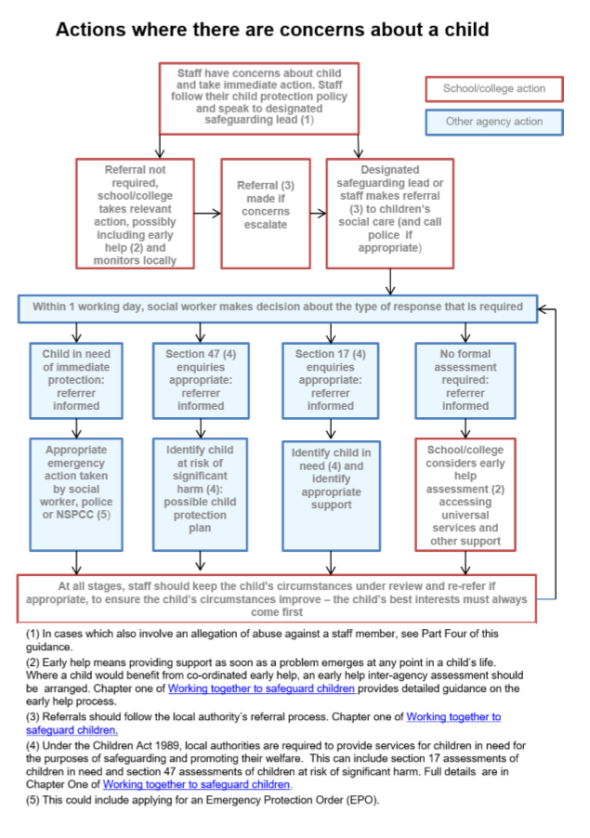

# Appendix F Safeguarding Team Poster

## 

# Appendix G Child-on-Child Abuse Toolkit

Contents

|  |
| --- |
| 1. Introduction |
| 2. Policy Aims |
| 3. Whole School approach to promoting positive child-to-child relationships  3.1 Lead Members of staff  3.2 Fielding a disclosure  3.3 Multi-Agency Working  3.4 Counselling Provision (Place2Be)  3.5 Digital Partners |
| 4. What is Child-on-Child Abuse  4.1 Contextual Safeguarding  4.2 Harmful Sexual Behaviours  4.3 Other harmful behaviours  4.4 How can a child who is being abused by their peers be identified?  4.5 Are some children particularly vulnerable to abusing or being abused by their peers? |
| 5. Responding to concerns or allegations of Child-on-Child Abuse  5.1 Safety Plans and Risk Assessments  5.2 Information sharing, data protection and record keeping  5.3 Ongoing Response  6. Disciplinary Action  7. Pro-active work to promote best practice |
| 8. Appendices  Appendix 2: Summary of Ofsted Review of Sexual Abuse in Schools (April/May 2021)  Appendix 3: Forest School Safety Plan  Appendix 4: Additional Resources |
|  |

**1.0 Introduction**

The governors, senior leadership team, and all staff at **Forest School** are committed to the prevention, early identification, and appropriate management of Child-on-Child Abuse (as defined below) both within and beyond the School.

In particular, we:

* believe that in order to protect children and young people, all schools should (a) be aware of the nature and level of risk to which their students are or may be exposed, and put in place a clear and comprehensive strategy which is tailored to their specific safeguarding context; and (b) take a whole-school community Contextual Safeguarding approach to preventing and responding to Child-on-Child Abuse,
* regard the introduction of this policy as a preventative measure. We (a) do not feel it is acceptable merely to take a reactive approach to Child-on-Child Abuse in response to alleged incidents of it; and (b) believe that in order to tackle Child-on-Child Abuse proactively, it is necessary to focus on all four of the following areas: (i) systems and structures; (ii) prevention; (iii) identification; and (iv) response/intervention,[1]
* recognise national and increasing concern about this issue, and wish to implement this policy in order to mitigate harmful attitudes and Child-on-Child Abuse in the school setting, and
* encourage parents to hold us to account on this issue, so that if their child feels unsafe as a result of the behaviour of any of their peers, they should inform the School so that it can ensure that appropriate and prompt action is taken in response.

## 2.0 Policy Aims

* is the School’s overarching policy for any issue that could constitute Child-on-Child Abuse. It relates to, and should be read alongside, the School’s Safeguarding and Child Protection Policy and any other relevant policies including, but not limited to, The Behaviour Policy, the Anti-Bullying Policy and The Mental Health Policy
* sets out our strategy for improving prevention and identifying and appropriately managing Child-on-Child Abuse. This policy is largely based upon the Farrer & Co, Child-on-Child Abuse Toolkit[2]. There are also significant references to the statutory Keeping Children Safe in Education (especially Part 5)[3], the DfE guidance entitled Sexual violence and Sexual harassment between children in schools and colleges [4] and various NSPCC resources.
* applies to all governors, the senior leadership team and staff. It is reviewed annually, and updated in the interim, as may be required, to ensure that it continually addresses the risks to which students are or may be exposed. A number of staff and students are to be involved in each annual review which involves, and is informed by, an assessment of the impact and effectiveness of this policy over the previous year,
* recognises that abuse is abuse, and should never be passed off as ‘banter’, ‘just having a laugh’, or ‘part of growing up’,

1. Whole School approach to promoting positive child-to-child relationship

The School actively seeks to raise awareness of and prevent all forms of Child-on-Child Abuse by:

educating all governors, its senior leadership team, staff, students, and parents about this issue.

This includes:

* training all governors, the senior leadership team, and staff on the nature, prevalence and effect of Child-on-Child Abuse, and how to prevent, identify, and respond to it. This includes (i) Contextual Safeguarding, (ii) the identification and classification of specific behaviours, including digital behaviours, (iii) the importance of taking seriously all forms of Child-on-Child Abuse (no matter how ‘low level’ they may appear) and ensuring that no form of Child-on-Child Abuse is ever dismissed as horseplay or teasing, and (iv) social media and online safety, including how to encourage children to use social media in a positive, responsible and safe way, and how to enable them to identify and manage abusive behaviour online.
* educating children about the nature and prevalence of Child-on-Child Abuse, positive, responsible and safe use of social media, and the unequivocal facts about consent, via Wellbeing Education and the wider curriculum. Educating students about consent includes teaching them basic facts such as (i) a child under the age of 13 can never consent to any sexual activity; (ii) the age of consent is 16; and (iii) sexual intercourse without consent is rape, and engaging parents on these issues by:

− talking about them with parents, both in groups and one to one,

− asking parents what they perceive to be the risks facing their child and how they would like to see the School address those risks,

− encouraging parents to hold the School to account on this issue, in part as a result of visibility of this policy.

* working with governors, senior leadership team, and all staff, students and parents to address equality issues, to promote positive values, and to encourage a culture of tolerance and respect amongst all members of the School community thereby creating conditions in which our students can aspire to, and realise, safe and healthy relationships fostering a whole-school culture. Every member of our School community is responsible for building and maintaining safe and positive relationships, and helping to create a safe School environment in which violence and abuse are never acceptable, in which students are able to develop trusting relationships with staff, and in which staff understand, through regular discussion and training, the importance of these relationships in providing students with a sense of belonging.

3.1 Lead Members of staff

Whilst all staff at Forest School are responsible for the promoting positive relationships between children and young people, the following staff play key roles:

* Jeff Kayne, Deputy Head Safeguarding (DSL)
* Natassja Milton, Deputy Head Pastoral (Senior) and Deputy DSL
* Jon Sloan, Head of Lower School and Deputy DSL
* Louise Lechmere-Smith, Head of Middle School and Deputy DSL
* Kate Spencer Ellis, Head of Sixth Form and Deputy DSL
* Kate Clark, Deputy Head of Pupil Development and Wellbeing (Prep) and Deputy DSL
* Anna Manlangit, Deputy Head of Welfare and Engagement (Prep) and Deputy DSL
* Emily Arthur, Deputy Head of Middle School (Pastoral and Safeguarding) and Deputy DSL
* Dr Maggie Krakowian, Director of Medical Provision
* Kim Wolstenhome, School Office Manager and Deputy DSL
* Wayne Bishop, Director Health & Safety and Compliance and Deputy DSL
* Amanda Gale, School Project Manager (Place2Be) and Deputy DSL
* Hattie Birkett, Lead Nurse and Medical Operations Manager and Deputy DSL
* Mel Wright, Head of Learning Support (Senior) and Deputy DSL
* Maggie Pickwick, Head of Learning Support (Prep) and Deputy DSL

**‘Children have said that they need:**

• vigilance: to have adults notice when things are troubling them

• understanding and action: to understand what is happening; to be heard and understood; and to have that understanding acted upon

• stability: to be able to develop an ongoing stable relationship of trust with those helping

them

• respect: to be treated with the expectation that they are competent rather than not

• information and engagement: to be informed about and involved in procedures, decisions,

concerns and plans

• support: to be provided with support in their own right as well as a member of their family

• advocacy: to be provided with advocacy to assist them in putting forward their views

• protection: to be protected against all forms of abuse and discrimination’ **[5]**

3.2 **Fielding a Disclosure**

All staff at Forest School are encouraged to listen to pupils and ‘hear’ what they say. We encourage staff to use coach-like language and prompt questions to help empower pupils to articulate what it is they would like to say. We want pupils to be able to disclose concerns about themselves or others to any member of staff. Therefore, specific guidance has been issued in relation to fielding disclosures:

* Listen carefully, reassure them that they were right to tell you
* Be calm, supportive and non-judgemental
* Don’t try to investigate or ask leading questions
* Explain that you must tell someone else who can help. Be specific about who you will tell, i.e. DSL

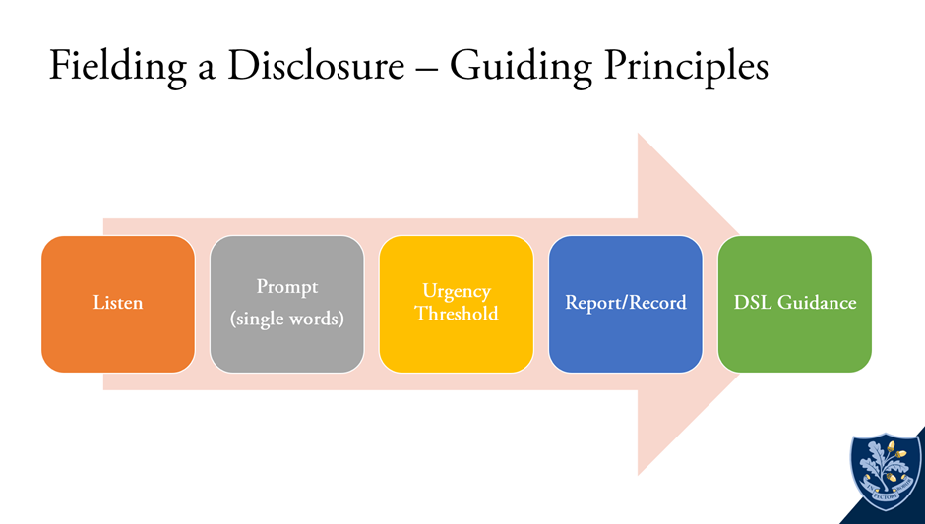**[6]**

**The Urgency Threshold:** Any member of staff fielding a disclosure must decide if the child is at risk of immediate harm. If so, the member of staff must bring the child to the relevant DSL immediately. If this is not the case, the member of staff should report/record the conversation via the school safeguarding software (CPOMS) as soon as is practically possible.

* 1. **Multi Agency Working**

The School actively engages with its Local Safeguarding Partnership in relation to Child-on-Child Abuse, and works closely with, for example, children’s social care and the police. We work very closely with Waltham Forest and subscribe to their Safeguarding in Education Service. We are in frequent contact with the LADO (Local Authority Designated Officer who provides expert advice on all aspects of Safeguarding and Child Protection. We also work regularly with children’s services in 8-10 other local authorities. Our Safer Schools Police Officer, PC Wiercioch contacts us every day to check-in and forwards any police reports recorded in respect of our students and their families. Of course, when necessary, we work closely with other schools.

The relationships the School has built with these partners are essential to ensuring that the School is able to prevent, identify early, and appropriately handle cases of Child-on-Child Abuse. They help the School to: (a) develop a good awareness and understanding of the different referral pathways that operate in its local area, as well as the preventative and support services which exist; (b) ensure that its students are able to access the range of services and support they need quickly; (c) support and help inform the School’s local community’s response to Child-on-Child Abuse;

(d) increase the School’s awareness and understanding of any concerning trends and emerging risks in its local area to enable it to take preventative action to minimise the risk of these being experienced by its students.

The School actively refers concerns and allegations of Child-on-Child Abuse where necessary to children’s social care and the police. This is particularly important because Child-on-Child Abuse can be a complex issue, and even more so where wider safeguarding concerns exist. It is often not appropriate for one single agency (where the alleged incident cannot appropriately be managed internally by the School itself) to try to address the issue alone – it requires effective partnership working.

**3.4 Counselling Provision (Place2Be)**

We are delighted to work in partnership with Place2Be [7] in order to provide counselling provision, on a 5-day per week basis, at Forest School. Amanda Gale, our Place2Be School Project Manager works closely with school staff to deliver the service which is available to children from Year 3 to year 13, inclusive.

**[8]**

The services Place2Be offer include advice and support for families and consultations and training for school staff. This builds resilience and raises awareness of the importance of good mental health across the whole school community. More specifically, the services Place2Be offer include:

* One-to-one counselling for pupils who are struggling
* Short appointments to talk about worries, booked by pupils
* Group work about friendship, self-esteem and other issues
* Training for school leaders and staff to make schools more mentally healthy
* Consultations for school staff about behaviour and wellbeing
* Advice and support for parents to help them look after their child
* Group programme using art and discussion to build pupils’ self-esteem.**[9]**

**Place2Talk** is an opportunity for pupils to request an appointment to see our school Project Manager. Appointments normally last for 15-20 minutes and the sessions are normally ‘solution-focused’. Pupils self-refer into Place2Talk by using the direct e-mail [place2talk@forest.org.uk](mailto:place2talk@forest.org.uk)

**1:1 Counselling** is available on a weekly basis after a full assessment of the case has been made. In the first instance, the Heads of Section will make a referral with the pupil often working closely with the relevant Head of House and/or Tutor. Once a referral has been made, the school project manager will commence the assessment to decide if the pupil’s case meets the threshold for 1:1 counselling. In most cases, parents will be directly involved in the assessment as we believe it is in the best interests of the pupil. On rare occasions, there may be exceptional circumstances evident in relation to safeguarding, when parents will not be informed that a pupil is receiving counselling at Forest School.

Place2Think is designed to provide guidance and advice to Forest staff to help support pupils in their care who may be experiencing difficulties in relation to their mental health and wellbeing. Staff can book a Place2Think consultation via the e-mail address: [place2think@forest.org.uk](mailto:place2think@forest.org.uk)

**3.5** **Digital Partners**

In order to ensure Forest pupils can self-advocate, access different types of support, seek child-to-child support and/or attain support in the evenings, weekend and during holidays, we have added a suite of digital partners to our -provision.

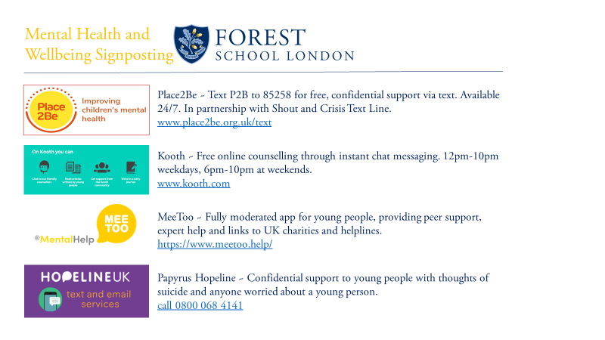

## 4.0 What is Child-to-child Abuse

For these purposes, Child-on-Child Abuse is any form of physical, sexual, emotional and financial abuse, and coercive control, exercised between children, and within children’s relationships (both intimate and nonintimate), friendships and wider peer associations.

Child-on-Child Abuse includes, but is not limited to:

* physical and sexual abuse
* sexual harassment and violence
* emotional harm
* on and offline bullying
* teenage relationship abuse [10]

**KCSIE 2024 states:**

**All** staff should be aware that children can abuse other children (often referred to as Child-on-Child Abuse). This is most likely to include, but may not be limited to:

• bullying (including cyberbullying)

• physical abuse: such as hitting, kicking, shaking, biting, hair pulling, or otherwise causing physical harm

• sexual violence: such as rape, assault by penetration and sexual assault

• sexual harassment: such as sexual comments, remarks, jokes and online sexual harassment, which may be stand-alone or part of a broader pattern of abuse

• upskirting: typically involves taking a picture under a person’s clothing without them knowing, with the intention of viewing their genitals or buttocks to obtain sexual gratification, or cause the victim humiliation, distress or alarm

• Youth produced sexual imagery (sometimes referred to as ‘sexting’

• initiation/hazing type violence and rituals

**4.1 Contextual Safeguarding**

This policy:

1. encapsulates our Contextual Safeguarding approach, which is about changing the way that professionals approach child protection when risks occur outside of the family, thereby requiring all those within a Local Safeguarding Partnership to consider how they work alongside, rather than just refer into, children’s social care, to create safe spaces in which children may have encountered Child-on-Child Abuse.
2. adopts a whole-school community Contextual Safeguarding approach, which means:

* being aware of and seeking to understand the impact that these wider social contexts may be having on the School’s students,
* creating a safe culture in the School by, for example, implementing policies and procedures that address Child-on-Child Abuse and harmful attitudes; promoting healthy relationships and attitudes to gender/ sexuality; hotspot mapping to identify risky areas in the School; training on potential bias and stereotyped assumptions,
* being alert to and monitoring changes in students’ behaviour and/or attendance, and
* contributing to local child protection agendas by, for example, challenging poor threshold decisions and referring concerns about contexts to relevant local agencies (see section entitled ‘multi-agency working’).
  1. **Harmful Sexual Behaviours**
* Around a third of child sexual abuse is by other children or young people
* There is some cross-over between online and offline HSB and between child sexual exploitation and HSB.
* HSB is most commonly identified in adolescent boys, but girls and younger children can also exhibit HSB.
* A significant proportion of children who display HSB also have a learning disability. The majority of children who display HSB have themselves experienced trauma, including abuse or neglect.
* The majority of children and young people displaying HSB do not become sexual offenders as adults. Young people who display HSB often experience other emotional, behavioural and peer-related difficulties.[11]

Simon Hackett has proposed the following continuum model to demonstrate the range of sexual behaviours presented by children, which may be helpful when seeking to understand a student’s sexual behaviour and deciding how to respond to it.[12]

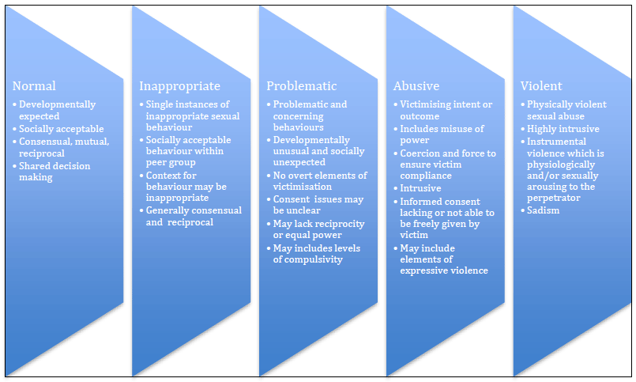

Hackett’s continuum relates exclusively to sexual behaviours and is not exhaustive.

The Brook Sexual Behaviours Traffic Light Tool can help professionals working with children to distinguish between three levels of sexual behaviour – green, amber and red, and to respond according to the level of concern.

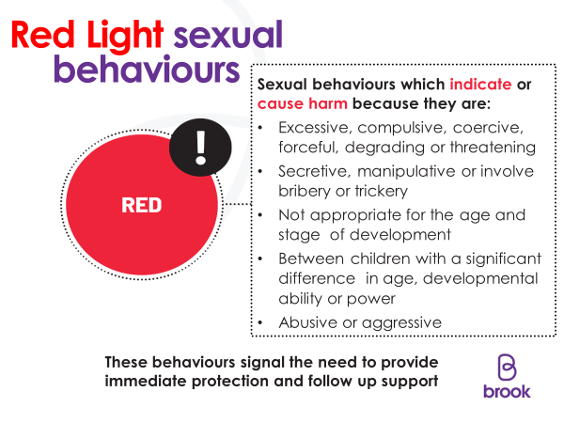

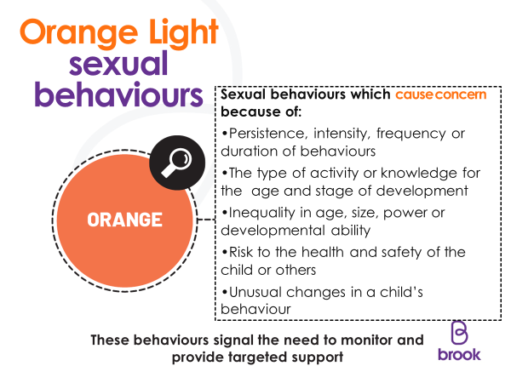

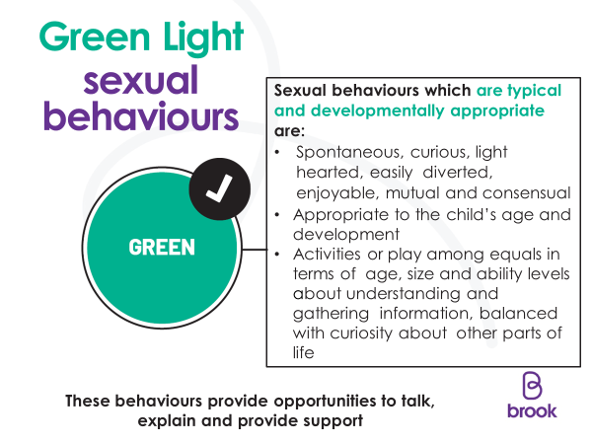

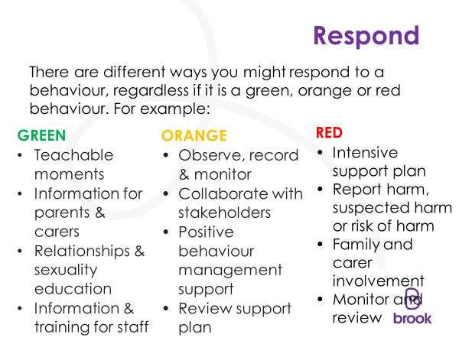

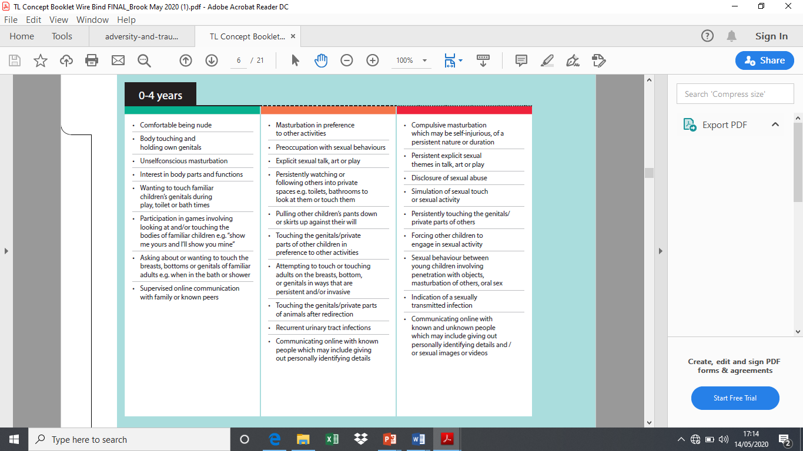

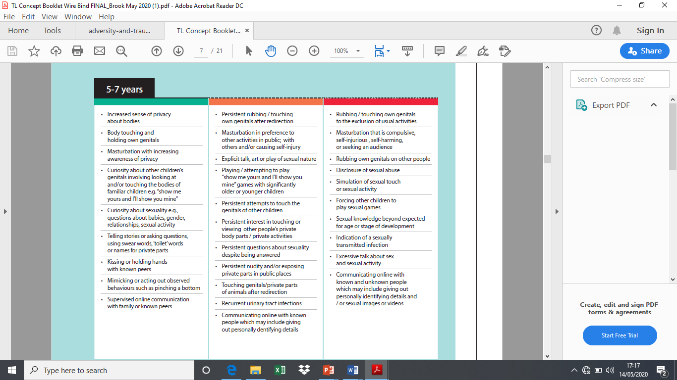

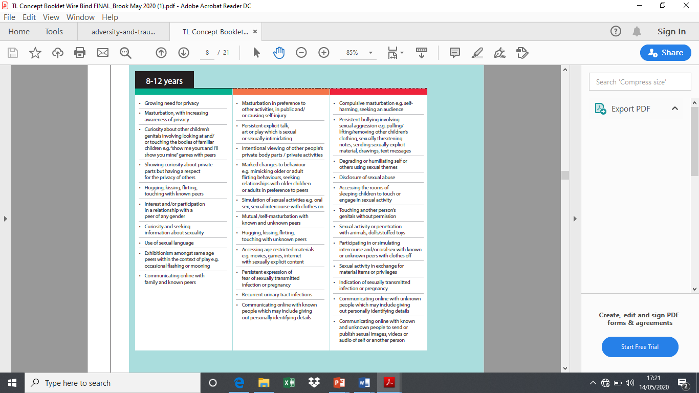

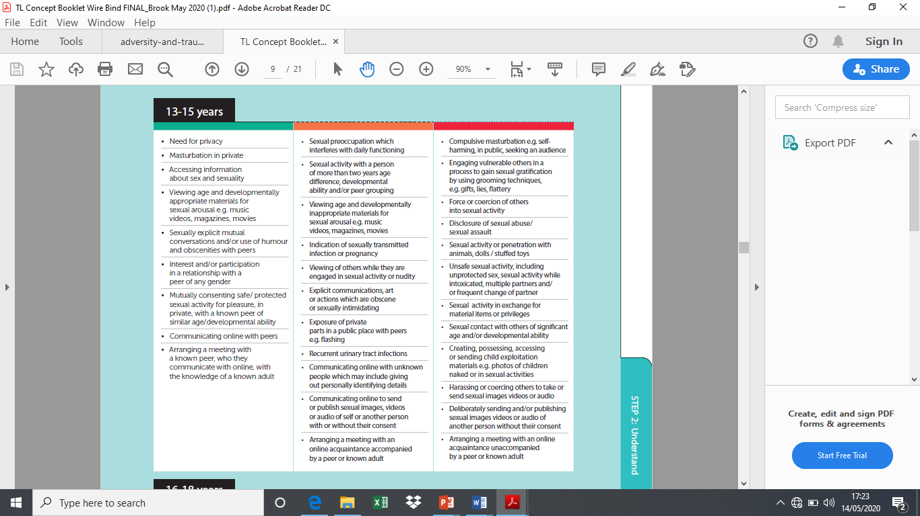

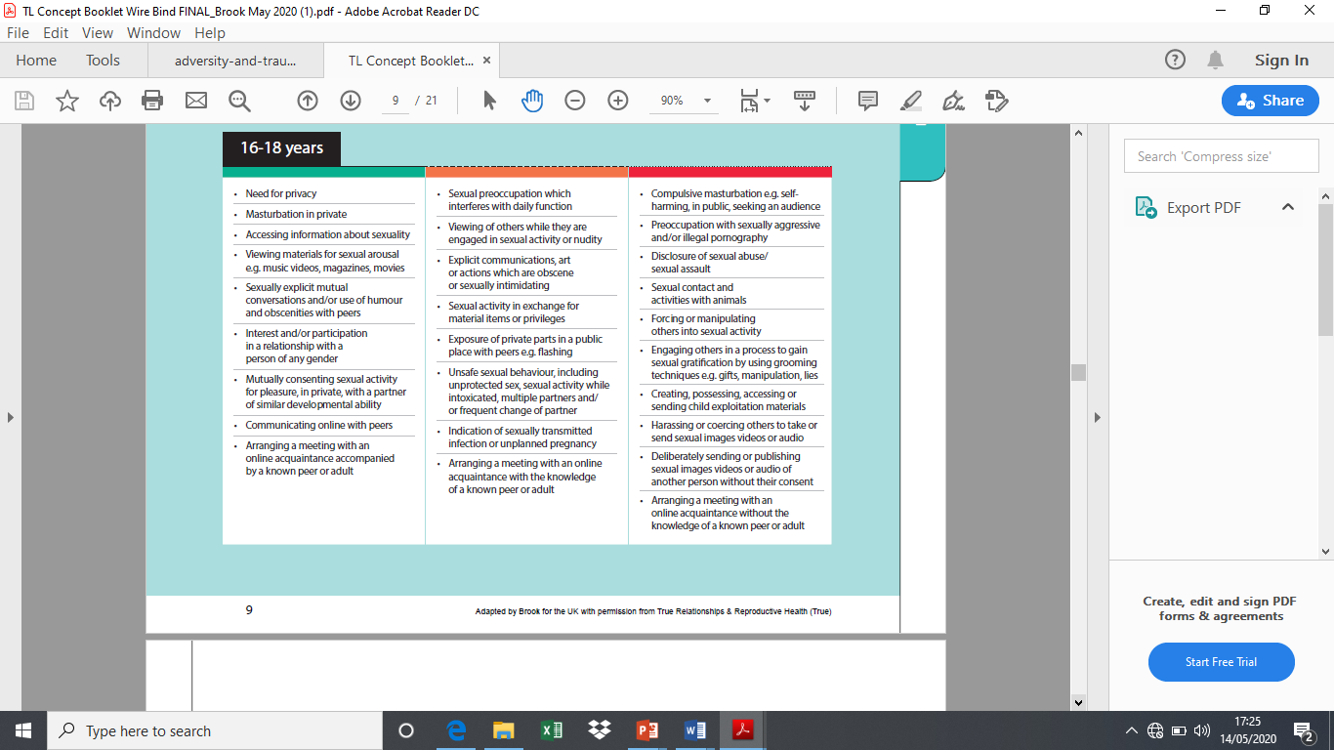

**4.3 Other behaviour**

When dealing with other alleged behaviour which involves reports of, for example, emotional and/or physical abuse, staff can draw on aspects of Hackett’s continuum to assess where the alleged behaviour falls on a spectrum and to decide how to respond. This could include, for example, whether it:

* is socially acceptable,
* involves a single incident or has occurred over a period of time,
* is socially acceptable within the peer group,
* is problematic and concerning,
* involves any overt elements of victimisation or discrimination e.g. related to race, gender,

sexual orientation, physical, emotional, or intellectual vulnerability,

* involves an element of coercion or pre-planning,
* involves a power imbalance between the child/ children allegedly responsible for the

behaviour and the child/children allegedly the subject of that power, and

* involves a misuse of power

**4.4** **How can a child who is being abused by their peers be identified?**

All staff should be alert to the well-being of students and to signs of abuse, and should engage with these signs, as appropriate, to determine whether they are caused by Child-on-Child Abuse. However, staff should be mindful of the fact that the way(s) in which children will disclose or present with behaviour(s) as a result of their experiences will differ.

Signs that a child may be suffering from Child-on-Child Abuse can also overlap with those indicating other types of abuse (please see the Safeguarding Policy for indicators of abuse) and can include:

* failing to attend school, disengaging from classes or struggling to carry out school-related tasks to the standard ordinarily expected;
* physical injuries;
* experiencing difficulties with mental health and/or emotional wellbeing;
* becoming withdrawn and/or shy; experiencing headaches, stomach aches, anxiety and/or panic attacks; suffering from nightmares or lack of sleep or sleeping too much;
* broader changes in behaviour, including alcohol or substance misuse;
* changes in appearance and/or starting to act in a way that is not appropriate for the child's age;

**Are some children particularly vulnerable to abusing or being abused by their peers?**

Any child can be vulnerable to Child-on-Child Abuse due to the strength of peer influence during adolescence, and staff should be alert to signs of such abuse amongst all children. Individual and situational factors can increase a child’s vulnerability to abuse by their peers. For example, an image of a child could be shared, following which they could become more vulnerable to Child-on-Child Abuse due to how others now perceive them, regardless of any characteristics which may be inherent in them and/or their family. Peer group dynamics can also play an important role in determining a child’s vulnerability to such abuse. For example, children who are more likely to follow others and/or who are socially isolated from their peers may be more vulnerable to Child-on-Child Abuse. Children who are questioning or exploring their sexuality may also be particularly vulnerable to abuse by their peers.

Research suggests that:

* Child-on-Child Abuse may affect boys differently from girls, and that this difference may result from societal norms (particularly around power, control and the way in which femininity and masculinity are constructed) rather than biological make-up. Barriers to disclosure will also be different. As a result, schools need to explore the gender dynamics of Child-on-Child Abuse within their settings, and recognise that these will play out differently in single sex, mixed or gender- imbalanced environments,
* children with Special Educational Needs and/or Disabilities (SEND) are three times more likely to be abused than their peers without SEND, and additional barriers can sometimes exist when recognising abuse in children with SEND. These can include:
* assumptions that indicators of possible abuse such as behaviour, mood and injury relate to a child’s disability without further exploration,
* the potential for children with SEND to be disproportionately impacted by behaviours such as bullying and harassment, without outwardly showing any signs,
* communication barriers and difficulties, and − overcoming these barriers
* some children may be more likely to experience Child-on-Child Abuse than others as a result of certain characteristics such as sexual orientation, ethnicity, race or religious beliefs.

## Responding to concerns or allegations of Child-on-Child Abuse

It is essential that all concerns and allegations of Child-on-Child Abuse are handled sensitively, appropriately and promptly. The way in which they are responded to can have a significant impact on our School environment.

Any response should:

* include a thorough investigation of the concern(s) or allegation(s), and the wider context in which it/they may have occurred (as appropriate) – depending on the nature and seriousness of the alleged incident(s), it may be appropriate for the police and/or children’s social care to carry out this investigation,
* treat all children involved as being at potential risk – while the child allegedly responsible for the abuse may pose a significant risk of harm to other children, s/he may also have considerable unmet needs and be at risk of harm themselves. The School should ensure that a safeguarding response is in place for both the child who has allegedly experienced the abuse, and the child who has allegedly been responsible for it, and additional sanctioning work may be required for the latter,

The following must be taken into account:

* that the abuse may indicate wider safeguarding concerns for any of the children involved and consider and address the effect of wider sociocultural contexts – such as the child’s/ children’s peer group (both within and outside the School); family; the School environment; their experience(s) of crime and victimisation in the local community; and the child/children’s online presence. Consider what changes may need to be made to these contexts to address the child/ children’s needs and to mitigate risk, and
* the potential complexity of Child-on-Child Abuse and of children´s experiences, and consider the interplay between power, choice and consent. While children may appear to be making choices, if those choices are limited they are not consenting
* the views of the child/children affected. Unless it is considered unsafe to do so (for example, where a referral needs to be made immediately), the DSL should discuss the proposed action with the child/ children and their parents, and obtain consent to any referral before it is made. The School should manage the child/children’s expectations about information sharing, and keep them and their parents informed of developments, where appropriate and safe to do so. It is particularly important to take into account the wishes of any child who has allegedly been abused, and to give that child as much control as is reasonably possible over decisions regarding how any investigation will be progressed and how they will be supported.

**What should you do if you suspect either that a child may be at risk of or experiencing abuse by their peer(s), or that a child may be at risk of abusing or may be abusing their peer(s)?**

If a member of staff thinks for whatever reason that a child may be at risk of or experiencing abuse by their peer(s), or that a child may be at risk of abusing or may be abusing their peer(s), they should discuss their concern with the DSL without delay (in accordance with the Safeguarding and Child Protection policy) so that a course of action can be agreed.

**How will the School respond to concerns or allegations of Child-on-Child Abuse?**

The DSL/DDSL will discuss the concern(s) or allegation(s) with the member of staff who has reported it/them and will, where necessary, take any immediate steps to ensure the safety of the child/all children affected.

Where any concern(s) or allegation(s) indicate(s) that indecent images of a child or children may have been shared online, the DSL should consider what urgent action can be taken in addition to the actions and referral duties set out in this policy, and in the School’s Safeguarding and Child Protection Policy with specific reference to YPSI.

DSL/DDSLs should always use their professional judgement to: (a) assess the nature and seriousness of the alleged behaviour, and (b) determine whether it is appropriate for the alleged behaviour to be to be dealt with internally and, if so, whether any external specialist support is required.

In borderline cases, the DSL/DDSL may wish to consult with children’s social care and/or the Waltham Forest LADO or our Safer Schools Police Officer [and/or other relevant agencies in accordance with the Local Safeguarding Partnership’s procedures] on a no-names basis (where possible) to determine the most appropriate response.

Where the DSL/DDSL considers or suspects that the alleged behaviour in question might be abusive or violent on a spectrum or where the needs and circumstances of the individual child/children in question might otherwise require it, the DSL should contact children’s social care and/or the police immediately and, in any event, within 24 hours of the DSL becoming aware of the alleged behaviour. The DSL will discuss the concern(s) or allegation(s) with the agency and agree on a course of action, which may include:

1. **Manage internally with help from external specialists where appropriate and possible.**

In some cases of sexual harassment, for example, one-off incidents, the school may take the view that the children concerned are not in need of early help or statutory intervention and that it would be appropriate to handle the incident internally, perhaps through utilising their behaviour and bullying policies and by providing pastoral support. Any response should be underpinned by the principle that sexual violence and sexual harassment is never acceptable and will not be tolerated.

1. **Undertake/contribute to an inter-agency early help assessment, with targeted early help services provided to address the assessed needs of the child/children and their family. Further guidance on effective assessment of the need for early help can be found in** [**Working Together to Safeguard Children.**](https://www.gov.uk/government/consultations/working-together-to-safeguard-children-changes-to-statutory-guidance)

The school may decide that the children involved may benefit from early help. Early help can be particularly useful to address non-violent harmful sexual behaviour and may prevent escalation of sexual violence.

1. **Refer the child/children to children’s social care for a section 17/47 statutory assessment.**

Where a child has been harmed, is at risk of harm, or is in immediate danger, schools should make a referral to local children’s social care and if appropriate the police, (see [when to call the police: guidance for schools and colleges (npss.police.uk)).](https://www.npcc.police.uk/SysSiteAssets/media/downloads/publications/publications-log/2020/when-to-call-the-police--guidance-for-schools-and-colleges.pdf) At this point, schools will generally inform parents or carers, unless there are compelling reasons not to (if informing a parent or carer is going to put the child at additional risk). Any such decision should be made with the support of children’s social care.

Schools and colleges should not wait for the outcome (or even the start) of a children’s social care investigation before protecting the victim and other children in the school or college.

Consideration of safeguarding the victim, alleged perpetrator, any children directly involved in the reported incident and all children (and adult students) at the school or college should be immediate.

In some cases, children’s social care will review the evidence and decide a statutory intervention is not appropriate. The school should be prepared to refer again if they believe the child remains in immediate danger or at risk of harm.

1. **Report alleged criminal behaviour to the police.**

Alleged criminal behaviour will ordinarily be reported to the police. However, there are some circumstances where it may not be appropriate to report such behaviour to the police. For example, where the exchange of youth involved sexual imagery does not involve any aggravating factors [see the School’s Safeguarding and Child Protection Policy for further information]. All concerns or allegations will be assessed on a case by case basis, and in light of the wider context.

**5.1 Safety plans and Risk Assessments**

The School will carry out a safety plan in respect of:

* any child who has reportedly been abused or affected by the alleged abusive or violent behaviour by another child, or
* any child who may be at risk due to the alleged abusive or violent behaviour by another child as deemed appropriate by the DSL.

Where other children have been identified as witnesses to alleged abuse or violence, consideration should also be given by the DSL to whether there might be any risks to those children, and whether a safety plan would be appropriate in relation to any risks presenting to them.

**5.2 Risk Assessments**

The School may decide to carry out a risk assessment in respect of:

* any child who is alleged to have behaved in a way that is considered to be abusive or violent,

Where it is alleged that a child has behaved in a way that is considered to be inappropriate or problematic (as opposed to abusive or violent), the DSL/DDSL will use their professional judgment – based on the particular concern(s) and/or allegation(s) raised, and the needs and circumstances of the individual child/children in question – to determine whether (as explained above) it would be appropriate to contact children’s services, and to carry out a risk assessment.

Careful judgment and consideration are required as to whether alleged behaviour which might be judged to be inappropriate by an adult might actually be harmful to another child. Consultation is recommended with children’s services if there is any doubt about this. Careful consideration should also be given to a range of factors including the context, severity of the alleged behaviour, impact of the alleged behaviour on others, risk to others, and whether there are any patterns of behaviour occurring.

**Information sharing, data protection and record keeping**

When responding to concern(s) or allegation(s) of Child-on-Child Abuse, the School will:

* always consider carefully, in consultation with children’s services the police and other relevant agencies (where they are involved), how to share information about the concern(s) or allegation(s) with the student(s) affected, their parents, staff, and other students and individuals,
* record the information that is necessary for the School and other relevant agencies (where they are involved) to respond to the concern(s) or allegation(s) and safeguard everyone involved,
* keep a record of the legal purpose for sharing the information with any third party, including relevant authorities, and be mindful of and act in accordance with its safeguarding and data protection duties, including those set out in *Working Together to Safeguard Children* (December 2023)[13] and the *HM Government advice on Information Sharing* (updated in July 2018).[14]

**5.3 Ongoing response (Victims)**

**The following principles should help shape any decisions regarding safeguarding and supporting the victim.**

* Schools should consider the most appropriate language to use when referring to the “victim”, as not everyone who has been subjected to sexual violence and/or sexual harassment considers themselves a victim or would want to be described in this way.
* Consider the age and the developmental stage of the victim, the nature of the allegations and the potential risk of further abuse.
* The needs and wishes of the victim should be paramount (along with protecting the child) in any response.
* It is important they feel in as much control of the process as is reasonably possible. Wherever possible, the victim, if they wish, should be able to continue in their normal routine, and school should be a safe space for them.
* The victim should never be made to feel they are the problem for making a report or made to feel ashamed for making a report.
* Consider the proportionality of the response. Support should be tailored on a case-by-case basis.

A victim of sexual violence is likely to be traumatised and, in some cases, may struggle in a normal classroom environment - there may be times when the victim finds it difficult to maintain a full-time timetable and may express a wish to withdraw from lessons and activities.

If the trauma results in the victim being unable to remain in school, alternative provision or a move to another school should be considered to enable them to continue to receive suitable education. This should only be at the request of the victim (and following discussion with their parents or carers). The School will continue to be responsible for the safeguarding of that pupil and should be satisfied that the placement meets the pupil’s needs.

**Ongoing response (Alleged Perpetrators)**

The following principles should help shape any decisions regarding safeguarding and supporting any alleged perpetrators.

* Schools should consider the most appropriate language to use when referring to the “perpetrator” or “allegedly perpetrator”. The guidance recognises that the school will have to balance safeguarding the victim (and the wider student body) with providing the alleged perpetrator with an education, safeguarding support as appropriate and implementing any disciplinary sanctions. Research has shown that many children who present with harmful behaviour towards others, in the context of Child-on-Child Abuse, are themselves vulnerable and may have been victimised by peers, parents or adults in the community prior to their abuse of peers,

**Consideration should be given to:**

**•** the age and the developmental stage of the alleged perpetrator and nature of the allegations

• the proportionality of the response. Support (and sanctions) should be considered on a

case-by-case basis

**6.0 Disciplinary action**

The School may wish to consider whether disciplinary action may be appropriate for any child/children involved. However, if there are police proceedings underway, or there could be, it is critical that the School works in partnership with the police and/or children’s services.

Where a matter is not of interest to the police and/ or children’s services, the School may still need to consider what is the most appropriate action to take to ensure positive behaviour management. Disciplinary action may sometimes be appropriate, including to:

1. ensure that the child/children take(s) responsibility for and realise(s) the seriousness of their behaviour.
2. demonstrate to the child/children and others that Child-on-Child Abuse can never be tolerated; and
3. ensure the safety and wellbeing of other children.

However, these considerations must be balanced against any police investigations, the child’s/children’s own potential unmet needs, and any action or intervention planned regarding safeguarding concerns. Before deciding on appropriate action the School will always consider its duty to safeguard all children in its care from harm; the underlying reasons for a child’s behaviour; any unmet needs, or harm or abuse suffered by the child; the risk that the child may pose to other children; and the severity of the Child-on-Child Abuse and the causes of it.

The School will, where appropriate, consider the potential benefit, as well as challenge, of temporary or permanent exclusion as a response. Permanent Exclusion will only be considered as a last resort and only where necessary to ensure the safety and wellbeing of the other children in the School.

Disciplinary interventions alone are rarely able to solve issues of Child-on-Child Abuse, and the School will always consider the wider actions that may need to be taken, and any lessons that may need to be learnt going forwards, as set out above and below.

In all cases, schools and colleges should record and be able to justify their decision

making. All of the above should be considered with the needs and wishes of the victim at the heart of the process (supported by parents and carers as required). Any arrangements should be kept under review.

**7.0 Ongoing proactive work for a whole-school community Contextual Safeguarding approach**

The School’s response to concerns or allegations of Child-on-Child Abuse should be part of on-going proactive work by the School to embed best practice and in taking a whole-school community Contextual Safeguarding approach (defined above) to such abuse. As such the School’s response can become part of its wider prevention work.

This response may involve the School working with the local authority to undertake, for example, a Contextual Safeguarding school assessment which would fit into a systems approach to Contextual Safeguarding [15] The response could also include the School asking itself a series of questions about the context in which an incident of Child-on-Child Abuse occurred in the School, the local community in which the School is based, and the wider physical and online environment – such as:

* What protective factors and influences exist within the School (such as positive peer influences, examples where Child-on-Child Abuse has been challenged, etc.) and how can the School bolster these?
* How (if at all) did the School’s physical environment or the students’ routes to and from the School contribute to the abuse, and how can the School address this going forwards, for example by improving the School’s safety, security and supervision, or by working with local safeguarding partners to mitigate the risks to students’ safety whilst travelling to and from the School?
* How (if at all) did the online environment contribute to the abuse, and how can the School address this going forwards, for example by strengthening the way in which the School encourages positive and safe use of the internet by students?
* Does the abuse indicate a need for staff training on, for example, underlying attitudes, a particular issue or the handling of particular types of abuse, or to address any victim-blaming narratives from staff?
* How have similar cases been managed in the past and what effect has this had?
* Does the case or any identified trends highlight areas for development in the way in which the School works with children to raise their awareness of and/or prevent Child-on-Child Abuse, including by way of the School’s Wellbeing Education curriculum and lessons that address underlying attitudes or behaviour such as gender and equalities work, respect, boundaries, consent, children’s rights and critical thinking and/or avoiding victim-blaming narratives?
* Are there any lessons to be learnt about the way in which the School engages with parents to address Child-on-Child Abuse issues?
* Are there underlying issues that affect other schools in the area and is there a need for a multi-agency response?
* Were there opportunities to intervene earlier or differently and/or to address common themes amongst the behaviour of other children in the School?

Answers to these questions can be developed into an action plan that is reviewed on a regular basis by the School’s leadership and the DSL. The School will, where possible and appropriate, work with the local authority and wider partners to deliver on this plan, possibly as part of a wider Contextual Safeguarding school assessment led by or with input from the local authority.

**Appendix 2 – Ofsted Review of Sexual Abuse in Schools (April/May 2021)**

The review included visits to 32 schools and colleges. Ofsted spoke to over 900 children and young people about the prevalence of child-on-child sexual harassment and sexual violence, including online. Ofsted also spoke to leaders, teachers, governors, LSPs, and parents.

This rapid thematic review does not report on individual schools and colleges or cases, all of which remain anonymous. A number of visits to schools named on the Everyone’s Invited website, as well as others not named. This should not be assumed to be a fully representative sample of all schools and colleges nationally. It presents a picture of strong and weaker practice across participating schools and colleges, from which conclusions have been drawn.

The sample included:

* 14 state-funded schools
* 14 ISI-inspected independent schools
* 2 Ofsted-inspected independent schools
* 2 FE colleges

* Visits took place over two days led by HMI. ISI Inspectors shadowed some visits.
* All inspectors involved attended two days’ training which included how to talk with children and young people about sexual abuse and how to deal with disclosures.
* Visits used a range of methods to collect information from school leaders, governors and other staff with a focus on safeguarding and the adequacy of school RSE (relationships and sex education)/RSHE/PSHE (personal, social, health and economic) curriculum and teaching.

**Safeguarding and curriculum**

* Is the existing safeguarding framework and guidance for inspectors strong enough to properly assess how schools and colleges safeguard and promote the welfare of children?
* How can schools and colleges be supported further to successfully deliver the new RSHE (relationships, sex and health education) curriculum, including in teaching about sexual abuse, cyber bullying and pornography as well as healthy relationships and consent

**Multi-agency safeguarding arrangements**

* How well are safeguarding guidance and processes understood and working between schools, colleges and local multi-agency partners?
* Does working between schools, colleges and local safeguarding partners (LSPs), including local authority children’s social care, the police, health services and other support, need to be strengthened

**Victims’ voice and reporting**

* How does the current system of safeguarding in schools and colleges listen to the voices of children when reporting sexual abuse whether occurring within or outside school?
* What prevents children from reporting sexual abuse?
* Do victims receive timely and appropriate support from the right place?
* Have inspections by ISI (the Independent Schools Inspectorate) and Ofsted been robust enough in relation to the issues raised?

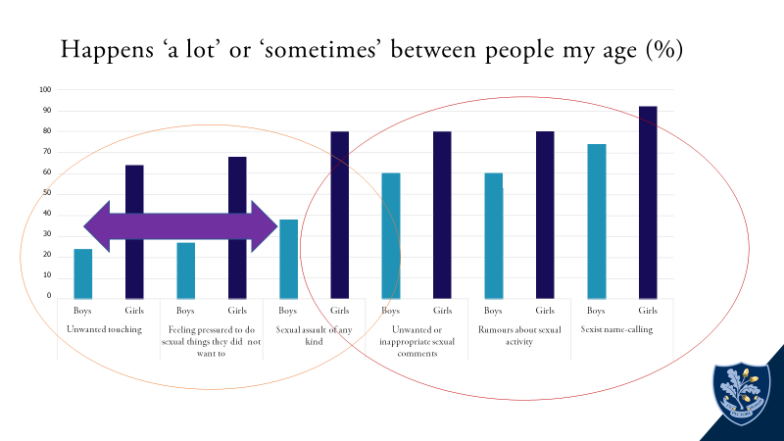

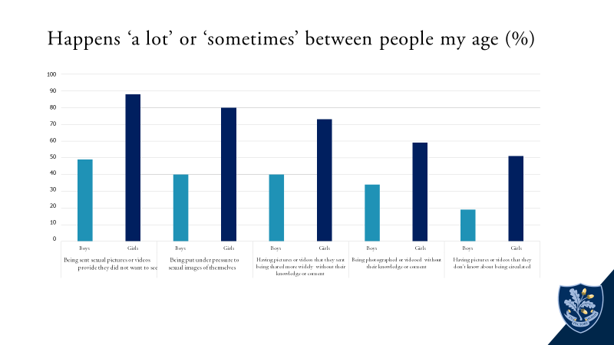

Generally, older teens (aged 16 and above) were more likely to say that sexual harassment and violence, including online, between peers was prevalent than younger teens, for example, 79% of young people aged 16 to 17 and 86% of those aged 18 and above said that rumours about sexual activity occurred a lot or sometimes between peers compared with 61% of those aged 13 to 15. Similarly, 54% of those aged 16 and above said unwanted touching occurred a lot or sometimes, compared with 40% of 13- to 15-year-olds. While figures are high for both groups, this increase could suggest that sexual harassment and violence, including online, happen more as children and young people grow older, or that they become more aware of them.

In terms of sexualised language, children and young people told us that ‘slag’ and ‘slut’ were commonplace. Many felt that staff either were not aware of this language, dismissed it as ‘banter’ or simply were not prepared to tackle it. Many also commented that they would be wary of tackling their peers’ use of this language, even when they did not feel comfortable with such terms. Sometimes, children and young people themselves saw the use of derogatory language as ‘banter’ or ‘just a joke’. Girls talked about boys being very persistent when asking for images – ‘they just won’t take no for an answer’ – some explained that if you block them on social media ‘they just create multiple accounts to harass you’. In one school, the girls spoken to by inspectors reported that some girls can be contacted by up to 10 or 11 different boys a night to be asked for nude/semi-nude images. Some children and young people thought that it was ‘ok’ and ‘acceptable’ to ask someone for a nude picture but had been taught to think about who else might see the pictures apart from the original recipient, and not to share them further.

Some girls expressed frustration that there was not explicit teaching of what was acceptable and unacceptable behaviour. They felt that the need to educate peers had been left to them. One girl said: ‘It shouldn’t be our responsibility to educate boys.’ A minority of boys felt that gender stereotyping meant that they were being made to ‘feel guilty all the time’ and that they were being unfairly blamed for things they had not done. Nearly half of boys also said that being sent sexual images or videos they did not want to see was something that happened ‘a lot’ or ‘sometimes’ to them or their peers.

**Responding to incidents**

There were many examples where incidents of sexual violence were dealt with appropriately and school policies and statutory guidance such as ‘Keeping children safe in education’ were informing practice. However, the review highlighted some inconsistencies in responses where professionals had interpreted guidance differently. Some schools were dealing with incidents of sexual harassment and sexual violence, including online abuse, in an isolated way, without considering the context and wider

safeguarding risks.

The review noted concern that many instances of sexual harassment, including the pressure to share nudes and the sharing of youth-produced sexual imagery without consent, were going unrecognised or unchallenged by school staff.

**Staff training and development**

The review found that most staff receive annual safeguarding training, which includes updates on ‘Keeping children safe in education’. However, most staff training on harmful sexual behaviours tended to be piecemeal. This was often because it was incorporated into training on other important aspects of safeguarding. In a few schools, there was no training on peer-on-peer sexual harassment and sexual violence. These schools expected staff to read the government’s guidance instead.

The review also found that governors would benefit from better training and greater

involvement in tackling harmful sexual behaviours.

**Delivering the new RSHE curriculum**

While acknowledging the disruption caused by the coronavirus pandemic, the review identified a number of issues that meant that children and young people were not getting the quality of relationships and sex and health education (RSHE) they should. These included weak implementation of RSHE, poor teacher subject knowledge, and significant gaps in curriculum coverage. The review found that children and young people were seldom positive about their RSHE and PSHE lessons. Some felt it was ‘too little, too late’, and talked about filling

in the gaps in their knowledge through social media or their peers.

**Multi-agency safeguarding arrangements**

The review held discussions with 12 local safeguarding partners (LSPs) to seek their views on how well multi-agency safeguarding arrangements to tackle sexual harassment and violence were working. The review found that some LSPs had been working closely with schools to track and analyse data from schools and understood children’s experiences of sexual harassment and violence. However, a small number told us that they were not aware that sexual harassment and violence, including online, in schools and colleges were significant problems in their local area.

The review identified a gap in guidance for how schools and colleges should respond when there are lengthy investigations into incidents of sexual harassment or violence, or when investigations do not lead to a prosecution or conviction. Some school and college leaders also wanted clearer guidance on where their responsibilities start and end, for example with incidents of harmful sexual behaviour that happen outside school.

**How does the current system of safeguarding listen to the voices of children and young people?**

The review found that children and young people rarely speak to adults about sexual harassment and sexual violence, including online abuse. Most children and young people said they would feel most comfortable talking to friends.

• not knowing what would happen next

• concerns about ‘reputational damage’, for example being ostracised from a social group or damage to a sexual reputation

• concerns about the reaction from adults, including feeling judged or blamed

• concerns about confidentiality and not knowing what will be done with the information

• feelings that things were so commonplace there was ‘no point’ in reporting them

• feelings of embarrassment or shame in talking to someone of a different generation about sex.

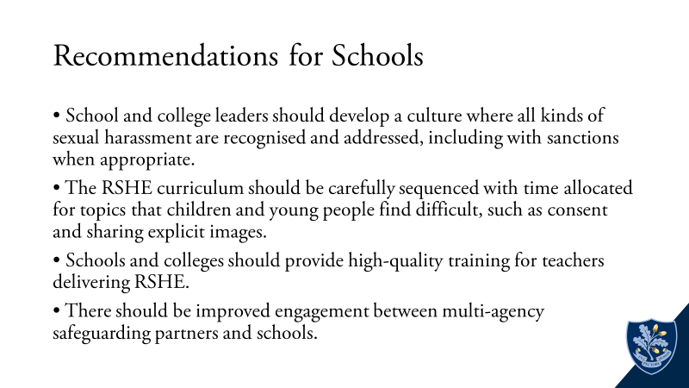

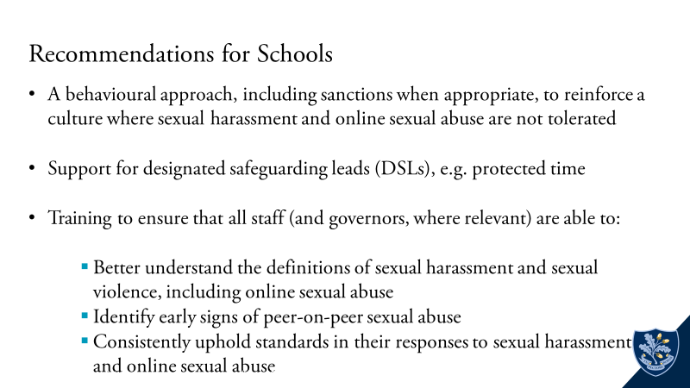

**Appendix 3 – Forest School Safety Plan**

**Safety Plan for:**

**Completed with pupil by:**

**Date:**

**Scheduled Date for Review:**

**What are the reasons that you want to stay safe?**

**What might make it harder to stay safe?**

Am I experiencing any mental health concerns or symptoms that make it harder to stay safe?

**What are the warning signs?**

These are the changes that you feel and the way you act that you can watch out for, to know that you might be at risk of a crisis.

**What do you look like at your best?**

These are all the things that make you, you. Sometimes when people are in a crisis, it can be hard to remember the positives. If you write down everything, big and small, that you care about and your best qualities, it can help to remind you when they’re hard to remember.

**What are your coping strategies?**

These are the activities or ideas that you can use if and when you find difficult thoughts hard to ignore. How will you make your environment safer? What can I do to keep me safe?

**What can you do to make yourself safe in School and at home?**

Things that you can do or change, if you think that you’re at risk of a crisis or feel vulnerable, to make your environment and surroundings less of a risk.

|  |  |
| --- | --- |
| **At School** | **At Home** |
|  |  |
|  |  |
|  |  |
|  |  |
|  |  |

**Who are the people that will support you?**

These are the people in your support network who will be there to listen and offer support

**Parent contribution to safety plan**

An opportunity for parents to add to the safety plan from their perspective

**Access to External Support**

We would like to signpost the following specialist services

* **Your GP** (<https://www.docready.org/#/advice>)
* **A&E**
* **Place2Be: Text P2B to 85258 (24 hours, 7 days)**
* **Kooth -** [**https://www.kooth.com/**](https://www.kooth.com/)
* **Papyrus Hopeline:** [**0800 068 4141**](tel:08000684141) **(9am – 10pm weekdays, 2pm – 10pm weekends, 2pm – 10pm bank holidays)**
* **Childline: 0800 1111**

**Call 0800 1111**

**Appendix 4 – Additional Resources**

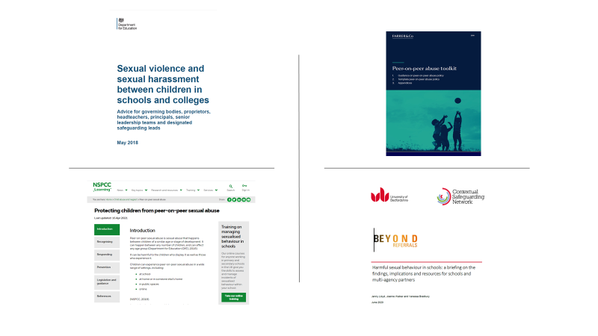

1. <https://www.gov.uk/government/publications/sexual-violence-and-sexual-harassment-between-children-in-schools-and-colleges>
2. <https://www.farrer.co.uk/news-and-insights/peer-on-peer-abuse-toolkit/>
3. <https://learning.nspcc.org.uk/child-abuse-and-neglect/peer-on-peer-sexual-abuse>
4. <https://www.csnetwork.org.uk/en/beyond-referrals-levers-for-addressing-harmful-sexual-behaviour-in-schools>

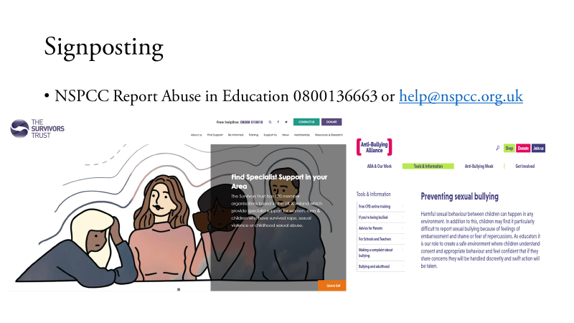

1. <https://www.nspcc.org.uk/about-us/news-opinion/2021/sexual-abuse-victims-schools-helpline/>
2. <https://www.thesurvivorstrust.org/>
3. <https://www.anti-bullyingalliance.org.uk/>

1. <https://contextualsafeguarding.org.uk/publications/beyond-referrals-levers-for-addressing-harmful-sexual-behaviour-in-schools>
2. <https://www.farrer.co.uk/news-and-insights/peer-on-peer-abuse-toolkit/>
3. <https://assets.publishing.service.gov.uk/government/uploads/system/uploads/attachment_data/file/954314/Keeping_children_safe_in_education_2020_-_Update_-_January_2021.pdf>
4. <https://www.gov.uk/government/publications/sexual-violence-and-sexual-harassment-between-children-in-schools-and-colleges>
5. <https://www.gov.uk/government/publications/working-together-to-safeguard-children--2>
6. Forest School Staff Safeguarding and Child Protection Training
7. <https://www.place2be.org.uk/>
8. Place2Be Presentation
9. <https://www.place2be.org.uk/about-us/our-work/our-approach/>
10. <https://educationinspection.blog.gov.uk/2019/10/04/what-is-peer-on-peer-abuse/>
11. <https://learning.nspcc.org.uk/research-resources/statistics-briefings/harmful-sexual-behaviour-hsb>
12. <https://learning.nspcc.org.uk/research-resources/2019/harmful-sexual-behaviour-framework>
13. <https://www.gov.uk/government/publications/working-together-to-safeguard-children--2>
14. <https://assets.publishing.service.gov.uk/government/uploads/system/uploads/attachment_data/file/721581/Information_sharing_advice_practitioners_safeguarding_services.pdf>
15. <https://contextualsafeguarding.org.uk/publications/school-assessment-toolkit>